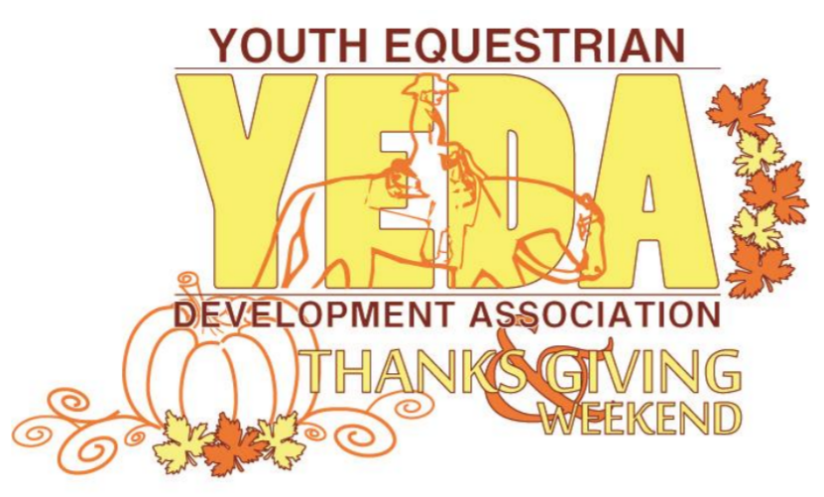
www.showyeda.com

THANKS’ & GIVING WEEKEND
SHOWBILL

November 22 - 23, 2025

GARWOOD ARENA
2538 Middleton Rd
Columbiana, OH 44408

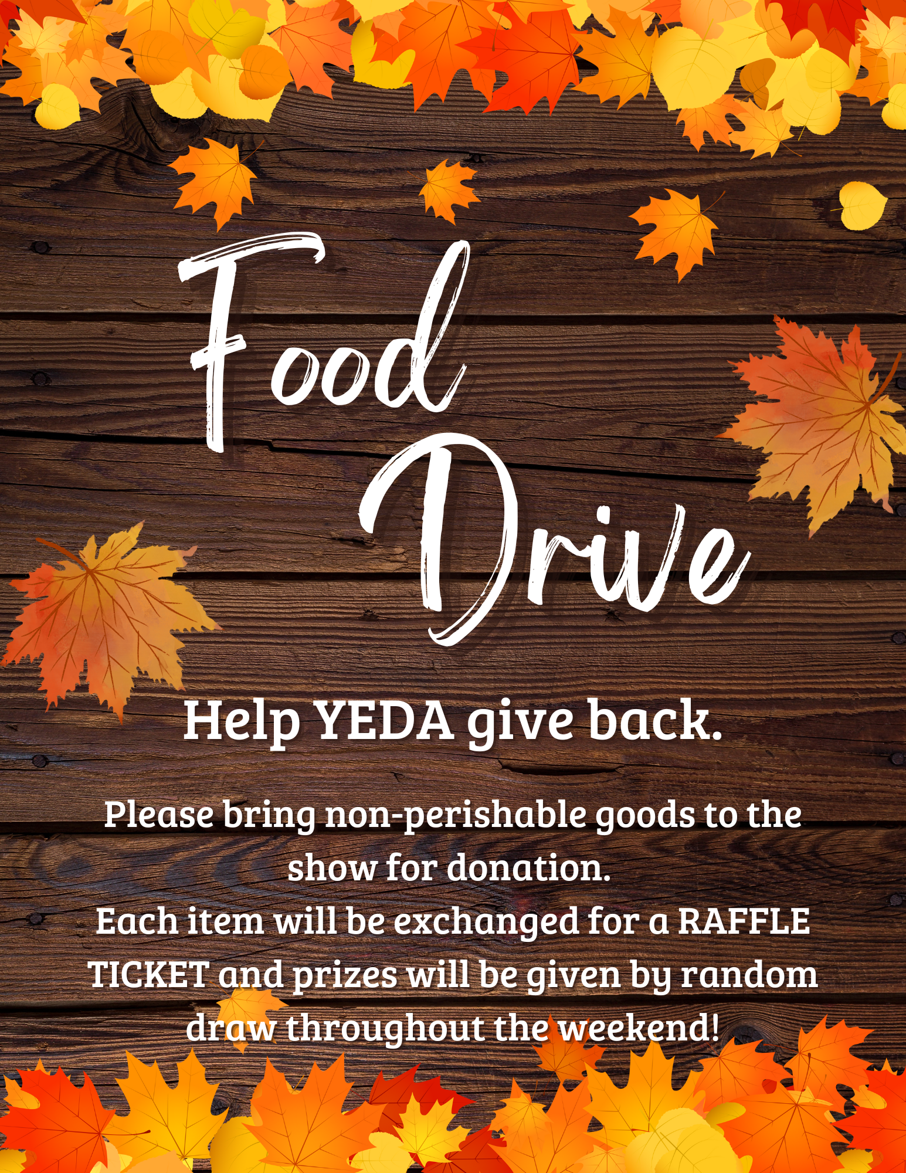
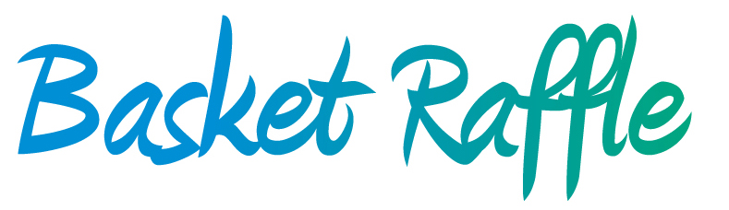

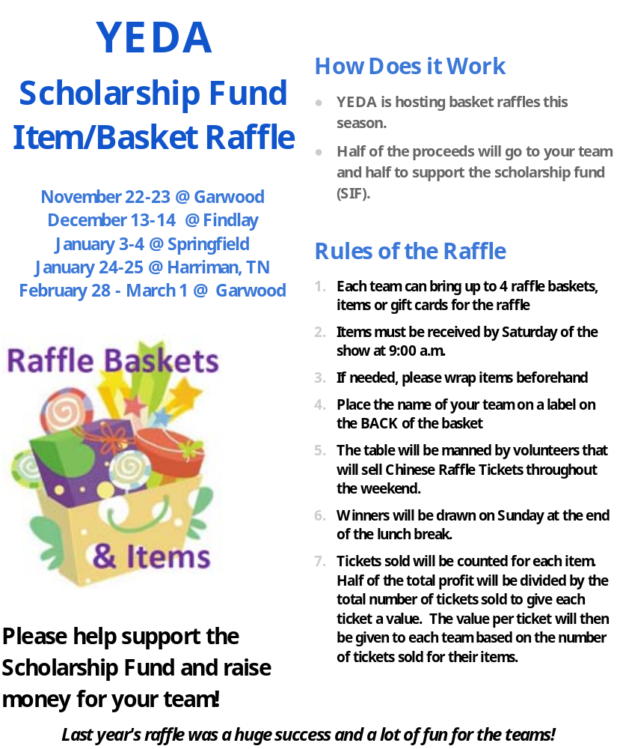

Time Schedule
7:00am Coaches Meeting/ Draw Horses
8:00am Schooling of Horses
9:00 am Competition Begins:

CLASS ORDER SUBJECT TO CHANGE – THE DAY WILL NOT CHANGE

SATURDAY | SUNDAY
Class 3 Junior High Opal Rail Horsemanship  Class 4 Junior High Opal Pattern Horsemanship  Class 5 Junior High Emerald Rail HMS  Class 6 Junior High Emerald Pattern HMS  Class 13 Senior High Emerald Rail HMS  Class 14 Senior High Emerald Pattern HMS  Class 11 Senior High Opal Rail Horsemanship  Class 12 Senior High Opal Pattern Horsemanship  Class 19 Senior High Diamond Pattern/Rail HMS  Class 20 Senior High Diamond Division - Reining  Class 21 Amber Div. Rail HMS Walk Only Assisted  Class 22 Amber Div. Pattern HMS Walk Only Assisted  Class 23 Amber Div. Rail HMS Walk Only Independent  Class 24 Amber Div. Pattern HMS Walk Only Independent  Class 25 Topaz Div. Rail HMS Walk/Trot Assisted  Class 26 Topaz Div. Pattern HMS Walk/Trot Assisted  Class 27 Topaz Div. Rail HMS Walk/Trot Independent  Class 28 Topaz Div. Pattern HMS Walk/Trot Independent  Class 35 Diamond Elite HMS TBD | Class 1 Elementary Pearl Rail Horsemanship  Class 2 Elementary Pearl Pattern Horsemanship  Class 7 Junior High Ruby Rail Horsemanship  Class 8 Junior High Ruby Pattern Horsemanship  Class 9 Junior High Sapphire Pattern/Rail HMS  Class 10 JR High Sapphire Div. Ranch Riding HMS  Class 15 Senior High Ruby Rail Horsemanship  Class 16 Senior High Ruby Pattern Horsemanship  Class 17 SR High Sapphire Div. Pattern/Rail HMS  Class 18 SR High Sapphire Div. Ranch Riding HMS  Class 29 Alumni Opal Division Rail HMS  Class 30 Alumni Opal Division Pattern HMS  Class 31 Alumni Emerald Division Rail HMS  Class 32 Alumni Emerald Division Pattern HMS  Class 33 Alumni Sapphire Div. Rail/Pattern HMS  Class 34 Alumni Sapphire Division Ranch Riding



Our mission is to provide an equestrian riding program for youth students, via both instructional and experiential learning opportunities. To accomplish this, we will engage in equestrian competitions, instructional clinics, networking events and occasions for recruitment that includes but not limited to scholarship disbursements.

Show Officials
Judges: Judge A: Lisa Mathews Judge B: Amy Watkins
Ring Stewards: Jay Lanzer & Kip Riley
Show Steward: Stephanie Steiner
Show Manager: Debbie Arnold & Ric Weitzel
Show Secretary: Megan Queen
Announcer: Spencer Dillinger
Medical Personnel: TBA

Patterns & Schedule of Classes
DAY | Class | PATTERNS
Saturday | Senior High Diamond Reining | YEDA #1/2
Saturday | Senior High Diamond Pattern/Rail Horsemanship | # 2
Sunday | Junior & Senior High Sapphire Ranch Riding | # 2
Sunday | Junior & Senior High Sapphire Pattern/Rail Horsemanship | # 2
Sunday | Junior & Senior High Ruby Pattern Horsemanship | # 2
Saturday | Junior & Senior High Emerald Pattern Horsemanship | # 2
Saturday | Junior & Senior High Opal Pattern Horsemanship | # 2
Sunday | Elementary Pearl Pattern Horsemanship | # 2
Saturday | EWD Amber and Topaz Pattern Horsemanship | # 2
Sunday | Alumni High Sapphire Ranch Riding | # 2
Sunday | Alumni High Sapphire Pattern/Rail Horsemanship | # 2
Sunday | Alumni High Emerald Pattern Horsemanship | # 2
Sunday | Alumni High Opal Pattern Horsemanship | # 2

The pattern book can be found on SHOWYEDA.com

Entry Information, Deadlines, and Scratch Refund Policy:
Entries will not be accepted without payment.
- Open date for entries October 10, 2025
- The due date for entries is November 7, 2025
    - It is suggested to send entries in ASAP, shows can fill up fast!
- Entries received after the due date may not be accepted.
- Entries are $90 per class plus a $10 office fee per class. For a total of $100 per class. The office fee will not be refunded in the event of a pre or post close date scratch.
- EWD Entries are $65 per class plus a $10 office fee per class. For a total of $75 per class. The office fee will not be refunded in the event of a pre or post close date scratch.
- Note: rented ride fees will not be refunded after the close date.
- R40.04 Number of Entries and Limiting Entries No show should exceed 250 rides per day. Entries will be accepted on a first come basis. Meaning that entries will only be considered accepted once originals are received with horse description or horse payment and total payment for entries. Emailing entries is helpful however this will not be considered an official entry. Teams are limited to 42 total entries between Jr and Sr high teams. EWD, Pearl and Alumni entries do not count toward the total number of entries (R1.01 B) Show committees may accept additional entries in the Jr and Sr high divisions from teams if the show has not exceeded the maximum number of entries by closing date. As long as it is done in a fair and equitable way.
- In the event that the maximum entries are reached entries will be accepted on a first come basis. Meaning that entries will only be considered accepted once originals are received with horse description or horse payment and total payment for entries. Emailed entries are considered official entries, once the payment has been received.
- The Closing Date is the date in which the program will be published and any changes after the closing date will not be in the official program and will be hand written in at the coaches meeting.
- The closing date for the show is November 12, 2025
- In the event you have a scratch prior to the closing date, use the Scratch and Refund Request Form to ensure a full refund. Remember, this document needs to completed in its entirety AND received by the show secretary by 5:00pm of the closing date to ensure a refund.
- Entry fees for scratches occurring after the closing date/time, will be refunded only under extraordinary circumstances. If you feel your rider/s circumstances rise to this level, you may complete a Scratch and Refund Request Form located under Coaches Forms on the YEDA Website.

Substitutions
Substitutions will be permitted providing they comply with ALL the below mentioned parameters:
- Same Day
- Same Division
- Same Class

Payment
- Please make checks payable to YEDA
- Any ‘Adds’ must be accompanied by payment
- When possible, please avoid writing multiple checks.

Rent and/or Provide a Horse
R12.05 Horse ratio requirements per type of show:
Split Combined Show: Teams are required to bring one (1) horse for every nine (9) entries, unless the host team reduces the team’s horse entry ratio because of space or entry limits. Horses that are considered height weight horses as defined (R16.01-B &C). Show management, when necessary, has the discretion to reduce the number of entries/rides height weight horses to less than 9.
One (1) horse for every nine (9) entries over the whole weekend. For example, one rider competing in both rail and pattern class will equal two rides.

Rented ride fees are not refunded after the close date.

If you are unable to provide enough horses to meet the needs of your entries, you may rent rides at the cost of $50 each.
Height/Weight:
Please take note the height/weight notification box. The show committee will follow the YEDA rulebook (R16.01-B & C) suggestion for Height/Weight riders. The limits for slight/older horses will be 5’9” – 160#. Height weight for Horses/Ponies 12.3 to 14.2 it is 5’5” – 125#. If the rider exceeds these either of these limits please mark the appropriate check box on the entry form. This will bring the rider to attention so that the riders height and weight can be observed in the database.

This same column is also offered on the horse description page to note which horses need to be height/weight horses. Horses who are height/weight horses are horses whom it is bad for their health or carry a rider of a size greater than 5’9” and/or 160#. Or a horse/pony between the size of 12.3 to 14.2, will have the limits of 5’5” – 125#.
Diamond Elite (Depending on the size of the show Diamond Elite may not be held)
The Diamond Elite class will be offered at this horse show. Teams who qualify to participate will be based on the top teams who are attending the show according to the posted online points as of the entry due date. Those teams will receive and email invitation before the show explaining that they have qualified to participate in the Diamond Elite class. If a team who has qualified chooses not to participate then the invitation will be offered to the team in in line according to points as of the due date of the show.

Entries for the Diamond Elite will be accepted at the show, with full payment.


Thanks’ & Giving Weekend
November 22 - 23, 2025
Junior High Team
Coach Name:
Team Name:
Coach Phone Number:
Coach Email:

For Questions Contact  Megan Queen  Cell: (419) 564-4388  Email: mqueen@showyeda.com  Mail Entries to:  9104 State Route 314  Mansfield, OH 44904 |  |  | 9 | 10 | 7 | 8 | 5 | 6 | 3 |  | 4 |  | $100  Per  Class
 |  |  | SUN | SUN | SUN | SUN | SAT | SAT | SAT |  | SAT |  | $100  Per  Class
 |  |  | Sapphire  Pattern/Rail | Sapphire  Ranch Riding | Ruby Rail Horsemanship | Ruby Pattern Class | Emerald Rail Horsemanship | Emerald Pattern Class | Opal Rail Horsemanship |  | Opal Pattern Class |  | $100  Per  Class
Back # | Ht Wt | Rider Name | ☐ | ☐ | ☐ | ☐ | ☐ | ☐ | ☐ |  | ☐ |  | Total $
 | ☐Ht  ☐Wt |  | ☐ | ☐ | ☐ | ☐ | ☐ | ☐ | ☐ |  | ☐
 | ☐Ht  ☐Wt |  | ☐ | ☐ | ☐ | ☐ | ☐ | ☐ | ☐ |  | ☐
 | ☐Ht  ☐Wt |  | ☐ | ☐ | ☐ | ☐ | ☐ | ☐ | ☐ |  | ☐
 | ☐Ht  ☐Wt |  | ☐ | ☐ | ☐ | ☐ | ☐ | ☐ | ☐ |  | ☐
 | ☐Ht  ☐Wt |  | ☐ | ☐ | ☐ | ☐ | ☐ | ☐ | ☐ |  | ☐
 | ☐Ht  ☐Wt |  | ☐ | ☐ | ☐ | ☐ | ☐ | ☐ | ☐ |  | ☐
 | ☐Ht  ☐Wt |  | ☐ | ☐ | ☐ | ☐ | ☐ | ☐ | ☐ |  | ☐
 | ☐Ht  ☐Wt |  | ☐ | ☐ | ☐ | ☐ | ☐ | ☐ | ☐ |  | ☐
 | ☐Ht  ☐Wt |  | ☐ | ☐ | ☐ | ☐ | ☐ | ☐ | ☐ |  | ☐
 | ☐Ht  ☐Wt |  | ☐ | ☐ | ☐ | ☐ | ☐ | ☐ | ☐ |  | ☐
If you need more room for more entries print additional entry forms Or extend the page using the inserting rows below tool. |  |  |  |  |  |  |  |  |  | Subtotal
Each Team Entry Form must contain the following statement to be signed by the Coach/ designated representative of each member team making entry.
This entry constitutes an agreement and affirmation that the team, riders, coaches, trainers and/or any affiliate, agent, and/or representative of the aforementioned individuals making entries (hereinafter collectively referred to as “Exhibitor(s)”), shall accept and abide by the rules of YEDA and of the Show, that each rider is eligible as entered. Exhibitors certify that each rider is eligible for competition in the level entered, and that Exhibitors will accept any rulings of the YEDA with respect to their conduct as final and beyond contestation. Additionally, Exhibitors agree to defend and hold YEDA, its directors, official, employees, and all persons, stables, and/or other entities providing facilities, horses or equipment for YEDA Shows and activities (hereinafter collectively referred to as “YEDA & Affiliates”), harmless for any claim action, or suit, including claim, action, or suit for injury, property damage, or death sustained during participation in the show by the entity, his/her coach, trainer or visitors.
Furthermore, Exhibitors hereby acknowledge and recognize that competing in YEDA and event and/or show is an inherently dangerous activity and may result in substantial and serious injury, including but not limited to, maiming, paralysis, and/or death, and that all of the aforementioned individuals openly and freely accept all of the potential risks association with participation in YEDA events/shows. Accordingly Exhibitors agree to waive, release, and hold harmless the YEDA & Affiliates from any and all actions, causes of action, suits, debts, promises, damages, judgments, claims, and/or demands whatsoever, in law and/or equity. In making entry into YEDA Competition or event, team and/or individuals explicitly indemnify YEDA & Affiliates from any threatened and/or actual liability, and agree to defend YEDA & Affiliates from the same.
Coaches Signature: ____________________________________________________________ Date: ________________
Thanks’ & Giving Weekend
November 22 - 23, 2025
Senior High Team
Coach Name:
Team Name:
Coach Phone Number:
Coach Email:
For Questions Contact  Megan Queen  Cell: (419) 564-4388  Email: mqueen@showyeda.com  Mail Entries to:  9104 State Route 314  Mansfield, OH 44904 |  |  | 20 |  | 19 | 17 | 18 | 15 | 16 | 13 | 14 |  | 11 |  | 12 | $100  Per  Class
 |  |  | SAT |  | SAT | SUN | SUN | SUN | SUN | SAT | SAT |  | SAT |  | SAT | $100  Per  Class
 |  |  | Diamond Reining |  | Diamond Pattern/Rail | Sapphire Pattern/Rail | Sapphire Ranch Riding | Ruby Rail Horsemanship | Ruby Pattern Class | Emerald Rail Horsemanship | Emerald Pattern Class |  | Opal Rail Horsemanship |  | Opal Pattern Class | $100  Per  Class
Back # | Ht Wt | Rider Name |  |  |  |  |  |  |  |  |  |  |  |  |  | Total $
 | ☐Ht  ☐Wt |  | ☐ |  | ☐ | ☐ | ☐ | ☐ | ☐ | ☐ | ☐ |  | ☐ |  | ☐
 | ☐Ht  ☐Wt |  | ☐ |  | ☐ | ☐ | ☐ | ☐ | ☐ | ☐ | ☐ |  | ☐ |  | ☐
 | ☐Ht  ☐Wt |  | ☐ |  | ☐ | ☐ | ☐ | ☐ | ☐ | ☐ | ☐ |  | ☐ |  | ☐
 | ☐Ht  ☐Wt |  | ☐ |  | ☐ | ☐ | ☐ | ☐ | ☐ | ☐ | ☐ |  | ☐ |  | ☐
 | ☐Ht  ☐Wt |  | ☐ |  | ☐ | ☐ | ☐ | ☐ | ☐ | ☐ | ☐ |  | ☐ |  | ☐
 | ☐Ht  ☐Wt |  | ☐ |  | ☐ | ☐ | ☐ | ☐ | ☐ | ☐ | ☐ |  | ☐ |  | ☐
 | ☐Ht  ☐Wt |  | ☐ |  | ☐ | ☐ | ☐ | ☐ | ☐ | ☐ | ☐ |  | ☐ |  | ☐
 | ☐Ht  ☐Wt |  | ☐ |  | ☐ | ☐ | ☐ | ☐ | ☐ | ☐ | ☐ |  | ☐ |  | ☐
 | ☐Ht  ☐Wt |  | ☐ |  | ☐ | ☐ | ☐ | ☐ | ☐ | ☐ | ☐ |  | ☐ |  | ☐
 | ☐Ht  ☐Wt |  | ☐ |  | ☐ | ☐ | ☐ | ☐ | ☐ | ☐ | ☐ |  | ☐ |  | ☐
If you need more room for more entries print additional entry forms Or extend the page using the inserting rows below tool. |  |  |  |  |  |  |  |  |  |  |  | Subtotal
Each Team Entry Form must contain the following statement to be signed by the Coach/ designated representative of each member team making entry.
This entry constitutes an agreement and affirmation that the team, riders, coaches, trainers and/or any affiliate, agent, and/or representative of the aforementioned individuals making entries (hereinafter collectively referred to as “Exhibitor(s)”), shall accept and abide by the rules of YEDA and of the Show, that each rider is eligible as entered. Exhibitors certify that each rider is eligible for competition in the level entered, and that Exhibitors will accept any rulings of the YEDA with respect to their conduct as final and beyond contestation. Additionally, Exhibitors agree to defend and hold YEDA, its directors, official, employees, and all persons, stables, and/or other entities providing facilities, horses or equipment for YEDA Shows and activities (hereinafter collectively referred to as “YEDA & Affiliates”), harmless for any claim action, or suit, including claim, action, or suit for injury, property damage, or death sustained during participation in the show by the entity, his/her coach, trainer or visitors.
Furthermore, Exhibitors hereby acknowledge and recognize that competing in YEDA and event and/or show is an inherently dangerous activity and may result in substantial and serious injury, including but not limited to, maiming, paralysis, and/or death, and that all of the aforementioned individuals openly and freely accept all of the potential risks association with participation in YEDA events/shows. Accordingly Exhibitors agree to waive, release, and hold harmless the YEDA & Affiliates from any and all actions, causes of action, suits, debts, promises, damages, judgments, claims, and/or demands whatsoever, in law and/or equity. In making entry into YEDA Competition or event, team and/or individuals explicitly indemnify YEDA & Affiliates from any threatened and/or actual liability, and agree to defend YEDA & Affiliates from the same.
Coaches Signature: ____________________________________________________________ Date: ________________
Thanks’ & Giving Weekend
November 22 - 23, 2025
Non-Team Classes (Pearl & Alumni)
Coach Name:
Team Name:
Coach Phone Number:
Coach Email:

For Questions Contact  Megan Queen  Cell: (419) 564-4388  Email: mqueen@showyeda.com  Mail Entries to:  9104 State Route 314  Mansfield, OH 44904 |  |  | 33 | 34 | 31 | 32 | 29 | 30 |  | 1 | 2 |  | $100  Per  Class
 |  |  | SUN | SUN | SUN | SUN | SUN | SUN |  | SUN | SUN |  | $100  Per  Class
 |  |  | Sapphire Alumni  Rail/Patterns | Sapphire Alumni  Ranch Riding | Emerald Alumni  Rail Horsemanship | Emerald Alumni  Pattern | Opal Alumni Rail Horsemanship | Opal Alumni Pattern Horsemanship |  | Pearl Rail Horsemanship | Pearl Pattern Class |  | $100  Per  Class
Back # | Ht Wt | Rider Name |  |  |  |  |  |  |  |  |  |  | Total $
 | ☐Ht  ☐Wt |  | ☐ | ☐ | ☐ | ☐ | ☐ | ☐ |  | ☐ | ☐
 | ☐Ht  ☐Wt |  | ☐ | ☐ | ☐ | ☐ | ☐ | ☐ |  | ☐ | ☐
 | ☐Ht  ☐Wt |  | ☐ | ☐ | ☐ | ☐ | ☐ | ☐ |  | ☐ | ☐
 | ☐Ht  ☐Wt |  | ☐ | ☐ | ☐ | ☐ | ☐ | ☐ |  | ☐ | ☐
 | ☐Ht  ☐Wt |  | ☐ | ☐ | ☐ | ☐ | ☐ | ☐ |  | ☐ | ☐
 | ☐Ht  ☐Wt |  | ☐ | ☐ | ☐ | ☐ | ☐ | ☐ |  | ☐ | ☐
 | ☐Ht  ☐Wt |  | ☐ | ☐ | ☐ | ☐ | ☐ | ☐ |  | ☐ | ☐
 | ☐Ht  ☐Wt |  | ☐ | ☐ | ☐ | ☐ | ☐ | ☐ |  | ☐ | ☐
 | ☐Ht  ☐Wt |  | ☐ | ☐ | ☐ | ☐ | ☐ | ☐ |  | ☐ | ☐
 | ☐Ht  ☐Wt |  | ☐ | ☐ | ☐ | ☐ | ☐ | ☐ |  | ☐ | ☐
If you need more room for more entries print additional entry forms Or extend the page using the inserting rows below tool. |  |  |  |  |  |  |  |  | Subtotal
Each Team Entry Form must contain the following statement to be signed by the Coach/ designated representative of each member team making entry.
This entry constitutes an agreement and affirmation that the team, riders, coaches, trainers and/or any affiliate, agent, and/or representative of the aforementioned individuals making entries (hereinafter collectively referred to as “Exhibitor(s)”), shall accept and abide by the rules of YEDA and of the Show, that each rider is eligible as entered. Exhibitors certify that each rider is eligible for competition in the level entered, and that Exhibitors will accept any rulings of the YEDA with respect to their conduct as final and beyond contestation. Additionally, Exhibitors agree to defend and hold YEDA, its directors, official, employees, and all persons, stables, and/or other entities providing facilities, horses or equipment for YEDA Shows and activities (hereinafter collectively referred to as “YEDA & Affiliates”), harmless for any claim action, or suit, including claim, action, or suit for injury, property damage, or death sustained during participation in the show by the entity, his/her coach, trainer or visitors.
Furthermore, Exhibitors hereby acknowledge and recognize that competing in YEDA and event and/or show is an inherently dangerous activity and may result in substantial and serious injury, including but not limited to, maiming, paralysis, and/or death, and that all of the aforementioned individuals openly and freely accept all of the potential risks association with participation in YEDA events/shows. Accordingly Exhibitors agree to waive, release, and hold harmless the YEDA & Affiliates from any and all actions, causes of action, suits, debts, promises, damages, judgments, claims, and/or demands whatsoever, in law and/or equity. In making entry into YEDA Competition or event, team and/or individuals explicitly indemnify YEDA & Affiliates from any threatened and/or actual liability, and agree to defend YEDA & Affiliates from the same.
Coaches Signature: ____________________________________________________________ Date: ________________
Thanks’ & Giving Weekend
November 22 - 23, 2025
Non-Team Classes (EWD)
Coach Name:
Team Name:
Coach Phone Number:
Coach Email:
NOTE: Saturday classes
Back # | Rider Name | Rider Division  Amber or Topaz | Assisted  or Independent | Rail Class $75 |  | Pattern Class $75 |  | Total $
If you need more room for more entries print additional entry forms Or extend the page using the inserting rows below tool. |  |  |  |  | Subtotal

*EWD Riders will have the option to show two classes. They can choose to show both classes or one class. Their horse they draw will be the SAME for both classes, and classes will run back-to-back, the rider will not dismount between classes. Due to this these rides will only be counted as ONE ride when it comes to horse ratios and rented ride costs. If the rider chooses to only complete one class, this will still count as ONE ride for rented ride costs and ratios.*

Each Team Entry Form must contain the following statement to be signed by the Coach/ designated representative of each member team making entry.
This entry constitutes an agreement and affirmation that the team, riders, coaches, trainers and/or any affiliate, agent, and/or representative of the aforementioned individuals making entries (hereinafter collectively referred to as “Exhibitor(s)”), shall accept and abide by the rules of YEDA and of the Show, that each rider is eligible as entered. Exhibitors certify that each rider is eligible for competition in the level entered, and that Exhibitors will accept any rulings of the YEDA with respect to their conduct as final and beyond contestation. Additionally, Exhibitors agree to defend and hold YEDA, its directors, official, employees, and all persons, stables, and/or other entities providing facilities, horses or equipment for YEDA Shows and activities (hereinafter collectively referred to as “YEDA & Affiliates”), harmless for any claim action, or suit, including claim, action, or suit for injury, property damage, or death sustained during participation in the show by the entity, his/her coach, trainer or visitors.
Furthermore, Exhibitors hereby acknowledge and recognize that competing in YEDA and event and/or show is an inherently dangerous activity and may result in substantial and serious injury, including but not limited to, maiming, paralysis, and/or death, and that all of the aforementioned individuals openly and freely accept all of the potential risks association with participation in YEDA events/shows. Accordingly Exhibitors agree to waive, release, and hold harmless the YEDA & Affiliates from any and all actions, causes of action, suits, debts, promises, damages, judgments, claims, and/or demands whatsoever, in law and/or equity. In making entry into YEDA Competition or event, team and/or individuals explicitly indemnify YEDA & Affiliates from any threatened and/or actual liability, and agree to defend YEDA & Affiliates from the same.
Coaches Signature: ____________________________________________________________ Date: ________________

Thanks’ & Giving Weekend
Teams must provide
1 horse for every 9 rides
Rented rides are available for
$ 50 per ride

November 22 - 23, 2025
Horse Description Form

Entries will not be accepted without the inclusion of a YEDA Horse Description Form
Day Available |  | Team Name |  |  |  |  | Diamond Reining | Diamond Pattern/Rail | Sapphire Pattern/Rail | Sapphire Ranch Riding | Ruby Rail | Ruby Pattern | Emerald Rail | Emerald Pattern | Opal Rail | Opal Pattern | Pearl Rail | Pearl Pattern | EWD ALL CLASSES
SAT | SUN | Horse Name | Ht Wt | 1 or 2 hand | S  P  U  R | Description  Include: Spur option, gate information, if noted as a Ht/Wt Horse please indicates if it is a pony or slight horse, any other directions that would be helpful to the horse draw organizer or the rider.
 |  |  | ☐Ht  ☐Wt |  |  | Please use the horse grid document:  https://docs.google.com/spreadsheets/d/1r0tGWaYR3glPBmcPM55CTmvd8aO2lEpxkhkOVVLdHo8/edit?usp=sharing | ☐ | ☐ | ☐ | ☐ | ☐ | ☐ | ☐ | ☐ | ☐ | ☐ | ☐ | ☐ | ☐
 |  |  | ☐Ht  ☐Wt |  |  |  | ☐ | ☐ | ☐ | ☐ | ☐ | ☐ | ☐ | ☐ | ☐ | ☐ | ☐ | ☐ | ☐
 |  |  | ☐Ht  ☐Wt |  |  |  | ☐ | ☐ | ☐ | ☐ | ☐ | ☐ | ☐ | ☐ | ☐ | ☐ | ☐ | ☐ | ☐
 |  |  | ☐Ht  ☐Wt |  |  |  | ☐ | ☐ | ☐ | ☐ | ☐ | ☐ | ☐ | ☐ | ☐ | ☐ | ☐ | ☐ | ☐
 |  |  | ☐Ht  ☐Wt |  |  |  | ☐ | ☐ | ☐ | ☐ | ☐ | ☐ | ☐ | ☐ | ☐ | ☐ | ☐ | ☐ | ☐
If you need more room for more horses print additional forms. Or extend the page using the inserting rows below tool.

Account Summary
Thanks’ & Giving Weekend
November 22 - 23, 2025

Team: ___________________________________________________________

SATURDAY | # of Rides |  | Subtotal
Saturday Junior High | __________ | X $100 | $_________
Saturday Senior High | __________ | X $100 | $_________
Saturday Non-Team Pearl & Alumni Entries | ____N/A___ | X $100 | $_________
Saturday Non-Team EWD Entries * | __________ | X $75 | $_________
Entry Subtotals | __________ |  | $_________

# of rides providing | __________
# of rented rides needed on Saturday*  Number of entries – (Number of riders)  *both EWD classes count at “ONE” ride* | __________ | X $50 | $_________

SUNDAY | # of Rides |  | Subtotal
Sunday Junior High | __________ | X $100 | $_________
Sunday Senior High | __________ | X $100 | $_________
Sunday Non-Team Pearl & Alumni Entries | __________ | X $100 | $_________
Sunday Non-Team EWD Entries * | ____N/A___ | X $75 | $_________
Entry Subtotals | __________ |  | $_________

# of rides providing | __________
# of rented rides needed on Saturday*  Number of entries – (Number of riders)  *both EWD classes count at “ONE” ride* | __________ | X $50 | $_________

Add up all subtotals

____________ | ____________ | ____________ | ____________ | ____________
Saturday Entries + | Saturday Rented Rides + | Sunday Entries + | Sunday Rented Rides = | Total Amount Due

Please make checks payable to: YEDA Due date for entries and payment is November 7, 2025
Office Use:
Date Received: _________________ Check # _____________________





