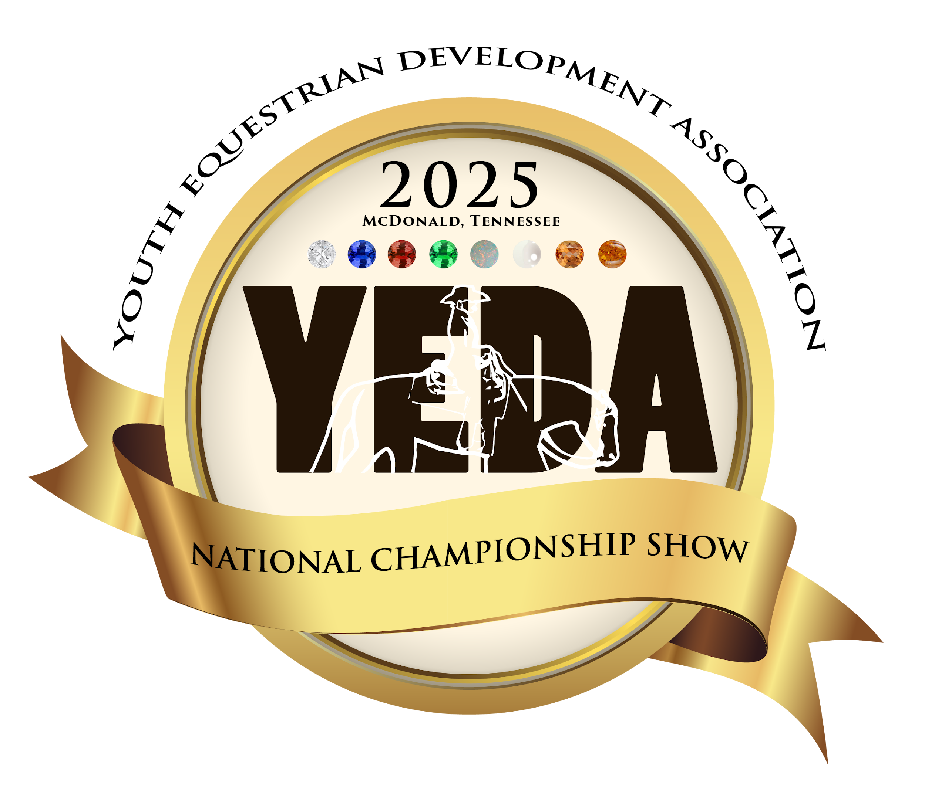

JUNE 5-8
THURSDAY – FRIDAY – SATURDAY – SUNDAY

SHOWBILL CATALOG

Tri-State Exhibition Center
200 Natures Trail SW
McDonald, TN 37353
Tri – State Exhibition Center Information

Address: 200 Natures Trail, McDonald, TN 37303

Directions:
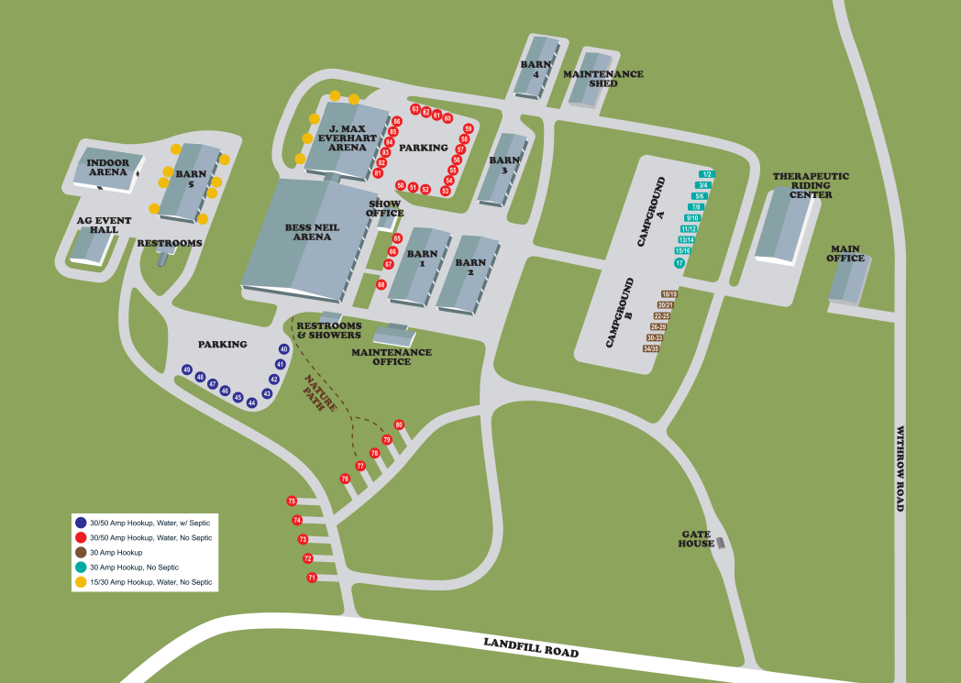
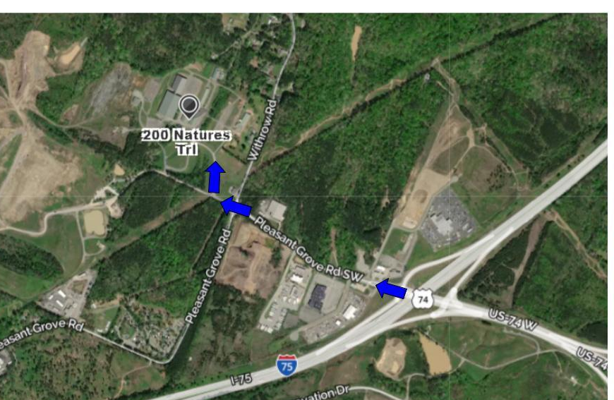
 | Show Officials | 

The Judges

Judge A:  Jill Paxton | Judge B:  Tom McBeath | Judge C:  Rob Meneely | Judge D:  John Tuckey

Stewards
Show Stewards  Stephanie Steiner  National Steward  Milly Cavender  Kelli Wainscott  Andrea Rego | Ring Stewards  Jay Lanzer  Lauren Brown  Hannah Rolland  Tammy Cranouski

Announcer  Bess Neil Arena  Josh Straight |  | Announcer  J. Max Everhart Arena  Pepper Hitchcock
Show Manager  Molly Niese | Show Secretary  Lacie Yeager |  | Point Secretaries  Shelby Zimmerman  Nicole Archer
Medical
April Love

JUNE 5-8
YEDA MISSION STATEMENT
Our mission is to provide an equestrian riding program for youth students, via both instructional and experiential learning opportunities. To accomplish this we will engage in equestrian competitions, instructional clinics, networking events and occasions for recruitment that includes but not limited to scholarship disbursements.

National Championship Weekend Patterns
Patterns will be announced online after YEDA Qualifiers are announced. Please check the website and social media for updates about Nationals Patterns.
The pattern book can be found on SHOWYEDA.com

Watch Live:
Live Feed will be available, provided by National Sports Broadcasting, more details to come soon.
TEAM DOOR DECORATIONS CONTESTS:
All YEDA Teams will be given a dressing room to store their items during the show. We would like to invite ALL teams to participate in a door decorating contest that captures the essence of your team and YEDA. Teams will create a door decoration that will cover the exterior of their dressing room door facing the aisle and exterior.
2025 Team Stall Area Decorating Contest
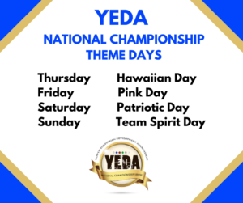

Time Schedule
JUNE 5-8

Tuesday, June 3:  Teams can move horses in anytime after 2pm. For earlier arrival, contact Laura Smith, lsmith@showyeda.com.  Wednesday, June 4:  - Horse Check-In  - YEDA Royalty Competition Starts at 12:30 pm  - Coaches Welcome and Intro Meeting 3:00 pm  - MTSU Horseology Contest Live Judging 4:00 pm  - Horse Warmup at 5:00 pm  Thursday , June 5:  THEME: Hawaiian Day  - 5:45 am Draw – All Coaches invited, not required  - 6:45 am Coaches Meeting  - 7:15 am Horse Warm Up  - 8:45 am Clear Arena and Drag  - 8:55 am Opening Ceremony  - 9:00 am Invitational Begins  - Lunch Break  - Present YEDA Royalty Court  - TETWP Durango Boot Race  - MTSU Horseology Written Contest  - Awards Presentation: Sportsmanship, Good Grooming and Horse of the Day  Friday , June 6  THEME: Pink Day  - 5:45 am Draw – All Coaches invited, not required.  - 6:45 am Coaches Meeting  - 7:15 am Horse Warm Up  - 8:45 am Clear Arena and Drag  - 8:55 am Opening Ceremony  - 9:00 am Individual Championship Day begins  - Lunch Break  - Parade of Teams with Special Events  - IHSA Welcome Event  - MTSU Horseology Contest Awards  - Awards Presentation: Sportsmanship, Good Grooming and Horse of the Day  - YEDA Prom: 7PM or 1 HR following the last class awards. |  | Saturday June 7:  THEME: Patriotic Day  - 5:45 am Draw – All Coaches invited, not required  - 6:45 am Coaches Meeting  - 7:15 am Horse Warm Up  - 8:45 am Clear Arena and Drag  - 8:55 am Opening Ceremony 9:00 am Finish the Individual Competition and begin  - Team Competition  - Lunch Break  - Award Team Stall Area Decorating Contest  - Memorial Coaches Calcutta  - Awards Presentation: High Point Rider Awards, Sportsmanship, Good Grooming and Horse of the Day  - Drawing for the custom saddle from Moran Saddlery  - Kickball Tournament: 1 hour after the last class.  Sunday June 8:  THEME: Team Spirit Day  - 5:45 am Draw – All Coaches invited, not required  - 6:45 am Coaches Meeting  - 7:15 am Horse Warm Up  - 8:45 am Clear Arena and Drag  - 8:55 am Opening Ceremony  - 9:00 am Show Begins finish Team Competition  - Lunch Break  - Presentation of Scholarships  - At the Conclusion of the show  - Parade of Teams  - Awards Presentation: Team Awards, Sportsmanship, Good Grooming and Horse of the Day.
Thursday June 5, 2025  State Invitational  2 Arenas | - 5:45 am Draw – All Coaches invited, not required  - 6:45 am Coaches Meeting  - 7:15 am Horse Warm Up  - 8:45 am Clear Arena and Drag  - 8:55 am Opening Ceremony  - 9:00am Invitational Begins  THEME: Hawaiian Day

Tentative Class Order – Final order and classes will be determined after the last regular season qualifying show. The day the rider will show will not change, however the order or arena could change.
Bess Neil Arena  - Invitational Grp. 20 Diamond Reining  - Invitational Grp. 15 SR High Ruby Rail HMS Split A  - Invitational Grp. 15 SR High Ruby Rail HMS Split B  - Invitational Grp. 13 SR High Emerald Rail HMS Split A  - Invitational Grp. 13 SR High Emerald Rail HMS Split B  - Invitational Grp. 3 JR High Opal Rail HMS Split A  - Invitational Grp. 3 JR High Opal Rail HMS Split B  - Invitational Grp. 1 Elem. Pearl Rail HMS Split A  - Invitational Grp. 1 Elem. Pearl Rail HMS Split B  - Invitational Grp. 5 JR High Emerald Rail HMS Split A  - Invitational Grp. 5 JR High Emerald Rail HMS Split B  - Invitational Grp. 19 SR High Diamond R/P HMS  - Invitational Grp 18 SR High Sapphire Ranch Riding  - Invitational Grp. 7 JR High Ruby Rail HMS  - Invitational Grp. 10 JR High Sapphire Ranch Riding  - Invitational Grp. 15 SR High Ruby Rail HMS Finals  - Invitational Grp. 34 Alumni Sapphire Ranch Riding  - Invitational Grp. 11 SR High Opal Rail HMS  - Invitational Grp. 13 SR High Emerald Rail HMS Finals  - Invitational Grp. 3 JR High Opal Rail HMS Finals  - Invitational Grp. 5 JR High Emerald Rail HMS Finals  - Invitational Grp. 1 Elem. Pearl Rail HMS Finals  - Invitational Grp 18 Senior High Sapphire R/P HMS |  | J. Max Everhart Arena  - Invitational Grp. 33 Alumni Sapphire R/P HMS  - Invitational Grp. 9 JR High Sapphire R/P HMS  - Invitational Grp 31 Alumni Emerald Rail HMS  - Invitational Grp 27 EWD Topaz Rail Independent HMS  - Invitational Grp 28 EWD Topaz Pattern Independent HMS  - Invitational Grp. 6 JR High Emerald Pattern HMS  - Invitational Grp 25 EWD Topaz Rail Assisted HMS  - Invitational Grp 26 EWD Topaz Pattern Assisted HMS  - Invitational Grp. 14 SR High Emerald Pattern HMS  - Invitational Grp 23 EWD Amber Rail Independent HMS  - Invitational Grp 24 EWD Amber Pattern Independent HMS  - Invitational Grp. 32 Alumni Emerald Pattern HMS  - Invitational Grp 21 EWD Amber Rail Assisted HMS  - Invitational Grp 22 EWD Amber Pattern Assisted HMS  - Invitational Grp. 4 JR High Opal Pattern HMS  - Invitational Grp. 12 SR High Opal Pattern HMS  - Invitational Grp. 2 Elem. Pearl Pattern HMS  - Invitational Grp. 8 JR High Ruby Pattern HMS  - Invitational Grp. 16 SR High Ruby Pattern HMS  - Invitational Grp. 29 Alumni Opal Rail HMS  - Invitational Grp. 30 Alumni Opal Pattern HMS  During the Lunch Break  Time will be announced during the show.  YEDA Royalty Court Presentation  Durango Boot Race  Awards Presentation  Sportsmanship  Schneiders Best Groomed Horse  Horse of the Day
Friday June 6, 2025  Individual National Championship  2 Arenas | - 5:45 am Draw – All Coaches invited, not required  - 6:45 am Coaches Meeting  - 7:15 am Horse Warm Up  - 8:45 am Clear Arena and Drag  - 8:55 am Opening Ceremony  - 9:00 am Show Begins  THEME: Pink Day
Tentative Class Order – Final order and classes will be determined after the last regular season qualifying show. The day the rider will show will not change, however the order or arena could change.
Bess Neil Arena  - Individual Grp 20 Diamond Reining  - *Individual Grp 15 SR High Ruby Rail HMS Split A  - *Individual Grp 15 SR High Ruby Rail HMS Split B  - * Individual Grp 18 Senior High Sapphire R/P HMS Split A  - * Individual Grp 18 Senior High Sapphire R/P HMS Split B  - *Individual Grp 3 JR High Opal Rail HMS Split A  - *Individual Grp 3 JR High Opal Rail HMS Split B  - *Individual Grp 3 JR High Opal Rail HMS Split C  - *Individual Grp 1 Elem. Pearl Rail HMS Split A  - *Individual Grp 1 Elem. Pearl Rail HMS Split B  - *Individual Grp 1 Elem. Pearl Rail HMS Split C  - *Individual Grp 19 SR High Diamond R/P HMS Split A  - *Individual Grp 19 SR High Diamond R/P HMS Split B  - *Individual Grp 5 JR High Emerald Rail HMS Split A  - *Individual Grp 5 JR High Emerald Rail HMS Split B  - *Individual Grp 5 JR High Emerald Rail HMS Split C  - *Individual Grp 13 SR High Emerald Rail HMS Split A  - *Individual Grp 13 SR High Emerald Rail HMS Split B  * Finals classes will be on Saturday June 7rd  4 riders from each split will be invited to the Finals  . |  |  | J. Max Everhart Arena  - Individual Grp 26 Alumni Emerald Pattern HMS  - Individual Grp 14 SR High Emerald Pattern HMS  - Individual Grp 6 JR High Emerald Pattern HMS  - Individual Grp 25 Alumni Opal Rail HMS  - Invitational Grp 27 EWD Topaz Rail Independent HMS  - Invitational Grp 28 EWD Topaz Pattern Independent HMS  - Individual Grp 16 SR High Ruby Pattern HMS  - Individual Grp 8 JR High Ruby Pattern HMS  - Invitational Grp 25 EWD Topaz Rail Assisted HMS  - Invitational Grp 26 EWD Topaz Pattern Assisted HMS  - Individual Grp 26 Alumni Opal Pattern  - Invitational Grp 23 EWD Amber Rail Independent HMS  - Invitational Grp 24 EWD Amber Pattern Independent HMS  - Invitational Grp 21 EWD Amber Rail Assisted HMS  - Invitational Grp 22 EWD Amber Pattern Assisted HMS  During Lunch Break  Time will be announced during the show.  Parade of Teams w/ Special Events  IHSA Welcome Event  Equine Knowledge Contest Awards  After the Show Awards Presentation  Sportsmanship  Schneiders Best Groomed Horse  Horse of the Day  YEDA Prom  Start Time 7PM or 1 HR following the last class awards.
Saturday June 7, 2025  Individual & Team National Championship  2 Arenas | - 5:45 am Draw – All Coaches invited, not required  - 6:45 am Coaches Meeting  - 7:15 am Horse Warm Up  - 8:45 am Clear Arena and Drag  - 8:55 am Opening Ceremony  - 9:00am Show Begins  THEME: Patriotic Day
Tentative Class Order – Final order and classes will be determined after the last regular season qualifying show. The day the rider will show will not change, however the order or arena could change.
Bess Neil Arena  - Individual Grp 28 Alumni Sapphire Division Ranch Riding  - Individual Grp 5 JR High Emerald Rail HMS Finals  - Individual Grp 10 JR High Sapphire Division Ranch Riding  - Individual Grp 13 SR High Emerald Rail HSM Finals  - Individual Grp 18 SR High Sapphire Division Ranch Riding  LUNCH  - Individual Grp 27 Alumni Sapphire R/P HMS  - Individual Grp 11 SR High Opal Rail HSM  - Individual Grp 10 JR High Sapphire R/P HMS  - Individual Grp 3 JR High Opal Rail HSM Finals  - Individual Grp 18 Senior High Sapphire R/P HMS Finals  - Individual Grp 1 Elem. Pearl Rail HSM Finals  - Individual Grp 15 SR High Ruby Rail HMS Finals  - Individual Grp 25 Alumni Emerald Rail HMS  - Individual Grp 7 JR High Ruby Rail HMS  - Individual Grp 19 SR High Diamond R/P HMS Finals | J. Max Everhart Arena  - Individual Grp 12 SR High Opal Pattern HMS  - Individual Grp 4 JR High Opal Pattern HMS  - Individual Grp 2 Elem. Pearl Pattern HMS  - Team Grp 16 SR High Ruby Pattern HSM  - Team Grp 8 JR High Ruby Pattern HSM  - Team Grp 14 SR High Emerald Pattern HSM  - Team Grp 6 JR High Emerald Pattern HSM  - Team Grp 12 SR High Opal Pattern HSM  - Team Grp 4 JR High Opal Pattern HSM  During Lunch Break  Time will be announced during the show.  Coaches Calcutta  After the Show Awards Presentation  Ag Pro Senior High Point Rider Awards  Ag Pro Junior High Point Rider Awards  Ag Pro Elementary High Point Rider Awards  Sportsmanship  Schneiders Best Groomed Horse  Horse of the Day  Kickball Tournament  Following 1 hour after the last class!

Sunday June 8, 2025  Team National Championship  1 Arena  Bess Neil Arena | - 5:45 am Draw – All Coaches invited, not required  - 6:45 am Coaches Meeting  - 7:15 am Horse Warm Up  - 8:45 am Clear Arena and Drag  8:15-8:45 ✞ Cowboy Church ✞  - 8:55 am Opening Ceremony  - 9:00 am Show Begins finish Team Competition  THEME: Team Spirit Day

Tentative Class Order – Final order and classes will be determined after the last regular season qualifying show. The day the rider will show will not change, however the order or arena could change.

- Team Grp 20 Senior High Diamond Division – Reining
- Team Grp 13 Senior High Emerald Rail Horsemanship
- Team Grp 3 Junior High Opal Rail Horsemanship
- Team Grp 5 Junior High Emerald Rail Horsemanship
- Team Grp 11 Senior High Opal Rail Horsemanship
- Team Grp 10 Junior Sapphire Ranch Riding
- Team Grp 18 Senior High Sapphire Ranch Riding
- Team Grp 19 Senior High Diamond Rail/Pattern Horsemanship
- Team Grp 15 Senior High Ruby Rail Horsemanship
- Team Grp 7 Junior High Ruby Rail Horsemanship
- Team Grp 9 Junior High Sapphire Rail/Pattern Horsemanship
- Team Grp 18 Senior High Sapphire Rail/Pattern Horsemanship
- Individual Grp 22 Diamond Elite Horsemanship

During Lunch Break
Time will be announced during the show.
Presentation of Scholarships

After the Show Awards Presentation
Parade of Teams
Ag Pro Senior High Point Team Awards
Ag Pro Junior High Point Team Awards
Sportsmanship
Schneiders Best Groomed Horse
Horse of the Day

Entry Information, Deadlines, and Scratch Refund Policy:
Please email all entries by April 22nd. This is necessary to invite other riders in the event that a qualifier chooses not to participate.
- The due date for hard copy entries and payment is April 30, 2025.
- Entries received after the due date may not be accepted.
- The Program Edit Closing Date, May 4, 2025, is the date in which the program will be published and any changes after the closing date will not be in the official program and will be hand written in at the coaches meeting.
- The closing date for the show is 8:00 am May 4, 2025. In the event you have a scratch prior to the closing date, use the attached Pre-Closing Date Refund Request Form to ensure a full refund. Remember, this document needs to complete in its entirety AND received by the show secretary by 8:00am of the closing date to ensure a refund.
  - Any rented ride fees will not be refunded after the CLOSE date of the show.
- Entry fees for scratches occurring after the closing date/time, will be refunded only under extraordinary circumstances. If you feel your rider/s circumstances rise to this level, you may complete a Post-Closing Date Refund Request Form located under Coaches Forms on the YEDA Website. Your request will be reviewed and voted on the first scheduled meeting following its receipt. You will be notified of the results within two business days of the vote. In the event a refund is to be issued, a check will be mailed within two weeks of the vote.

Substitutions
Substitutions will be permitted for team classes only providing they comply with ALL the listed parameters, same day, same division, same class.

Diamond Elite
All High School Teams who qualified for can have a Diamond Elite Rider participate in Sunday’s Diamond Elite class.

Payment
- $100 per entry + $10 Office Fee + $20 Media Fee
- EWD ONLY
  - First class $100 per entry + $10 Office Fee + $20 Media Fee = $130 total
  - Second class $70 total (entry fee, office fee and media fee)
- Please make checks payable to 'YEDA'. When possible, please avoid writing multiple checks

Rent and/or Provide a Horse
1 horse is required for every 12 rides for the entire show. 1 height weight horse will cover 10 rides for the entire show. (This is not per day, add up your total entries for the entries show to determine your rides) For example, one rider competing in both rail and pattern class will equal two rides. If you are unable to provide enough horses to meet the needs of your entries, you may rent rides at the cost of $50 each. Horses need to be provided or rental fee must be paid for all rides including riders who qualify for nationals through the invitational on Friday and diamond elite.
Any rented ride fees will not be refunded after the CLOSE date of the show.

Height/Weight:
Please take note the height/weight notification box. The show committee will follow the YEDA rulebook suggestion for Height/Weight riders. The limits for slight/older horses will be 5’9” – 160#. Please avoid bringing horses and ponies between the size of 13.3 – 14.2 if possible. If the rider exceeds either of these limits, please mark the appropriate check box on the entry form. This will bring the rider to attention so that the rider’s height and weight can be observed in the database.
This same column is also offered on the horse description page to note which horses need to be height/weight horses. Horses who are height/weight horses are horses whom it is bad for their health or carry a rider of a size greater than 5’9” and/or 160#. Please avoid bringing horses and ponies between the sizes of 13.3 – 14.2 if possible.
It is very important that you try to provide horses Wednesday Evening through Sunday, because of the warmup and to use the horses to their full potential. There will be great consideration used to not overuse the horses throughout the week! If you cannot provide your horses for the full show, please contact a YEDA Founder to discuss options.
National Championship State Invitational
Thursday, June 5, 2025
Junior High Team

Coach Name:
Team Name:
Coach Phone Number:
Coach Email:

For Questions Contact Laura Smith Cell: 419-957-9054  Email: showyedadocs@gmail.com  Mail Entries to:  Laura Smith  11125 CR 180  Findlay, Ohio 45840 |  |  | 9 | 10 | 7 | 8 | 5 | 6 | 3 |  | 4
 |  |  | Sapphire R/P Horsemanship | Sapphire Ranch Riding | Ruby Rail Horsemanship | Ruby Pattern Class | Emerald Rail Horsemanship | Emerald Pattern Class | Opal Rail Horsemanship |  | Opal Pattern Class |  | $130  Per  Class
Back # | Ht Wt | Rider Name |  |  |  |  |  |  |  |  |  |  | Total $
 | ☐Ht  ☐Wt |  | ☐ | ☐ | ☐ | ☐ | ☐ | ☐ | ☐ |  | ☐
 | ☐Ht  ☐Wt |  | ☐ | ☐ | ☐ | ☐ | ☐ | ☐ | ☐ |  | ☐
 | ☐Ht  ☐Wt |  | ☐ | ☐ | ☐ | ☐ | ☐ | ☐ | ☐ |  | ☐
 | ☐Ht  ☐Wt |  | ☐ | ☐ | ☐ | ☐ | ☐ | ☐ | ☐ |  | ☐
 | ☐Ht  ☐Wt |  | ☐ | ☐ | ☐ | ☐ | ☐ | ☐ | ☐ |  | ☐
 | ☐Ht  ☐Wt |  | ☐ | ☐ | ☐ | ☐ | ☐ | ☐ | ☐ |  | ☐
 | ☐Ht  ☐Wt |  | ☐ | ☐ | ☐ | ☐ | ☐ | ☐ | ☐ |  | ☐
 | ☐Ht  ☐Wt |  | ☐ | ☐ | ☐ | ☐ | ☐ | ☐ | ☐ |  | ☐
 | ☐Ht  ☐Wt |  | ☐ | ☐ | ☐ | ☐ | ☐ | ☐ | ☐ |  | ☐
If you need more room for more entries print additional entry forms Or extend the page using the inserting rows below tool. |  |  |  |  |  |  |  |  |  | Subtotal
Each Team Entry Form must contain the following statement to be signed by the Coach/ designated representative of each member team making entry.
This entry constitutes an agreement and affirmation that the team, riders, coaches, trainers and/or any affiliate, agent, and/or representative of the aforementioned individuals making entries (hereinafter collectively referred to as “Exhibitor(s)”), shall accept and abide by the rules of YEDA and of the Show, that each rider is eligible as entered. Exhibitors certify that each rider is eligible for competition in the level entered, and that Exhibitors will accept any rulings of the YEDA with respect to their conduct as final and beyond contestation. Additionally, Exhibitors agree to defend and hold YEDA, its directors, official, employees, and all persons, stables, and/or other entities providing facilities, horses or equipment for YEDA Shows and activities (hereinafter collectively referred to as “YEDA & Affiliates”), harmless for any claim action, or suit, including claim, action, or suit for injury, property damage, or death sustained during participation in the show by the entity, his/her coach, trainer or visitors.
Furthermore, Exhibitors hereby acknowledge and recognize that competing in YEDA and event and/or show is an inherently dangerous activity and may result in substantial and serious injury, including but not limited to, maiming, paralysis, and/or death, and that all of the aforementioned individuals openly and freely accept all of the potential risks association with participation in YEDA events/shows. Accordingly Exhibitors agree to waive, release, and hold harmless the YEDA & Affiliates from any and all actions, causes of action, suits, debts, promises, damages, judgments, claims, and/or demands whatsoever, in law and/or equity. In making entry into YEDA Competition or event, team and/or individuals explicitly indemnify YEDA & Affiliates from any threatened and/or actual liability, and agree to defend YEDA & Affiliates from the same.
Coaches Signature: ____________________________________________________________ Date: ________________
National Championship State Invitational
Thursday, June 5, 2025
Senior High Team

Coach Name:
Team Name:
Coach Phone Number:
Coach Email:

For Questions Contact Laura Smith Cell: 419-957-9054  Email: showyedadocs@gmail.com  Mail Entries to:  Laura Smith  11125 CR 180  Findlay, Ohio 45840 |  |  | 20 | 19 | 17 | 18 | 15 | 16 | 13 | 14 | 11 | 12
 |  |  | Diamond Reining | Diamond R/P Horsemanship | Sapphire R/P Horsemanship | Sapphire Ranch Riding | Ruby Rail Horsemanship | Ruby Pattern Class | Emerald Rail Horsemanship | Emerald Pattern Class | Opal Rail Horsemanship | Opal Pattern Class | $130  Per  Class
Back # | Ht Wt | Rider Name |  |  |  |  |  |  |  |  |  |  | Total $
 | ☐Ht  ☐Wt |  | ☐ | ☐ | ☐ | ☐ | ☐ | ☐ | ☐ | ☐ | ☐ | ☐
 | ☐Ht  ☐Wt |  | ☐ | ☐ | ☐ | ☐ | ☐ | ☐ | ☐ | ☐ | ☐ | ☐
 | ☐Ht  ☐Wt |  | ☐ | ☐ | ☐ | ☐ | ☐ | ☐ | ☐ | ☐ | ☐ | ☐
 | ☐Ht  ☐Wt |  | ☐ | ☐ | ☐ | ☐ | ☐ | ☐ | ☐ | ☐ | ☐ | ☐
 | ☐Ht  ☐Wt |  | ☐ | ☐ | ☐ | ☐ | ☐ | ☐ | ☐ | ☐ | ☐ | ☐
 | ☐Ht  ☐Wt |  | ☐ | ☐ | ☐ | ☐ | ☐ | ☐ | ☐ | ☐ | ☐ | ☐
 | ☐Ht  ☐Wt |  | ☐ | ☐ | ☐ | ☐ | ☐ | ☐ | ☐ | ☐ | ☐ | ☐
 | ☐Ht  ☐Wt |  | ☐ | ☐ | ☐ | ☐ | ☐ | ☐ | ☐ | ☐ | ☐ | ☐
 | ☐Ht  ☐Wt |  | ☐ | ☐ | ☐ | ☐ | ☐ | ☐ | ☐ | ☐ | ☐ | ☐
If you need more room for more entries print additional entry forms Or extend the page using the inserting rows below tool. |  |  |  |  |  |  |  |  |  |  | Subtotal
Each Team Entry Form must contain the following statement to be signed by the Coach/ designated representative of each member team making entry.

This entry constitutes an agreement and affirmation that the team, riders, coaches, trainers and/or any affiliate, agent, and/or representative of the aforementioned individuals making entries (hereinafter collectively referred to as “Exhibitor(s)”), shall accept and abide by the rules of YEDA and of the Show, that each rider is eligible as entered. Exhibitors certify that each rider is eligible for competition in the level entered, and that Exhibitors will accept any rulings of the YEDA with respect to their conduct as final and beyond contestation. Additionally, Exhibitors agree to defend and hold YEDA, its directors, official, employees, and all persons, stables, and/or other entities providing facilities, horses or equipment for YEDA Shows and activities (hereinafter collectively referred to as “YEDA & Affiliates”), harmless for any claim action, or suit, including claim, action, or suit for injury, property damage, or death sustained during participation in the show by the entity, his/her coach, trainer or visitors.

Furthermore, Exhibitors hereby acknowledge and recognize that competing in YEDA and event and/or show is an inherently dangerous activity and may result in substantial and serious injury, including but not limited to, maiming, paralysis, and/or death, and that all of the aforementioned individuals openly and freely accept all of the potential risks association with participation in YEDA events/shows. Accordingly Exhibitors agree to waive, release, and hold harmless the YEDA & Affiliates from any and all actions, causes of action, suits, debts, promises, damages, judgments, claims, and/or demands whatsoever, in law and/or equity. In making entry into YEDA Competition or event, team and/or individuals explicitly indemnify YEDA & Affiliates from any threatened and/or actual liability, and agree to defend YEDA & Affiliates from the same.

Coaches Signature: ____________________________________________________________ Date: ________________
National Championship State Invitational
Thursday, June 5, 2025
Pearl & Alumni Classes

Coach Name:
Team Name:
Coach Phone Number:
Coach Email:

For Questions Contact Laura Smith Cell: 419-957-9054  Email: showyedadocs@gmail.com  Mail Entries to:  Laura Smith  11125 CR 180  Findlay, Ohio 45840 |  |  | 29 | 30 | 31 | 32 | 33 | 34 | 1 |  | 2
 |  |  | Alumni Opal Rail Horsemanship | Alumni Opal Pattern | Emerald Alumni  Rail Horsemanship | Emerald Alumni  Pattern | Sapphire Alumni  Rail & Pattern | Sapphire Alumni  Ranch Riding | Peal Rail Horsemanship |  | Peal Pattern Class |  | $130  Per  Class
Back # | ☐ | Rider Name | ☐ | ☐ | ☐ | ☐ | ☐ | ☐ | ☐ |  | ☐ |  | Total $
 | ☐ |  | ☐ | ☐ | ☐ | ☐ | ☐ | ☐ | ☐ |  | ☐
 | ☐ |  | ☐ | ☐ | ☐ | ☐ | ☐ | ☐ | ☐ |  | ☐
 | ☐ |  | ☐ | ☐ | ☐ | ☐ | ☐ | ☐ | ☐ |  | ☐
 | ☐ |  | ☐ | ☐ | ☐ | ☐ | ☐ | ☐ | ☐ |  | ☐
 | ☐ |  | ☐ | ☐ | ☐ | ☐ | ☐ | ☐ | ☐ |  | ☐
 | ☐ |  | ☐ | ☐ | ☐ | ☐ | ☐ | ☐ | ☐ |  | ☐
 | ☐ |  | ☐ | ☐ | ☐ | ☐ | ☐ | ☐ | ☐ |  | ☐
 | ☐ |  | ☐ | ☐ | ☐ | ☐ | ☐ | ☐ | ☐ |  | ☐
 | ☐ |  | ☐ | ☐ | ☐ | ☐ | ☐ | ☐ | ☐ |  | ☐
If you need more room for more entries print additional entry forms Or extend the page using the inserting rows below tool. |  |  |  |  |  |  |  |  |  | Subtotal
Each Team Entry Form must contain the following statement to be signed by the Coach/ designated representative of each member team making entry.
This entry constitutes an agreement and affirmation that the team, riders, coaches, trainers and/or any affiliate, agent, and/or representative of the aforementioned individuals making entries (hereinafter collectively referred to as “Exhibitor(s)”), shall accept and abide by the rules of YEDA and of the Show, that each rider is eligible as entered. Exhibitors certify that each rider is eligible for competition in the level entered, and that Exhibitors will accept any rulings of the YEDA with respect to their conduct as final and beyond contestation. Additionally, Exhibitors agree to defend and hold YEDA, its directors, official, employees, and all persons, stables, and/or other entities providing facilities, horses or equipment for YEDA Shows and activities (hereinafter collectively referred to as “YEDA & Affiliates”), harmless for any claim action, or suit, including claim, action, or suit for injury, property damage, or death sustained during participation in the show by the entity, his/her coach, trainer or visitors.
Furthermore, Exhibitors hereby acknowledge and recognize that competing in YEDA and event and/or show is an inherently dangerous activity and may result in substantial and serious injury, including but not limited to, maiming, paralysis, and/or death, and that all of the aforementioned individuals openly and freely accept all of the potential risks association with participation in YEDA events/shows. Accordingly Exhibitors agree to waive, release, and hold harmless the YEDA & Affiliates from any and all actions, causes of action, suits, debts, promises, damages, judgments, claims, and/or demands whatsoever, in law and/or equity. In making entry into YEDA Competition or event, team and/or individuals explicitly indemnify YEDA & Affiliates from any threatened and/or actual liability, and agree to defend YEDA & Affiliates from the same.
Coaches Signature: ____________________________________________________________ Date: ________________
National Championship State Invitational
Thursday, June 5, 2025
EWD Classes

Coach Name:
Team Name:
Coach Phone Number:
Coach Email:

For Questions Contact Laura Smith Cell: 419-957-9054  Email: showyedadocs@gmail.com  Mail Entries to:  Laura Smith  11125 CR 180  Findlay, Ohio 45840 |  |  | 21 | 22 | 23 | 24 | 25 | 26 | 27 | 28 | $130 for the 1st class  $70 for second class  $200 total for both classes w/o rented rides
 |  |  | EWD Amber Rail Assisted | EWD Amber Pattern Assisted | EWD Amber Rail Independent | EWD Amber Pattern Independent | EWD Topaz Rail Assisted | EWD Topaz Pattern Assisted | EWD Topaz Rail Independent | EWD Topaz Pattern Independent
Back # | ☐ | Rider Name | ☐ | ☐ | ☐ | ☐ | ☐ | ☐ | ☐ | ☐ | Total $
 | ☐ |  | ☐ | ☐ | ☐ | ☐ | ☐ | ☐ | ☐ | ☐
 | ☐ |  | ☐ | ☐ | ☐ | ☐ | ☐ | ☐ | ☐ | ☐
 | ☐ |  | ☐ | ☐ | ☐ | ☐ | ☐ | ☐ | ☐ | ☐
 | ☐ |  | ☐ | ☐ | ☐ | ☐ | ☐ | ☐ | ☐ | ☐
 | ☐ |  | ☐ | ☐ | ☐ | ☐ | ☐ | ☐ | ☐ | ☐
If you need more room for more entries print additional entry forms Or extend the page using the inserting rows below tool. |  |  |  |  |  |  |  |  | Subtotal
$130 for the 1st class $70 for second class $200 total for both classes w/o rented rides per rider

If there is a need to rent rides, only need to pay 1 rented ride fee of $50 per rider, because the same drawn horse will be used in both classes.
Each Team Entry Form must contain the following statement to be signed by the Coach/ designated representative of each member team making entry.
This entry constitutes an agreement and affirmation that the team, riders, coaches, trainers and/or any affiliate, agent, and/or representative of the aforementioned individuals making entries (hereinafter collectively referred to as “Exhibitor(s)”), shall accept and abide by the rules of YEDA and of the Show, that each rider is eligible as entered. Exhibitors certify that each rider is eligible for competition in the level entered, and that Exhibitors will accept any rulings of the YEDA with respect to their conduct as final and beyond contestation. Additionally, Exhibitors agree to defend and hold YEDA, its directors, official, employees, and all persons, stables, and/or other entities providing facilities, horses or equipment for YEDA Shows and activities (hereinafter collectively referred to as “YEDA & Affiliates”), harmless for any claim action, or suit, including claim, action, or suit for injury, property damage, or death sustained during participation in the show by the entity, his/her coach, trainer or visitors.
Furthermore, Exhibitors hereby acknowledge and recognize that competing in YEDA and event and/or show is an inherently dangerous activity and may result in substantial and serious injury, including but not limited to, maiming, paralysis, and/or death, and that all of the aforementioned individuals openly and freely accept all of the potential risks association with participation in YEDA events/shows. Accordingly Exhibitors agree to waive, release, and hold harmless the YEDA & Affiliates from any and all actions, causes of action, suits, debts, promises, damages, judgments, claims, and/or demands whatsoever, in law and/or equity. In making entry into YEDA Competition or event, team and/or individuals explicitly indemnify YEDA & Affiliates from any threatened and/or actual liability, and agree to defend YEDA & Affiliates from the same.
Coaches Signature: ____________________________________________________________ Date: ________________
National Championships
Individual Entries
June 6 - 7, 2025
Friday & Saturday
Junior High Team

Coach Name:
Team Name:
Coach Phone Number:
Coach Email:

For Questions Contact Laura Smith Cell: 419-957-9054  Email: showyedadocs@gmail.com  Mail Entries to:  Laura Smith  11125 CR 180  Findlay, Ohio 45840 |  |  | 9 | 10 | 7 | 8 | 5 | 6 | 3 |  | 4
 |  |  | Sapphire R/P Horsemanship | Sapphire Ranch Riding | Ruby Rail Horsemanship | Ruby Pattern Class | Emerald Rail Horsemanship | Emerald Pattern Class | Opal Rail Horsemanship |  | Opal Pattern Class |  | $130  Per  Class
Back # | Ht Wt | Rider Name |  |  |  |  |  |  |  |  |  |  | Total $
 | ☐Ht  ☐Wt |  | ☐ | ☐ | ☐ | ☐ | ☐ | ☐ | ☐ |  | ☐
 | ☐Ht  ☐Wt |  | ☐ | ☐ | ☐ | ☐ | ☐ | ☐ | ☐ |  | ☐
 | ☐Ht  ☐Wt |  | ☐ | ☐ | ☐ | ☐ | ☐ | ☐ | ☐ |  | ☐
 | ☐Ht  ☐Wt |  | ☐ | ☐ | ☐ | ☐ | ☐ | ☐ | ☐ |  | ☐
 | ☐Ht  ☐Wt |  | ☐ | ☐ | ☐ | ☐ | ☐ | ☐ | ☐ |  | ☐
 | ☐Ht  ☐Wt |  | ☐ | ☐ | ☐ | ☐ | ☐ | ☐ | ☐ |  | ☐
 | ☐Ht  ☐Wt |  | ☐ | ☐ | ☐ | ☐ | ☐ | ☐ | ☐ |  | ☐
 | ☐Ht  ☐Wt |  | ☐ | ☐ | ☐ | ☐ | ☐ | ☐ | ☐ |  | ☐
If you need more room for more entries print additional entry forms Or extend the page using the inserting rows below tool. |  |  |  |  |  |  |  |  |  | Subtotal
Each Team Entry Form must contain the following statement to be signed by the Coach/ designated representative of each member team making entry.

This entry constitutes an agreement and affirmation that the team, riders, coaches, trainers and/or any affiliate, agent, and/or representative of the aforementioned individuals making entries (hereinafter collectively referred to as “Exhibitor(s)”), shall accept and abide by the rules of YEDA and of the Show, that each rider is eligible as entered. Exhibitors certify that each rider is eligible for competition in the level entered, and that Exhibitors will accept any rulings of the YEDA with respect to their conduct as final and beyond contestation. Additionally, Exhibitors agree to defend and hold YEDA, its directors, official, employees, and all persons, stables, and/or other entities providing facilities, horses or equipment for YEDA Shows and activities (hereinafter collectively referred to as “YEDA & Affiliates”), harmless for any claim action, or suit, including claim, action, or suit for injury, property damage, or death sustained during participation in the show by the entity, his/her coach, trainer or visitors.

Furthermore, Exhibitors hereby acknowledge and recognize that competing in YEDA and event and/or show is an inherently dangerous activity and may result in substantial and serious injury, including but not limited to, maiming, paralysis, and/or death, and that all of the aforementioned individuals openly and freely accept all of the potential risks association with participation in YEDA events/shows. Accordingly Exhibitors agree to waive, release, and hold harmless the YEDA & Affiliates from any and all actions, causes of action, suits, debts, promises, damages, judgments, claims, and/or demands whatsoever, in law and/or equity. In making entry into YEDA Competition or event, team and/or individuals explicitly indemnify YEDA & Affiliates from any threatened and/or actual liability, and agree to defend YEDA & Affiliates from the same.

Coaches Signature: ____________________________________________________________ Date: ________________
National Championships
Individual Entries
June 6 - 7, 2025
Friday & Saturday
Senior High Team

Coach Name:
Team Name:
Coach Phone Number:
Coach Email:

For Questions Contact Laura Smith Cell: 419-957-9054  Email: showyedadocs@gmail.com  Mail Entries to:  Laura Smith  11125 CR 180  Findlay, Ohio 45840 |  |  | 20 | 19 | 17 | 18 | 15 | 16 | 13 | 14 | 11 | 12
 |  |  | Diamond Reining | Diamond R/P Horsemanship | Sapphire R/P Horsemanship | Sapphire Ranch Riding | Ruby Rail Horsemanship | Ruby Pattern Class | Emerald Rail Horsemanship | Emerald Pattern Class | Opal Rail Horsemanship | Opal Pattern Class | $130  Per  Class
Back # | Ht Wt | Rider Name |  |  |  |  |  |  |  |  |  |  | Total $
 | ☐Ht  ☐Wt |  | ☐ | ☐ | ☐ | ☐ | ☐ | ☐ | ☐ | ☐ | ☐ | ☐
 | ☐Ht  ☐Wt |  | ☐ | ☐ | ☐ | ☐ | ☐ | ☐ | ☐ | ☐ | ☐ | ☐
 | ☐Ht  ☐Wt |  | ☐ | ☐ | ☐ | ☐ | ☐ | ☐ | ☐ | ☐ | ☐ | ☐
 | ☐Ht  ☐Wt |  | ☐ | ☐ | ☐ | ☐ | ☐ | ☐ | ☐ | ☐ | ☐ | ☐
 | ☐Ht  ☐Wt |  | ☐ | ☐ | ☐ | ☐ | ☐ | ☐ | ☐ | ☐ | ☐ | ☐
 | ☐Ht  ☐Wt |  | ☐ | ☐ | ☐ | ☐ | ☐ | ☐ | ☐ | ☐ | ☐ | ☐
 | ☐Ht  ☐Wt |  | ☐ | ☐ | ☐ | ☐ | ☐ | ☐ | ☐ | ☐ | ☐ | ☐
 | ☐Ht  ☐Wt |  | ☐ | ☐ | ☐ | ☐ | ☐ | ☐ | ☐ | ☐ | ☐ | ☐
If you need more room for more entries print additional entry forms Or extend the page using the inserting rows below tool. |  |  |  |  |  |  |  |  |  |  | Subtotal
Each Team Entry Form must contain the following statement to be signed by the Coach/ designated representative of each member team making entry.

This entry constitutes an agreement and affirmation that the team, riders, coaches, trainers and/or any affiliate, agent, and/or representative of the aforementioned individuals making entries (hereinafter collectively referred to as “Exhibitor(s)”), shall accept and abide by the rules of YEDA and of the Show, that each rider is eligible as entered. Exhibitors certify that each rider is eligible for competition in the level entered, and that Exhibitors will accept any rulings of the YEDA with respect to their conduct as final and beyond contestation. Additionally, Exhibitors agree to defend and hold YEDA, its directors, official, employees, and all persons, stables, and/or other entities providing facilities, horses or equipment for YEDA Shows and activities (hereinafter collectively referred to as “YEDA & Affiliates”), harmless for any claim action, or suit, including claim, action, or suit for injury, property damage, or death sustained during participation in the show by the entity, his/her coach, trainer or visitors.

Furthermore, Exhibitors hereby acknowledge and recognize that competing in YEDA and event and/or show is an inherently dangerous activity and may result in substantial and serious injury, including but not limited to, maiming, paralysis, and/or death, and that all of the aforementioned individuals openly and freely accept all of the potential risks association with participation in YEDA events/shows. Accordingly Exhibitors agree to waive, release, and hold harmless the YEDA & Affiliates from any and all actions, causes of action, suits, debts, promises, damages, judgments, claims, and/or demands whatsoever, in law and/or equity. In making entry into YEDA Competition or event, team and/or individuals explicitly indemnify YEDA & Affiliates from any threatened and/or actual liability, and agree to defend YEDA & Affiliates from the same.

Coaches Signature: ____________________________________________________________ Date: ________________
National Championships
Individual Entries
June 6 - 7, 2025
Friday & Saturday
Pearl & Alumni Classes

Coach Name:
Team Name:
Coach Phone Number:
Coach Email:

For Questions Contact Laura Smith Cell: 419-957-9054  Email: showyedadocs@gmail.com  Mail Entries to:  Laura Smith  11125 CR 180  Findlay, Ohio 45840 |  |  | 29 | 30 | 31 | 32 | 33 | 34 | 1 |  | 2
 |  |  | Alumni Opal Rail Horsemanship | Alumni Opal Pattern | Emerald Alumni  Rail Horsemanship | Emerald Alumni  Pattern | Sapphire Alumni  Rail & Pattern | Sapphire Alumni  Ranch Riding | Peal Rail Horsemanship |  | Peal Pattern Class |  | $130  Per  Class
Back # | ☐ | Rider Name | ☐ | ☐ | ☐ | ☐ | ☐ | ☐ | ☐ |  | ☐ |  | Total $
 | ☐ |  | ☐ | ☐ | ☐ | ☐ | ☐ | ☐ | ☐ |  | ☐
 | ☐ |  | ☐ | ☐ | ☐ | ☐ | ☐ | ☐ | ☐ |  | ☐
 | ☐ |  | ☐ | ☐ | ☐ | ☐ | ☐ | ☐ | ☐ |  | ☐
 | ☐ |  | ☐ | ☐ | ☐ | ☐ | ☐ | ☐ | ☐ |  | ☐
 | ☐ |  | ☐ | ☐ | ☐ | ☐ | ☐ | ☐ | ☐ |  | ☐
 | ☐ |  | ☐ | ☐ | ☐ | ☐ | ☐ | ☐ | ☐ |  | ☐
 | ☐ |  | ☐ | ☐ | ☐ | ☐ | ☐ | ☐ | ☐ |  | ☐
 | ☐ |  | ☐ | ☐ | ☐ | ☐ | ☐ | ☐ | ☐ |  | ☐
If you need more room for more entries print additional entry forms Or extend the page using the inserting rows below tool. |  |  |  |  |  |  |  |  |  | Subtotal

Each Team Entry Form must contain the following statement to be signed by the Coach/ designated representative of each member team making entry.

This entry constitutes an agreement and affirmation that the team, riders, coaches, trainers and/or any affiliate, agent, and/or representative of the aforementioned individuals making entries (hereinafter collectively referred to as “Exhibitor(s)”), shall accept and abide by the rules of YEDA and of the Show, that each rider is eligible as entered. Exhibitors certify that each rider is eligible for competition in the level entered, and that Exhibitors will accept any rulings of the YEDA with respect to their conduct as final and beyond contestation. Additionally, Exhibitors agree to defend and hold YEDA, its directors, official, employees, and all persons, stables, and/or other entities providing facilities, horses or equipment for YEDA Shows and activities (hereinafter collectively referred to as “YEDA & Affiliates”), harmless for any claim action, or suit, including claim, action, or suit for injury, property damage, or death sustained during participation in the show by the entity, his/her coach, trainer or visitors.

Furthermore, Exhibitors hereby acknowledge and recognize that competing in YEDA and event and/or show is an inherently dangerous activity and may result in substantial and serious injury, including but not limited to, maiming, paralysis, and/or death, and that all of the aforementioned individuals openly and freely accept all of the potential risks association with participation in YEDA events/shows. Accordingly Exhibitors agree to waive, release, and hold harmless the YEDA & Affiliates from any and all actions, causes of action, suits, debts, promises, damages, judgments, claims, and/or demands whatsoever, in law and/or equity. In making entry into YEDA Competition or event, team and/or individuals explicitly indemnify YEDA & Affiliates from any threatened and/or actual liability, and agree to defend YEDA & Affiliates from the same

Coaches Signature: ____________________________________________________________ Date: ________________
National Championships
Individual Entries
June 6 - 7, 2025
Friday & Saturday
EWD Classes

Coach Name:
Team Name:
Coach Phone Number:
Coach Email:

For Questions Contact Laura Smith Cell: 419-957-9054  Email: showyedadocs@gmail.com  Mail Entries to:  Laura Smith  11125 CR 180  Findlay, Ohio 45840 |  |  | 21 | 22 | 23 | 24 | 25 | 26 | 27 | 28
 |  |  | EWD Amber Rail Assisted | EWD Amber Pattern Assisted | EWD Amber Rail Independent | EWD Amber Pattern Independent | EWD Topaz Rail Assisted | EWD Topaz Pattern Assisted | EWD Topaz Rail Independent | EWD Topaz Pattern Independent | $130 for the 1st class  $70 for second class  $200 total for both classes w/o rented rides
Back # | ☐ | Rider Name | ☐ | ☐ | ☐ | ☐ | ☐ | ☐ | ☐ | ☐ | Total $
 | ☐ |  | ☐ | ☐ | ☐ | ☐ | ☐ | ☐ | ☐ | ☐
 | ☐ |  | ☐ | ☐ | ☐ | ☐ | ☐ | ☐ | ☐ | ☐
 | ☐ |  | ☐ | ☐ | ☐ | ☐ | ☐ | ☐ | ☐ | ☐
 | ☐ |  | ☐ | ☐ | ☐ | ☐ | ☐ | ☐ | ☐ | ☐
 | ☐ |  | ☐ | ☐ | ☐ | ☐ | ☐ | ☐ | ☐ | ☐
If you need more room for more entries print additional entry forms Or extend the page using the inserting rows below tool. |  |  |  |  |  |  |  |  | Subtotal
$130 for the 1st class $70 for second class $200 total for both classes w/o rented rides per rider

If there is a need to rent rides, only need to pay 1 rented ride fee of $50 per rider.
Each Team Entry Form must contain the following statement to be signed by the Coach/ designated representative of each member team making entry.
This entry constitutes an agreement and affirmation that the team, riders, coaches, trainers and/or any affiliate, agent, and/or representative of the aforementioned individuals making entries (hereinafter collectively referred to as “Exhibitor(s)”), shall accept and abide by the rules of YEDA and of the Show, that each rider is eligible as entered. Exhibitors certify that each rider is eligible for competition in the level entered, and that Exhibitors will accept any rulings of the YEDA with respect to their conduct as final and beyond contestation. Additionally, Exhibitors agree to defend and hold YEDA, its directors, official, employees, and all persons, stables, and/or other entities providing facilities, horses or equipment for YEDA Shows and activities (hereinafter collectively referred to as “YEDA & Affiliates”), harmless for any claim action, or suit, including claim, action, or suit for injury, property damage, or death sustained during participation in the show by the entity, his/her coach, trainer or visitors.
Furthermore, Exhibitors hereby acknowledge and recognize that competing in YEDA and event and/or show is an inherently dangerous activity and may result in substantial and serious injury, including but not limited to, maiming, paralysis, and/or death, and that all of the aforementioned individuals openly and freely accept all of the potential risks association with participation in YEDA events/shows. Accordingly Exhibitors agree to waive, release, and hold harmless the YEDA & Affiliates from any and all actions, causes of action, suits, debts, promises, damages, judgments, claims, and/or demands whatsoever, in law and/or equity. In making entry into YEDA Competition or event, team and/or individuals explicitly indemnify YEDA & Affiliates from any threatened and/or actual liability, and agree to defend YEDA & Affiliates from the same.
Coaches Signature: ____________________________________________________________ Date: ________________
National Championships
Team Entries
June 7 - 8, 2025
Saturday & Sunday
Junior High Team

Coach Name:
Team Name:
Coach Phone Number:
Coach Email:

For Questions Contact Laura Smith Cell: 419-957-9054  Email: showyedadocs@gmail.com  Mail Entries to:  Laura Smith  11125 CR 180  Findlay, Ohio 45840 |  |  | 9 | 10 | 7 | 8 | 5 | 6 | 3 |  | 4
 |  |  | Sapphire R/P Horsemanship | Sapphire Ranch Riding | Ruby Rail Horsemanship | Ruby Pattern Class | Emerald Rail Horsemanship | Emerald Pattern Class | Opal Rail Horsemanship |  | Opal Pattern Class |  | $130  Per  Class
Back # | Ht Wt | Rider Name |  |  |  |  |  |  |  |  |  |  | Total $
 | ☐Ht  ☐Wt |  | ☐ | ☐ | ☐ | ☐ | ☐ | ☐ | ☐ |  | ☐
 | ☐Ht  ☐Wt |  | ☐ | ☐ | ☐ | ☐ | ☐ | ☐ | ☐ |  | ☐
 | ☐Ht  ☐Wt |  | ☐ | ☐ | ☐ | ☐ | ☐ | ☐ | ☐ |  | ☐
 | ☐Ht  ☐Wt |  | ☐ | ☐ | ☐ | ☐ | ☐ | ☐ | ☐ |  | ☐
 | ☐Ht  ☐Wt |  | ☐ | ☐ | ☐ | ☐ | ☐ | ☐ | ☐ |  | ☐
 | ☐Ht  ☐Wt |  | ☐ | ☐ | ☐ | ☐ | ☐ | ☐ | ☐ |  | ☐
 | ☐Ht  ☐Wt |  | ☐ | ☐ | ☐ | ☐ | ☐ | ☐ | ☐ |  | ☐
 | ☐Ht  ☐Wt |  | ☐ | ☐ | ☐ | ☐ | ☐ | ☐ | ☐ |  | ☐
If you need more room for more entries print additional entry forms Or extend the page using the inserting rows below tool. |  |  |  |  |  |  |  |  |  | Subtotal
Each Team Entry Form must contain the following statement to be signed by the Coach/ designated representative of each member team making entry.
This entry constitutes an agreement and affirmation that the team, riders, coaches, trainers and/or any affiliate, agent, and/or representative of the aforementioned individuals making entries (hereinafter collectively referred to as “Exhibitor(s)”), shall accept and abide by the rules of YEDA and of the Show, that each rider is eligible as entered. Exhibitors certify that each rider is eligible for competition in the level entered, and that Exhibitors will accept any rulings of the YEDA with respect to their conduct as final and beyond contestation. Additionally, Exhibitors agree to defend and hold YEDA, its directors, official, employees, and all persons, stables, and/or other entities providing facilities, horses or equipment for YEDA Shows and activities (hereinafter collectively referred to as “YEDA & Affiliates”), harmless for any claim action, or suit, including claim, action, or suit for injury, property damage, or death sustained during participation in the show by the entity, his/her coach, trainer or visitors.
Furthermore, Exhibitors hereby acknowledge and recognize that competing in YEDA and event and/or show is an inherently dangerous activity and may result in substantial and serious injury, including but not limited to, maiming, paralysis, and/or death, and that all of the aforementioned individuals openly and freely accept all of the potential risks association with participation in YEDA events/shows. Accordingly Exhibitors agree to waive, release, and hold harmless the YEDA & Affiliates from any and all actions, causes of action, suits, debts, promises, damages, judgments, claims, and/or demands whatsoever, in law and/or equity. In making entry into YEDA Competition or event, team and/or individuals explicitly indemnify YEDA & Affiliates from any threatened and/or actual liability, and agree to defend YEDA & Affiliates from the same.

Coaches Signature: ____________________________________________________________ Date: ________________
National Championships
Team Entries
June 7 - 8, 2025
Saturday & Sunday
Senior High Team

Coach Name:
Team Name:
Coach Phone Number:
Coach Email:

For Questions Contact Laura Smith  Cell: 419-957-9054  Email: showyedadocs@gmail.com  Mail Entries to:  11125 CR 180  Findlay, Ohio 45840 |  |  | 20 | 19 | 17 | 18 | 15 | 16 | 13 | 14 | 11 | 12 | 22
 |  |  | Diamond Reining | Diamond R/P Horsemanship | Sapphire R/P HMS | Sapphire Ranch Riding | Ruby Rail Horsemanship | Ruby Pattern Class | Emerald Rail Horsemanship | Emerald Pattern Class | Opal Rail Horsemanship | Opal Pattern Class | Diamond Elite | $130  Per  Class
Back # | Ht Wt | Rider Name |  |  |  |  |  |  |  |  |  |  |  | Total $
 | ☐Ht  ☐Wt |  | ☐ | ☐ | ☐ | ☐ | ☐ | ☐ | ☐ | ☐ | ☐ | ☐ | ☐
 | ☐Ht  ☐Wt |  | ☐ | ☐ | ☐ | ☐ | ☐ | ☐ | ☐ | ☐ | ☐ | ☐ | ☐
 | ☐Ht  ☐Wt |  | ☐ | ☐ | ☐ | ☐ | ☐ | ☐ | ☐ | ☐ | ☐ | ☐ | ☐
 | ☐Ht  ☐Wt |  | ☐ | ☐ | ☐ | ☐ | ☐ | ☐ | ☐ | ☐ | ☐ | ☐ | ☐
 | ☐Ht  ☐Wt |  | ☐ | ☐ | ☐ | ☐ | ☐ | ☐ | ☐ | ☐ | ☐ | ☐ | ☐
 | ☐Ht  ☐Wt |  | ☐ | ☐ | ☐ | ☐ | ☐ | ☐ | ☐ | ☐ | ☐ | ☐ | ☐
 | ☐Ht  ☐Wt |  | ☐ | ☐ | ☐ | ☐ | ☐ | ☐ | ☐ | ☐ | ☐ | ☐ | ☐
 | ☐Ht  ☐Wt |  | ☐ | ☐ | ☐ | ☐ | ☐ | ☐ | ☐ | ☐ | ☐ | ☐ | ☐
 | ☐Ht  ☐Wt |  | ☐ | ☐ | ☐ | ☐ | ☐ | ☐ | ☐ | ☐ | ☐ | ☐ | ☐
If you need more room for more entries print additional entry forms Or extend the page using the inserting rows below tool. |  |  |  |  |  |  |  |  |  |  | Subtotal
Each Team Entry Form must contain the following statement to be signed by the Coach/ designated representative of each member team making entry.

This entry constitutes an agreement and affirmation that the team, riders, coaches, trainers and/or any affiliate, agent, and/or representative of the aforementioned individuals making entries (hereinafter collectively referred to as “Exhibitor(s)”), shall accept and abide by the rules of YEDA and of the Show, that each rider is eligible as entered. Exhibitors certify that each rider is eligible for competition in the level entered, and that Exhibitors will accept any rulings of the YEDA with respect to their conduct as final and beyond contestation. Additionally, Exhibitors agree to defend and hold YEDA, its directors, official, employees, and all persons, stables, and/or other entities providing facilities, horses or equipment for YEDA Shows and activities (hereinafter collectively referred to as “YEDA & Affiliates”), harmless for any claim action, or suit, including claim, action, or suit for injury, property damage, or death sustained during participation in the show by the entity, his/her coach, trainer or visitors.

Furthermore, Exhibitors hereby acknowledge and recognize that competing in YEDA and event and/or show is an inherently dangerous activity and may result in substantial and serious injury, including but not limited to, maiming, paralysis, and/or death, and that all of the aforementioned individuals openly and freely accept all of the potential risks association with participation in YEDA events/shows. Accordingly Exhibitors agree to waive, release, and hold harmless the YEDA & Affiliates from any and all actions, causes of action, suits, debts, promises, damages, judgments, claims, and/or demands whatsoever, in law and/or equity. In making entry into YEDA Competition or event, team and/or individuals explicitly indemnify YEDA & Affiliates from any threatened and/or actual liability, and agree to defend YEDA & Affiliates from the same.

Coaches Signature: ____________________________________________________________ Date: ________________

If you would like to put your horse description information directly online that if very helpful here is the link

CLICK HERE LIVE Horse Description Document
for Coaches and Horse Providers to Edit

If you would like to add them to a sheet and have the secretary handle putting them online that is an option too, you can use the next page.

EXTRA HORSES: There is a significant chance we will need to rent horses from teams to provide for the extra rides at nationals and rented rides. If you have extra horses and ways to get them to Nationals please email that information to showyedadocs@gmail.com or include them in the sheet on the next page. We will analyze which horses are most needed due to class sizes and other horses coming and let you know if your extra horse is what we would like to rent.
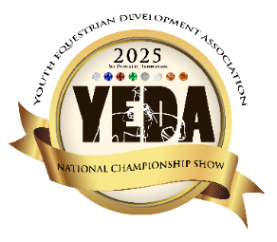
To help have the best horses for each class we would like to use the horses any day they are there. Consideration will be taken regarding frequency.
1 – 12 rides = 1 horse
13 – 24 rides = 2 horses
25 – 36 rides = 3 horses
37 – 48 rides = 4 horses
This is based on the horses being there all 4 days of the horse show.
If a horse cannot be provided $_50_ per rented ride

National Championships
JUNE 5-8
Horse Description Form
Ride & Horse count is based on the total number of riders for the entire show.
Day  Available |  |  |  | Team Name |  |  |  |  | Diamond Reining | Diamond Pattern/Rail & Elite | Sapphire Pattern/Rail | Sapphire Ranch Riding | Ruby Rail | Ruby Pattern | Emerald Rail | Emerald Pattern | Opal Rail | Opal Pattern | Pearl Rail | Pearl Pattern | EWD ALL CLASSES
HUR | FRI | SAT | SUN | Horse Name | Ht Wt | 1 or 2 hand | S  P  U  R | Description  Include: color, breed, gate information include any other directions that would be helpful to the horse draw organizer or the rider.
☐Ht
☐Wt
☐Ht
☐Wt
☐Ht
☐Wt
☐Ht
☐Wt
☐Ht
☐Wt

 | YEDA National Championships  JUNE 5-8  Account Summary | 
Team: ___________________________________________________________
State Invitational Entries THURSDAY | # of Rides | $100 Entire Fee  $10 Office Fee  $20 Media Fee | Subtotal
Junior High | __________ | X $130 | $_________
Senior High | __________ | X $130 | $_________
Alumni & Pearl Entries | __________ | X $130 | $_________
EWD Classes (Both Classes) | __________ | $200 for both classes | $_________
Entry Subtotals | __________ | X $130 | $_________

Individual Entries FRIDAY & SATURDAY | # of Rides | $100 Entire Fee  $10 Office Fee  $20 Media Fee | Subtotal
Junior High | __________ | X $130 | $_________
Senior High | __________ | X $130 | $_________
Alumni & Pearl Entries | __________ | X $130 | $_________
EWD Classes (Both Classes) | __________ | $200 for both classes | $_________
Entry Subtotals | __________ | X $130 | $_________

Team Entries SATURDAY & SUNDAY | # of Rides | $100 Entire Fee  $10 Office Fee  $20 Media Fee | Subtotal
Junior High | __________ | X $130 | $_________
Senior High | __________ | X $130 | $_________
Entry Subtotals | __________ | X $130 | $_________

Renting or Providing Horses? # Horses  This is based on brining horses all 4 days.  1 Horse = 12 rides  1 H/W Horse = 10 rides |  | # of Rides Providing | # Rides Renting  $50/ride |  | Subtotal
Total Number of Entries for the entire show | ________ | ________ | TH_______X$50 |  | $_________
Total Number of Entries for the entire show | ________ | ________ | FRI_______X$50 |  | $_________
__________ | ________ | ________ | SAT_______X$50 |  | $_________
__________ | ________ | ________ | SUN_______X$50 |  | $_________
It is important that you try to provide horses Wednesday Evening through Sunday, because of the warmup and to use the horses to their full potential. There will be great consideration used to not overuse the horses throughout the week! If you cannot provide your horses for the full show please contact a YEDA Founder to discuss options. |  |  |  | Subtotal | $_________
Ride & Horse count is based on the total number of riders for the entire show.

Total Owed: ______________
Please make checks payable to: YEDA Due date for entries and payment is April 29, 2025
For Questions Contact Laura Smith Cell: 419-957-9054 Email: showyedadocs@gmail.com
Mail Entries to: 11125 CR 180 Findlay, Ohio 45840

