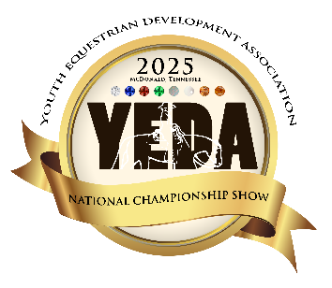
YEDA National Championship Show
Parking Pass Form
Tri State Exhibition Center
June 5 – 8, 2025

**Does Not Apply to**
Coaches, Staff, Vendors or Handicap Permits

In order to accommodate parking in a safe and efficient way, YEDA will now be requiring Parking Passes to park in certain areas of the showgrounds. (View the Map attached)
If you would like to purchase a parking pass to park in these areas, please complete the form below.

Things you need to know:
- Passes will be issued in the order this form is received.
- There are only 100 Pre-Show Parking Passes being sold.
- Additional passes may be available at the show but not guaranteed.
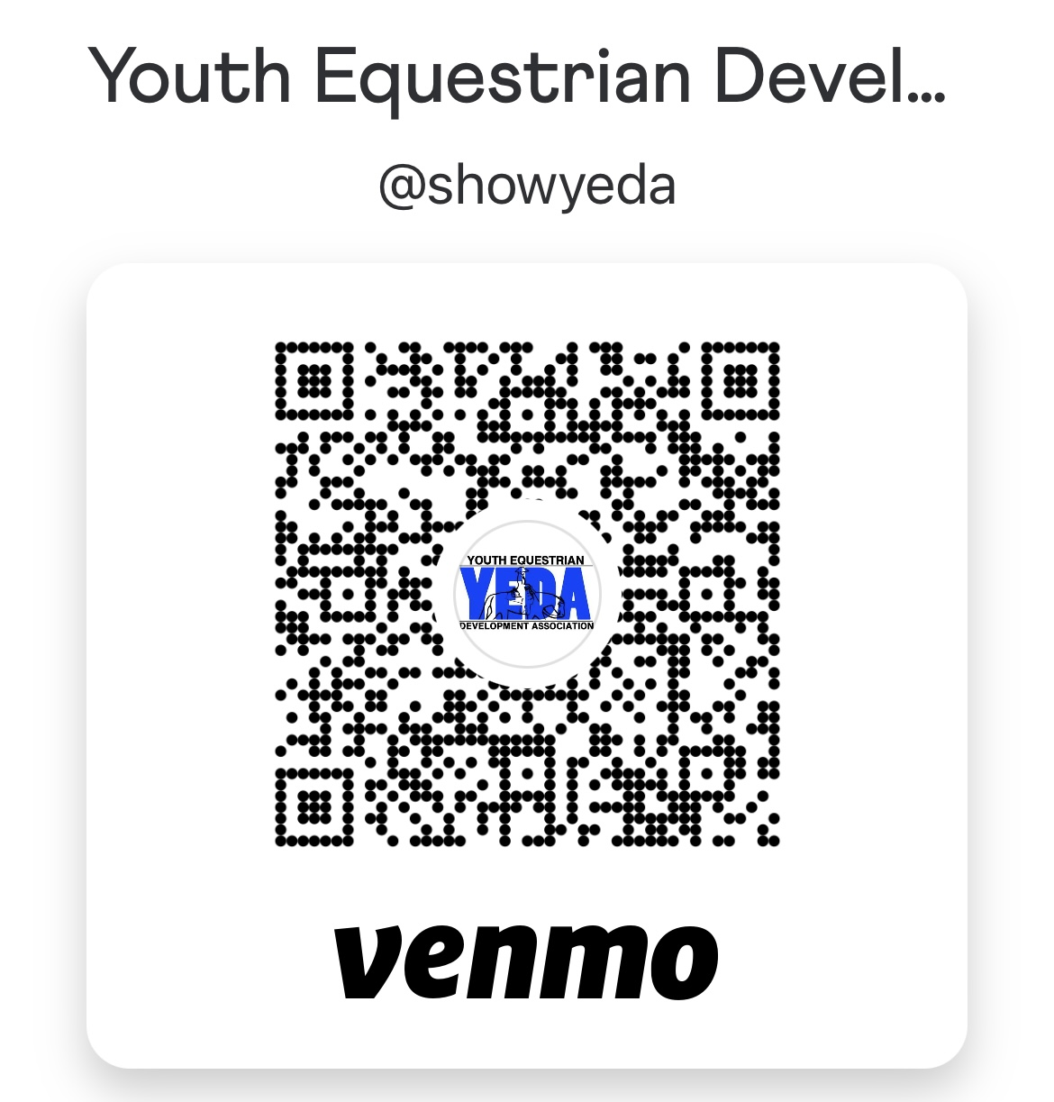
- Parking Passes are valid for the entire show
- Email form (Do Not Mail) Darnold@showyeda.com
- Cost $30 (credit card or Venmo only)

Would you like to pre-order a 2025 Nationals Program?
Guarantee your copy! Pick up at the event.
$15 each Pre-order your souvenir program(s) today!
Credit Card or Venmo only
Name_______________________________
When sending Venmo please include what the payment is for in detail
Phone Number______________________

# of Passes_________________________ # of Programs ________________

Credit Card: Account Type: ( Add’l 4% fee)
◻ Visa ◻ MasterCard ◻AMEX ◻ Discover
Cardholder Name _____________________ CC# _________________________________________
Exp Date _______ CVV ______ ZIP _______ Credit Card Charge Total ______________
Email: ______________________________ SIGNATURE _______________ DATE ____
I authorize the YEDA to charge the credit card indicated in this authorization form according to the terms outlined above. This payment authorization is for the goods/services described, for the amount indicated only, and is valid for one time use only. I certify that I am an authorized user of this credit card and that I will not dispute the payment with my credit card company; so long as the transaction corresponds to the terms indicated in this form.

Confirmation of the pass form received will be emailed to you.
Parking passes will be distributed at the entrance gate.
Questions: contact Debbie Arnold Darnold@showyeda.com or 419-566-6589
YEDA National Championship Show
Parking Pass Form
Tri State Exhibition Center
June 5 – 8, 2025

**Does Not Apply to**
Coaches, Staff, Vendors or Handicap Permits

2025 Parking Map


