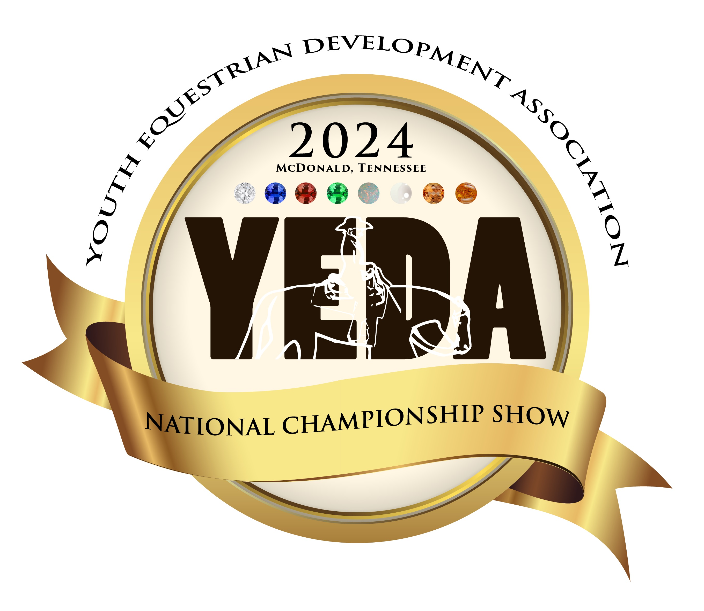
YEDA National Championship Show
Parking Pass Form
Tri State Exhibition Center
May 30-June 2
** NEW FOR 2024**

**Does Not Apply to**
Coaches, Staff, Vendors or Handicap Permits

In order to accommodate parking in a safe and efficient way, YEDA will now be requiring Parking Passes to park in certain areas of the showgrounds. (View the Map attached)
If you would like to purchase a parking pass to park in these areas, please complete the form below.

Things you need to know:
- Passes will be issued in the order this form is received.
- There are only 100 Pre-Show Parking Passes being sold.
- Additional passes may be available at the show, but not guaranteed.
- Parking Passes are valid for the entire show
- Email form (Do Not Mail) Darnold@showyeda.com
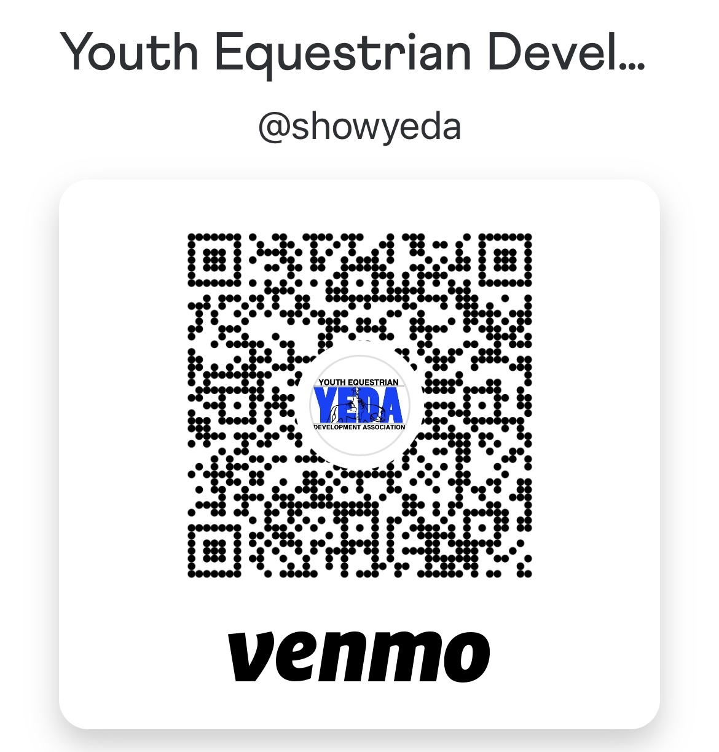
- Cost $30 (credit card or Venmo only)

Name_______________________________
Phone Number______________________
# of Passes_________________________

Credit Card: Account Type: ( Add’l 4% fee)
◻ Visa ◻ MasterCard ◻AMEX ◻ Discover
Cardholder Name _____________________
CC# ___________ _____________________
Exp Date _______ CVV ______ ZIP _______
Email: ______________________________ SIGNATURE _______________ DATE ____
I authorize the YEDA to charge the credit card indicated in this authorization form according to the terms outlined above. This payment authorization is for the goods/services described, for the amount indicated only, and is valid for one time use only. I certify that I am an authorized user of this credit card and that I will not dispute the payment with my credit card company; so long as the transaction corresponds to the terms indicated in this form.

A confirmation of the pass form received will be emailed to you. Parking passes will be distributed at the gate entrance.
Questions: contact Debbie Arnold Darnold@showyeda.com or 419-566-6589
YEDA National Championship Show
Parking Pass Form
Tri State Exhibition Center
May 30-June 2
** NEW FOR 2024**

**Does Not Apply to**
Coaches, Staff, Vendors or Handicap Permits

2024 Parking Map
