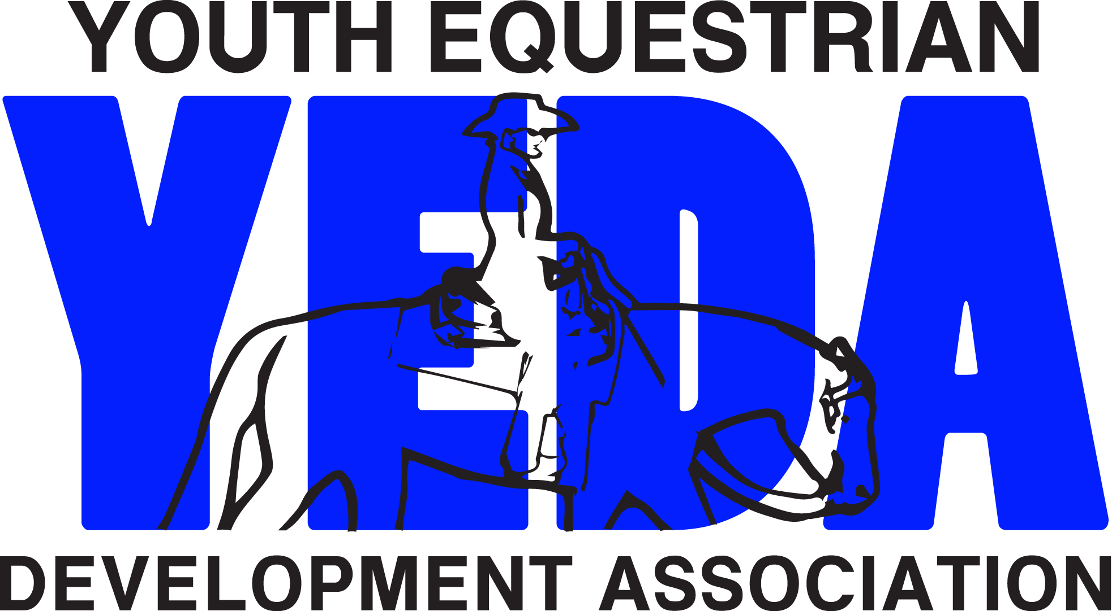
TRY IT
Individual Membership & Placement Form
2023 - 2024
All completed transactions will be processed
in the order in which they are received.
Please allow fifteen business days for processing

Try It Membership is $20

This gives the rider temporary YEDA Membership to show for a weekend. If the rider decides within 30 days to upgrade to a regular membership this $20 will be applied to your $80 regular YEDA membership.

☐ New Member ☐ Returning Member
Team Name
Rider Name
Back # | # | Current Grade  _{for ’2023-24 School year}
Riders Height |  | Riders Weight
Rider’s Email |  |  |  |  | Riders DOB
Home Mailing Address
 | Street Address City State Zip
Cell/Primary PH #: | ( ) - |  | Expected Graduation Year
Parent’s Name:
Parent Email |  |  |  | Parent PH # |  | ( ) -
Rider’s Parent’s Home Address
 | Street Address City State Zip
School of Record
School Address | Street Address City State Zip
After completing the following pages and determining the riders Category and Division please fill out the following box.
2023/2024 Western Category: (choose one) ☐ Elementary ☐ Jr. High ☐ Sr. High
2023/2024 Division: ____________________

If you have competed in “recognized shows” you may be asked to submit a printed copy of your competition/points records along with this form. For YEDA purposes, “recognized shows” includes AQHA, NRHA, NSBA, APHA, PtHA, ApHC, IBHA, ABRA & POA, USEF, and any other association that keeps national records.
Coach’s Assessment of YEDA Divisions:
Note: If either the coach or student believes that this form places the rider into a class unfairly, and that this rider should be placed into a division other than the one indicated by the form, please explain your circumstances in the appropriate place on the back page and suggest an appropriate level. This form will be given to the National Steward for review and final placement decision.
NOTICE: YEDA does not assume any responsibility for the safety of participants and/or attendees at all equine events. Equine events are inherently risky. “Inherent risk of an equine activity" means a danger or condition that is an integral part of an equine activity, including, but not limited to, any of the following:(a) The propensity of an equine to behave in ways that may result in injury, death, or loss to persons on or around the equine; (b) The unpredictability of an equine's reaction to sounds, sudden movement, unfamiliar objects, persons, or other animals; (c) Hazards, including, but not limited to, surface or subsurface conditions; (d) A collision with another equine, another animal, a person, or an object; or (e) The potential of an equine activity participant to act in a negligent manner that may contribute to injury, death, or loss to the person of the participant or to other persons, including, but not limited to, failing to maintain control over an equine or failing to act within the ability of the participant. The parent or guardian, on behalf of their participating minor, assumes all risk of personal injury or property damage occurring as a result of the participation and does hereby release and discharge YEDA and Show Management, their respective officers, directors, representatives, and employees from any and all liability, whenever or however arising from such participation.
Your signature below acknowledges that coach, guardian, and rider have fully reviewed the YEDA Rule Book 2023-2024 and understand the conduct, competition requirements, and possible sanctions outlined therein. You are hereby guaranteeing that coach, guardian, and rider will adhere to YEDA social media policy and rules of the organization. Your signature additionally acknowledges that the rider is a fulltime student in good academic standing. Coach, guardian, and rider are subject to all rules, fines and disciplinary actions for violations of the YEDA rules.

Coach’s Signature: ____________________________________________ Date: __________

Rider Signature: ______________________________________________ Date: __________

Parent/Guardian Signature: _____________________________________ Date: __________

Photo Release:
May your likeness in photos taken in photos by our official photographers be used in promotional literature for YEDA? ☐ YES ☐ NO
If no, please enclose a current photo of the rider so that we can ensure their likeness is not used.
**The Youth Equestrian Development Association (YEDA) highly recommends that all riders be actively enrolled in a weekly lesson program.**

YEDA Individual Placement Form Rule
In order to compete in YEDA shows, an individual member showing YEDA must submit a completed YEDA Individual Placement Form to the Team Coach who will sign and forward it to the CFO, listed below prior to the Member’s first show. Coaches are responsible for accurately evaluating a rider in the appropriate division. An Individual Placement Form must be retained annually for the entirety of student’s eligibility.
NOTE:
- Because of the yes/no format of this form, the questions in each section are not intended to always match the class description of the same section. Rather, a “yes” answer in one section is, in many cases, an affirmation of the rider being over-qualified for the class description in the next lower class.)

- For those students coming to YEDA from another team riding national organization that places their riders in divisions based on experience those students must compete in the equivalent division equal or greater than that division they have completed.

All class descriptions refer to the guidelines specified in Rule R33.

Class 1 & 2: Pearl Western Horsemanship
Pearl riders are student riders of any skill level that walk jog and who are riders currently enrolled in 4th of 5th grade for the school year of competition. Pearl riders have two years of eligibility starting with their initial completion of the YEDA Individual Membership Form.
Are you entering the 4th or 5th grade for this competition year?
☐ YES ☐ NO
Classes 3, 4, 11 & 12: Opal Western Horsemanship
Opal riders are Walk-jog students who are beginning riders who have not competed in mounted competition which require them to canter or lope.
Is this statement true? I have never competed in a class that requires me to lope or canter. ☐ YES ☐ NO
Classes 5, 6, 13 & 14: Emerald Western Horsemanship
Emerald riders are students that have competed in twelve (12) or fewer shows that require them to lope or canter.

HAVE YOU COMPETED IN 12 OR FEWER SHOWS WHICH REQUIRE YOU TO LOPE OR CANTER? ☐ YES ☐ NO

Classes 7, 8, 15, & 16: Ruby Western Horsemanship
Ruby riders have competed in more than twelve (12) shows that require a rider to lope or canter. Ruby riders may not have earned more than 25 national points from any association including novice classes. This excludes roping, games, halter, showmanship 10 & under classes, and/or non-loping classes.
Is this statement true? I have not earned 25 national points from any national association including novice but excluding roping, games, halter, showmanship 10 & under classes, and/or non-loping classes. ☐ YES ☐ NO

Classes 9, 10, 17, & 18 : Sapphire Western Horsemanship / Ranch Riding
Sapphire riders are those who have earned 26 or more national points from any national association including novice but excluding roping, games, halter, showmanship 10 & under classes, and/or non-loping classes. Sapphire riders are also riders who have completed at a national run show including but not limited to World Championships, National Championships, Novice Championships, Congress, and Derby.

Have you earned 26 or more national points from any national association including novice but excluding roping, games, halter, showmanship 10 & under classes, and/or non-loping classes. ☐ YES ☐ NO

Have you competed in a national run show including but not limited to World Championships, National Championships, Novice Championships, Congress, and Derby? ☐ YES ☐ NO

Class 19: Diamond Western Horsemanship
Diamond riders are those who have finished in Top Fifteen (15) at a national run show including but not limited to World Championships, National Championships, Novice Championships, Congress, and Derby. Including novice but excluding roping, games, halter, showmanship 10 & under classes, and/or non-loping classes.

Have you ever finished in the Top Fifteen (15) at a national run show including but not limited to World Championships, National Championships, Novice Championships, Congress, and Derby Including novice but excluding roping, games, halter, showmanship 10 & under classes, and/or non-loping classes? ☐ YES ☐ NO

Class 20: Diamond Reining
Are you eligible for Class 19: Diamond Horsemanship?
☐ YES ☐ NO

Have you had at least 6 month of Professional Reining training within the Past year? ☐ YES ☐ NO

NOTE:
- A Student must be enrolled in school full-time at the time of any YEDA Competition. Proper documentation must be on file prior to the first competition of each academic term.
- If you consider yourself a lower-level rider than this form indications, please attach an explanation page.
- For those students coming to YEDA from another team riding national organization that places their riders in divisions based on experience those students must compete in the equivalent division equal or greater than that division they have completed.
TO DOCUMENT PRIOR COMPETITION RECORDS:
LIST YOUR NAME EXACTLY AS IT APPEARS IN ASSOCIATION RECORDS, AND list your ID# for each association in which you have competed. (Not one in which you are simply a card holding member who has never participated in competition).
United States Equestrian Federation (USEF):
United States Eventing Association (USEA) :
American Quarter Horse Association (AQHA):
American Paint Horse Association (APHA):
Pinto Horse Association (PtHA):
Appaloosa Horse Club (ApHC):
National Reining Horse Association (NRHA):
United States Dressage Federation (USDF):
International Buckskin Horse Association (IBHA)
American Buckskin Registry Association (ABRA)
Palomino Horse Breeders Association (PHBA)
Pony of the Americas (POA)
Other:

Please send all forms to: Debbie Arnold, CFO
2415 State Route 603
Ashland, OH 44805
For Questions Contact Debbie Arnold (CFO)
Phone: 419 – 566 – 6589
Email: DArnold@showyeda.com

Make all Checks Payable to YEDA

