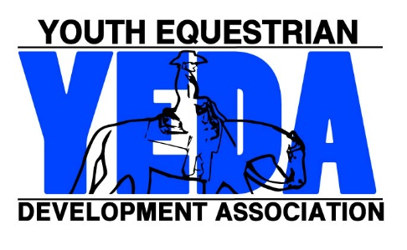
YEDA Show Hosting Application
2023-2024 Season
All completed applications will be processed in the order in which they are received.
Please allow fifteen business days for processing.

Submit Show Hosting Application a minimum of 60 days before your intended show date.
The 60-day deadline can be waved for extemporaneous circumstances. If this applies contact YEDA directly

The following information is required.
Hosting Team(s)
Show Date(s) |  |  | Show Name
Show Manager
Managers Address:
 |  | Street Address City State Zip
Phone Number: |  |  |  |  | Email:
The Maximum Number of Entries for any show is 250.
However, as the host this number can be smaller based on the resources of the host. What is the maximum number of entries that the show will accept?
Event Insurance Payment & Office Fees
YEDA Home Office will secure Equisure Event Insurance for each day of your show. Include with your application $200 per day of your show. This will cover the cost of the Equisure Event Insurance. Payment includes expenses for the use of the database, posting on the website, and processing fees for the show. Make check out to YEDA or pay with attached credit card form.
Please Note: Insurance costs are reevaluated in October this fee could change.
The following information is due 30-days before the show. Please provide/update this information as soon as you know it, however it is not required for initial show approval.
Location
Name and Address
Venue/Arena Description  Describe the Venue and Arena: # of stalls, size of the arena, arena indoor or outdoor, # of parking spots, spectator seating etc. |  |  |  |  | Judge(s):
 |  |  |  |  | Patterns:
Show Steward:  Name and Email |  |  |  |  | Secretary:  Name and Email
Mail Form & Check To:  Laura Smith  11125 County Road 180  Findlay, Ohio 45840 |  |  |  | For Questions or Updates  Contact Laura Smith (CEO)  Phone: 419 – 957 – 9054  Email: LSmith@showyeda.com
One Time Credit Card Payment Authorization Form

Sign and complete this form to authorize Youth Equestrian Development Association to make a one-time debit to your credit card listed below.

By signing this form, you give us permission to debit your account for the amount indicated on or after the indicated date. This is permission for a single transaction only and does not provide authorization for any additional unrelated debits or credits to your account.

There will be an additional 4% fee charge for all credit card transactions.

Please complete the information below:

I _________________ authorize Youth Equestrian Development Association (full name)
to charge my credit card account indicated below for _____________ on or after ____________. This payment is for: (amount)
(date)

YEDA Membership SIF Annual Membership
YEDA Show Shirt Purchase Other ______________

Billing Address ________________ Phone# _________________
City, State, Zip ___________________ Email ________________

Account Type: Visa MasterCard AMEX Discover
Cardholder Name _________________________________________________
Account Number _________________________________________________
Expiration Date ____________ CVV ____________ Zip ________

SIGNATURE _____ DATE

I authorize the above named business to charge the credit card indicated in this authorization form according to the terms outlined above. This payment authorization is for the goods/services described above, for the amount indicated above only, and is valid for one time use only. I certify that I am an authorized user of this credit card and that I will not dispute the payment with my credit card company; so long as the transaction corresponds to the terms indicated in this form.
Updated 9/10/2021

