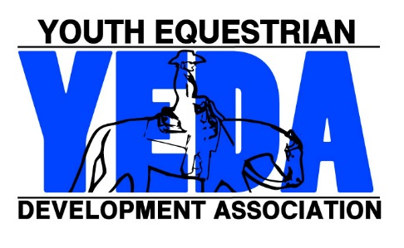
YEDA Assistant Coach Registration Form
2023-2024
All completed applications will be processed in the order in which they are received.
Please allow fifteen business days for processing.

Payment of $60 fee must be accompanied with this form

Name:
Team Name
Coach Address:
 | Street Address City State Zip
Phone Number: | ( ) - - |  | Email:
Emergency Contact | Name |  | PH #
Please Mark all professional affiliations
☐ USEF ☐ USHJA ☐ USPC ☐ AQHA ☐ APHA ☐ NRHA ☐ PATH
☐ CHA ☐ 4H ☐ PtHA ☐ IHSA ☐ NSBA ☐ Other ___________________
☐ PATH ☐ Special Olympics ☐ Certified therapeutic riding instructor

YEDA Coach Code of Conduct

By registering as a coach in YEDA you agree to the following:
- Know the current YEDA rules and abide by them.
- Put the emotional and physical wellbeing of All YEDA riders, staff, and coaches ahead of your personal desire to win.
- Respect all YEDA staff and officials and refrain from questioning them in a disrespectful or abusive manner.
- Maintain control over your emotions and avoid language, actions, or gestures that could be interpreted as disrespectful, demeaning, hostile, or humiliating.
- Set the example of being humble and generous when winning, and proud and courteous in defeat.
- Ensure that all riders, parents, and other personal associated with your team always demonstrate good sportsmanship and maturity.
Signature __________________________________ Date _______________

Make Checks out to: YEDA  Mail Form to:  Debbie Arnold  2415 State Route 603  Ashland, OH 44805 |  | For Questions Contact Debbie Arnold (CFO)  Phone: 419 – 566 – 6589  Email: DArnold@showyeda.com

