Dear School Administrator,
The purpose of this letter is to inform you that a student at your school is a member of the Youth Equestrian Development Association (YEDA). YEDA is a national organization with a mission that includes providing instructional and experiential learning opportunities for students in grades 4-12. In addition to the development of riders’ skills, YEDA emphasizes exposure to scholarship opportunities, provides riders with connections to college and university equestrian programs and a possible trip to YEDA Nationals. The sport of equestrian riding is now a recognized sport of the NCAA and many riders are earning full ride scholarships from their accomplishments in YEDA. All YEDA riders are competing for Scholarship dollars starting in the 4th grade. In the last 6 seasons YEDA has awarded over $950,000 in scholarships to our student riders.
The regular YEDA competition season runs from September thru April each year and each of our student riders can show at 12 competitions. The competitions are held around the country. If a rider can earn a top 20% spot in their division, they are qualified to compete at the YEDA National Show held in early June. We have many college coaches recruiting at our Nationals show and will award over $250,000 in scholarships at the National Championship event.
As you are likely aware, student-athletes are among the most successful students academically. We would like to propose that our organization members be recognized student-athletes and be afforded the same support as other student-athletes participating in school-sponsored events. There are times that our student riders need to be excused from school for a YEDA competition. We ask that you are understanding in this matter. We have an official form attached to this letter that we ask students to fill out and present to their school administrators.
If you would like to learn more about YEDA please visit our website at showyeda.com. If you have questions, you are welcome to contact me.
Sincerely,
Laura Smith YEDA CEO
lsmith@showyeda.com
419-957-9054

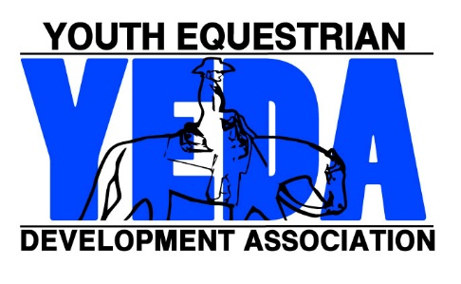
YEDA COMPETITION
EXCUSED ABSENCE
REQUEST

showyeda.com

Rider’s Name
YEDA Competition Name
Competition Dates
Absence Dates
YEDA Team Name
Coach Name
Coach Contact Information
Student Signature |  | Date
Parent Signate |  | Date
YEDA acknowledges the importance of academics. We encourage students request work ahead of their travels and complete assignments in a timely respectful manner.
The YEDA mission is to provide an equestrian riding program for youth students, via both instructional and experiential learning opportunities. To accomplish this, we will engage in equestrian competitions, instructional clinics, networking events, and occasions for recruitment that includes but not limited to scholarship disbursements.

