
YEDA Official Show Shirt Order Form
2022

Please allow 15-30 business days for processing.

All shirts will come with YEDA logo embroidery .
Make checks out to YEDA


Ladies Shirts Button & Zip Combo $110
Black
Grey
Blue
Black & White Pinstripe
Light Blue & White Pinstripe

Men’s Shirts $90

Black
Burgundy
Purple
Royal Blue


Girls Shirts Button Zip Combo
$90 2022 Black Single Collar
$110 Plum Double Collar
$110 Teal Double Collar

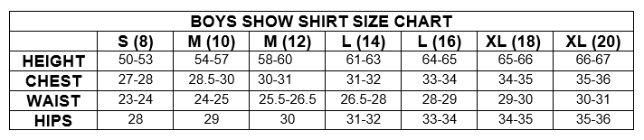
Boys $90
Black
Burgundy
Purple
Royal Blue

Please Note: Not all colors and sizes will be available all season as inventory is sold out.



YEDA Official Show Shirt Order Form
2022
Please allow 15-30 business days for processing.
**ONE SHEET PER MEMBER**
Please Note: Not all colors and sizes will be available all season as inventory is sold out.
YEDA Member |  | Team Name
Address |  | Phone Number
Payment Option:
Check Cash Credit Card ^{(additional 4% fee)}
Check # _____________
Credit Card:
Account Type:
Visa MasterCard AMEX Discover

Cardholder Name _____________________
CC# ___________ _____________________
Exp Date _______ CVV ______ ZIP _______
Email: ______________________________
SIGNATURE _______________ DATE ____
I authorize the YEDA charge the credit card indicated in this authorization form according to the terms outlined above. This payment authorization is for the goods/services described, for the amount indicated only, and is valid for one time use only. I certify that I am an authorized user of this credit card and that I will not dispute the payment with my credit card company; so long as the transaction corresponds to the terms indicated in this form.

Style | Color | Size |  |  |  |  |  |  | Price | AMT  $
Style | Color | XS | S | M | L | XL | 2XL | 3XL | Price | AMT  $
Ladies | Black |  |  |  |  |  |  |  | $110
Ladies | Grey |  |  |  |  |  |  |  | $110
Ladies | Plum |  |  |  |  |  |  |  | $110
Ladies | Royal Blue |  |  |  |  |  |  |  | $110
Ladies | Black & White Pinstripe |  |  |  |  |  |  |  | $110
Ladies | Light Blue & White Pinstripe |  |  |  |  |  |  |  | $110
Men’s | Black |  |  |  |  |  |  |  | $90
Men’s | Burgundy |  |  |  |  |  |  |  | $90
Men’s | Purple |  |  |  |  |  |  |  | $90
Men’s | Royal Blue |  |  |  |  |  |  |  | $90
Girls | Black But/Zip Combo Db Collar |  |  |  |  |  |  |  | $110
Girls | Teal But/Zip Combo Db Collar |  |  |  |  |  |  |  | $110
Girls | Plum But/Zip Combo Db Collar |  |  |  |  |  |  |  | $110
Girls | 2022 Black But/Zip Sg Collar |  |  |  |  |  |  |  | $90
Boys | Black |  |  |  |  |  |  |  | $90
Boys | Burgundy |  |  |  |  |  |  |  | $90
Boys | Purple |  |  |  |  |  |  |  | $90
Boys | Blue |  |  |  |  |  |  |  | $90

Make checks out to YEDA . Tax and Shipping Included TOTAL: _______
Order form can be mailed with credit card info or check to Laura Smith Address: 11125 County Road 180, Findlay, Ohio 45840
Or Email the order form with credit card payment Email: Lsmith@showyeda.com For Questions Call: Laura Smith 419-957-9054
FOR OFFICE USE ONLY
Date Received: | Shipping:

