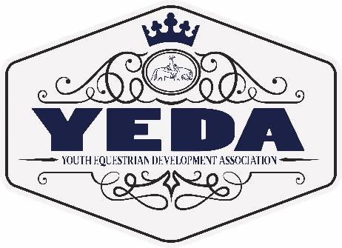
YEDA Royalty Contest
Rules and Guidelines
2023-2024

The following royalty positions will be awarded at the 2024 YEDA National Show in McDonald, TN:
- Queen: chosen from high school female applicants
- King: chosen from high school male applicants
- Princess: chosen from middle school female applicants
- Prince: chosen from middle school male applicants
- Lil Miss: chosen from elementary female applicants
- Lil Mister: chosen from elementary male applicants
- Ambassador: chosen from EWD female applicants
- Ambassador: chosen from EWD male applicants
Each royalty position listed above will also have a first runner up award, and other awards if a large number of applicants apply.

The competition will consist of the following:
Each of the below 5 categories’ will be scored from 0-60 points all points will be totaled to choose the winner and first runner up.
- Application filled out and sent in with entry of $50 by May 1, 2024. Checks can be made out to YEDA.
- Essay on the topic “What it means to be a YEDA Ambassador” sent in by May 1, 2024
  - High School minimum 500 – 800 words
  - Junior High minimum 250 – 500 words
  - Elementary minimum of 100 – 250 words
  - EWD minimum of 100 – 250 words
- Year end points earned under the top 6 judge score from both of the riders classes for that 2023-2024 YEDA season
- An interview to be held at YEDA Nationals on Wednesday, May 29, 2024 from 3 pm till completed.
- A YEDA knowledge test based on the YEDA website and Rulebook. To be given at YEDA Nationals on Wednesday, May 29, 2024 immediately after the interview.
In the event of a tie the following categories highest score will break the tie, if there is still a tie then the next category listed will be used to break the tie.
  - Interview
  - Year end point total
  - Essay
  - The YEDA knowledge test
  - Application score

Responsibilities of YEDA Royalty winners:
To be an ambassador for YEDA:
- Royalty will serve in their position from the 2023-2024 YEDA National show thru the 2024-2025 YEDA National show when new royalty is crowned.
- Royalty will help hand out awards and be in photos for the 2024 YEDA National show.
- Royalty will attend equine events in your area representing YEDA at their expense. YEDA will assist in setting up these events if needed.
  - High School Royalty is expected to attend a minimum of 6 equine events.
  - Middle School Royalty is expected to attend a minimum of 4 equine events.
  - Elementary and EWD is expected to attend a minimum of 2 equine events.
- Royalty will attend the 2024-2025 YEDA National show and help with the royalty contest and be present to crown the new royalty and mentor them in the job.
- Assist at YEDA Shows with the following: hand out awards, assist with presentations, and general help where needed. Be present with the crown, sash, and YEDA apparel for these duties.

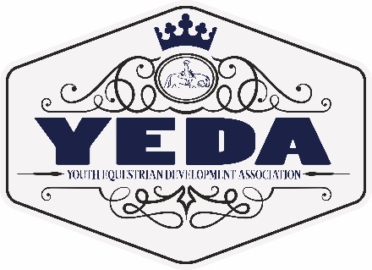
YEDA Royalty Contest
High School (9-12)
Contestant Application
2023-2024

Please indicate which royalty potion you are applying for
☐ King ☐ Queen

Application Cost $50 Due Date May 1, 2024 .
Rider Name
Team Name
YEDA Division |  |  | Back Number
Current Grade  _{for ’22-‘23 School year} |  |  | Riders DOB
Rider’s Email
Home Mailing Address | Street Address City State Zip Code
Cell/Primary PH #: | ( ) -
Parent’s Name:
Parent Email |  | Parent PH # |  | ( ) -

Essay Topic: What it means to be a YEDA Ambassador
Please complete the essay in 500-800 words and attach it to your application.

For Questions Contact Laura Smith (CEO)
Phone: 419 – 957 – 9054 Email: LSmith@showyeda.com

Mail completed application to Laura Smith
11125 Township Road 180, Findlay Ohio 45840

Rider Name
What do you like most about YEDA?
List interests, hobbies, and/or sports outside of YEDA.
Community Service
Interesting facts about yourself:
Career Ambition:
Applicant is encouraged to extend this application or include attachments to be thorough. Please be sure to have applicants name on each page.
YEDA Royalty Contest
Junior High School (6-8)
Contestant Application
2023-2024

Please indicate which royalty potion you are applying for
☐ Prince ☐ Princess

Application Cost $50 Due Date May 1, 2024 .
Rider Name
Team Name
YEDA Division |  |  | Back Number
Current Grade  _{for ’22-‘23 School year} |  |  | Riders DOB
Rider’s Email
Home Mailing Address | Street Address City State Zip Code
Cell/Primary PH #: | ( ) -
Parent’s Name:
Parent Email |  | Parent PH # |  | ( ) -

Essay Topic: What it means to be a YEDA Ambassador
Please complete the essay in 250-500 words and attach it to your application.

For Questions Contact Laura Smith (CEO)
Phone: 419 – 957 – 9054 Email: LSmith@showyeda.com

Mail completed application to Laura Smith
11125 Township Road 180, Findlay Ohio 45840

Rider Name
What do you like most about YEDA?
List interests, hobbies, and/or sports outside of YEDA
What is the last community service you were involved in (and explain)?
What is one thing that you would like everyone to know about you (and explain):
What is one goal you have made for yourself?
Applicant is encouraged to extend this application or include attachments to be thorough. Please be sure to have applicants name on each page.
YEDA Royalty Contest
Elementary (4-5)
Contestant Application
2023-2024

Please indicate which royalty potion you are applying for
☐ Lil Mister ☐ Lil Miss

Application Cost $50 Due Date May 1, 2024 .
Rider Name
Team Name
YEDA Division |  |  | Back Number
Current Grade  _{for ’22-‘23 School year} |  |  | Riders DOB
Rider’s Email
Home Mailing Address | Street Address City State Zip Code
Cell/Primary PH #: | ( ) -
Parent’s Name:
Parent Email |  | Parent PH # |  | ( ) -

Essay Topic: What it means to be a YEDA Ambassador
Please complete the essay in 100-250 words and attach it to your application.

For Questions Contact Laura Smith (CEO)
Phone: 419 – 957 – 9054 Email: LSmith@showyeda.com

Mail completed application to Laura Smith
11125 Township Road 180, Findlay Ohio 45840
Rider Name
What do you like most about YEDA?
List interests, hobbies, and/or sports outside of YEDA
What is one thing that you would like everyone to know about you (and explain):
What Would You Like To Be When You Grow Up
Applicant is encouraged to extend this application or include attachments to be thorough. Please be sure to have applicants name on each page.

YEDA Royalty Contest
EWD Ambassador
Contestant Application
2023-2024

Please indicate which royalty potion you are applying for
☐ Male Ambassador ☐ Female Ambassador

Application Cost $50 Due Date May 1, 2024 .
Rider Name
Team Name
YEDA Division |  |  | Back Number
Current Grade  _{for ’19-‘20 School year} |  |  | Riders DOB
Rider’s Email
Home Mailing Address | Street Address City State Zip Code
Cell/Primary PH #: | ( ) -
Parent’s Name:
Parent Email |  | Parent PH # |  | ( ) -

Essay Topic: What it means to be a YEDA Ambassador
Please complete the essay in 100-250 words and attach it to your application.

For Questions Contact Laura Smith (CEO)
Phone: 419 – 957 – 9054 Email: LSmith@showyeda.com

Mail completed application to Laura Smith
11125 Township Road 180, Findlay Ohio 45840
Rider Name
What do you like most about YEDA?
List interests, hobbies, and/or sports outside of YEDA
What is one thing that you would like everyone to know about you (and explain):
What is one goal you have made for yourself?
Applicant is encouraged to extend this application or include attachments to be thorough. Please be sure to have applicants name on each page.

