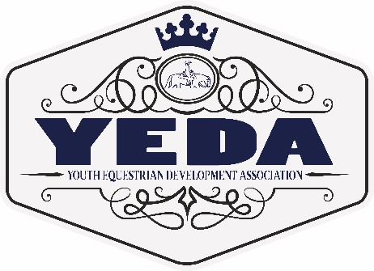
YEDA Royalty Contest
Rules and Guidelines
2022-2022

The following royalty positions will be awarded at the 2022 YEDA National Show in McDonald, TN:
- Queen: chosen from high school female applicants
- King: chosen from high school male applicants
- Princess: chosen from middle school female applicants
- Prince: chosen from middle school male applicants
- Lil Miss: chosen from elementary female applicants
- Lil Mister: chosen from elementary male applicants
- Ambassador: chosen from EWD female applicants
- Ambassador: chosen from EWD male applicants
Each category listed above will also have a first runner up award.

The competition will consist of the following:
Each of the above 5 categories’ will be scored from 0-60 points all points will be totaled to choose the winner and first runner up.
- Application filled out and sent in with entry of $50 by May 1, 2022. Checks can be made out to YEDA.
- Essay on the topic “What it means to be a YEDA Ambassador” sent in by May 1, 2022.
  - High School minimum 500 – 800 words
  - Junior High minimum 500 – 250 words
  - Elementary minimum of 250 – 100 words
  - EWD minimum of 250 – 100 words
- Yearend points earned under all 12 judges in your highest point earning class for that 2021-2022 YEDA season
- An interview to be held at YEDA Nationals on Wednesday, June 22, 2022 from 3 pm till completed.
- A YEDA knowledge test based on the YEDA website and Rulebook. To be given at YEDA Nationals on Wednesday, June 22, 2022 immediately after the interview.
In the event of a tie the following categories highest score will break the tie, if there is still a tie then the next category listed will be used to break the tie.
  - Interview
  - Yearend point total
  - Essay
  - The YEDA knowledge test
  - Application score
2022-2022 Royalty will be crowned on Thursday, June 23, 2022. They will receive crowns, sashes and/or many nice prizes for all winners and first runner up in each category.

Responsibilities of YEDA Royalty winners:
To be an ambassador for YEDA:
- Royalty will serve in their position from the 2021-2022 YEDA National show thru the 2022-2022 YEDA National show when new royalty is crowned.
- Royalty will help hand out awards and be in photos for the 2021-2022 YEDA National show.
- Royalty will attend equine events in your area representing YEDA at their expense, YEDA will assist in setting up these events if needed.
  - High School Royalty is expected to attend a minimum of 6 equine events
  - Middle School Royalty is expected to attend a minimum of 4 equine events
  - Elementary and EWD is expected to attend a minimum of 2 equine events
- The entire Royalty Court will work together to plan one fundraiser and carry it out and the money raised will go back in the royalty budget to help with awards and other royalty expenses.
- Royalty will attend the 2022-2023 YEDA National show and help with the royalty contest and be present to crown the new royalty and mentor them in the job.

For Questions Contact Laura Smith (CEO)
Phone: 419 – 957 – 9054 Email: LSmith@showyeda.com

Mail completed application to
Laura Smith
11125 Township Road 180
Findlay, Ohio 45840

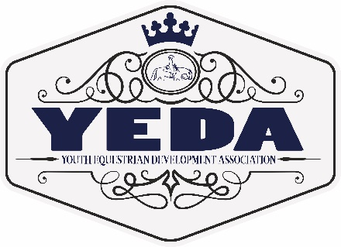
YEDA Royalty Contest
High School (9-12)
Contestant Application
2021-2022

Please indicate which royalty potion you are applying for
☐ King ☐ Queen

Application Cost $50 Due Date May 1, 2022 .
Rider Name
Team Name
YEDA Division |  |  | Back Number
Current Grade  _{for ’19-‘20 School year} |  |  | Riders DOB
Rider’s Email
Home Mailing Address | Street Address City State Zip Code
Cell/Primary PH #: | ( ) -
Parent’s Name:
Parent Email |  | Parent PH # |  | ( ) -
T Shirt Size | Adult S M L XL XXL Childs S M L XL

Essay Topic: What it means to be a YEDA Ambassador
Please complete the essay in 500-800 words and attach it to your application.

For Questions Contact Laura Smith (CEO)
Phone: 419 – 957 – 9054 Email: LSmith@showyeda.com

Mail completed application to Laura Smith
11125 Township Road 180
Findlay, Ohio 45840
Rider Name
What do you like most about YEDA?
List interests, hobbies, and/or sports outside of YEDA.
Community Service
Interesting facts about yourself:
Career Ambition:
Applicant is encouraged to extend this application or include attachments to be thorough. Please be sure to have applicants name on each page.
YEDA Royalty Contest
Junior High School (6-8)
Contestant Application
2021-2022

Please indicate which royalty potion you are applying for
☐ Prince ☐ Princess

Application Cost $50 Due Date May 1, 2022 .
Rider Name
Team Name
YEDA Division |  |  | Back Number
Current Grade  _{for ’19-‘20 School year} |  |  | Riders DOB
Rider’s Email
Home Mailing Address | Street Address City State Zip Code
Cell/Primary PH #: | ( ) -
Parent’s Name:
Parent Email |  | Parent PH # |  | ( ) -
T Shirt Size | Adult S M L XL XXL Childs S M L XL

Essay Topic: What it means to be a YEDA Ambassador
Please complete the essay in 500-250 words and attach it to your application.

For Questions Contact Laura Smith (CEO)
Phone: 419 – 957 – 9054 Email: LSmith@showyeda.com

Mail completed application to Laura Smith
11125 Township Road 180
Findlay, Ohio 45840

Rider Name
What do you like most about YEDA?
List interests, hobbies, and/or sports outside of YEDA
What is the last community service you were involved in (and explain)?
What is one thing that you would like everyone to know about you (and explain):
What is one goal you have made for yourself?
Applicant is encouraged to extend this application or include attachments to be thorough. Please be sure to have applicants name on each page.
YEDA Royalty Contest
Elementary (4-5)
Contestant Application
2021-2022

Please indicate which royalty potion you are applying for
☐ Lil Mister ☐ Lil Miss

Application Cost $50 Due Date May 1, 2022 .
Rider Name
Team Name
YEDA Division |  |  | Back Number
Current Grade  _{for ’19-‘20 School year} |  |  | Riders DOB
Rider’s Email
Home Mailing Address | Street Address City State Zip Code
Cell/Primary PH #: | ( ) -
Parent’s Name:
Parent Email |  | Parent PH # |  | ( ) -
T Shirt Size | Adult S M L XL XXL Childs S M L XL

Essay Topic: What it means to be a YEDA Ambassador
Please complete the essay in 250-100 words and attach it to your application.

For Questions Contact Laura Smith (CEO)
Phone: 419 – 957 – 9054 Email: LSmith@showyeda.com

Mail completed application to Laura Smith
11125 Township Road 180
Findlay, Ohio 45840
Rider Name
What do you like most about YEDA?
List interests, hobbies, and/or sports outside of YEDA
What is one thing that you would like everyone to know about you (and explain):
What Would You Like To Be When You Grow Up
Applicant is encouraged to extend this application or include attachments to be thorough. Please be sure to have applicants name on each page.

YEDA Royalty Contest
EWD Ambassador
Contestant Application
2021-2022

Please indicate which royalty potion you are applying for
☐ Male Ambassador ☐ Female Ambassador

Application Cost $50 Due Date March 1, 2022 .
Rider Name
Team Name
YEDA Division |  |  | Back Number
Current Grade  _{for ’19-‘20 School year} |  |  | Riders DOB
Rider’s Email
Home Mailing Address | Street Address City State Zip Code
Cell/Primary PH #: | ( ) -
Parent’s Name:
Parent Email |  | Parent PH # |  | ( ) -
T Shirt Size | Adult S M L XL XXL Childs S M L XL

Essay Topic: What it means to be a YEDA Ambassador
Please complete the essay in 250-100 words and attach it to your application.

For Questions Contact Laura Smith (CEO)
Phone: 419 – 957 – 9054 Email: LSmith@showyeda.com

Mail completed application to Laura Smith
11125 Township Road 180
Findlay, Ohio 45840
Rider Name
What do you like most about YEDA?
List interests, hobbies, and/or sports outside of YEDA
What is one thing that you would like everyone to know about you (and explain):
What is one goal you have made for yourself?
Applicant is encouraged to extend this application or include attachments to be thorough. Please be sure to have applicants name on each page.

