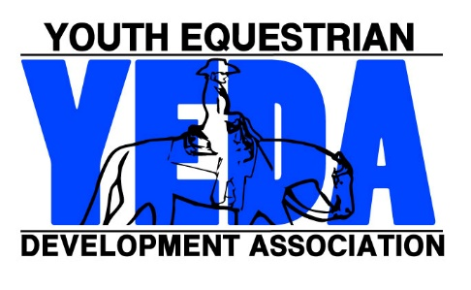
YEDA Sportsmanship Patch Order From
2018-2019 Season

All completed applications will be processed in the order in which they are received.
Please allow fifteen businesses days for processing.

. Each Patch is $15. Order at least 3 weeks before your show. .

Name of Show | Show Name.
Hosting Team(s) | Team(s) Name
Show Date | Month/Day
Show Manager | Name of Show Manager
Coach Address: | Street Address
Coach Address: | City State Zip Code
Phone Number: | ( ) - - |  |  |  | Email:
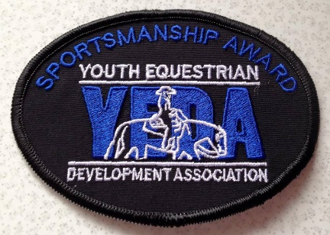 |  | The Sportsmanship Award is designed to nominate an outstanding rider/exhibitor who has shown extraordinary levels of sportsmanship. Award need not be awarded at every show, but only in situations where show staff feels extra acknowledgment is appropriate. There is no minimum or maximum number of awards to be given in a single season or a single show.
Each patch is $15

 |  |  |  | X $15 =
# of Patches Desired |  |  |  |  |  | Total
Make Checks Out to YEDA
Mail Form & Payment To:  Laura Smith  11125 Township Road 180  Findlay, Ohio 45840 |  |  | For Questions Contact Laura Smith (CEO)  Phone: 419 – 957 – 9054  Email: LSmith@showyeda.com

