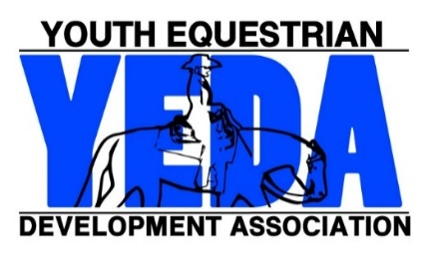
YEDA Associate Membership Form
2024-2025

All completed transactions will be processed
in the order in which they are received.
Please allow fifteen business days for processing

Examples of Associate Membership:
Show Stewards, Show Secretaries, Paddock Manager, Ring Stewards, Announcers, Any Paid or Volunteering member who is in the position of staff and decision making for a horse show.
Individuals who plan to assist EWD riders at a horse show in the show ring.

Payment of $30 fee must be accompanied with this form
Name:
Address:
Address: | Street Address City State Zip
Phone Number: |  |  | Email:
Emergency Contact |  |  | PH:
YEDA Code of Conduct
By registering as a m member in YEDA you agree to the following:
- Know the current YEDA rules and abide by them.
- Put the emotional and physical wellbeing of All YEDA riders, staff, and coaches ahead of your personal desire to win.
- Respect all YEDA staff and officials and refrain from questioning them in a disrespectful or abusive manner.
- Maintain control over your emotions and avoid language, actions, or gestures that could be interpreted as disrespectful, demeaning, hostile, or humiliating.
- Set the example of being humble and generous when winning, and proud and courteous in defeat.
- Ensure that all riders, parents, and other personal associated with your team always demonstrate good sportsmanship and maturity.
Signature __________________________________ Date _______________

Make Checks out to: YEDA  Mail Form to:  Debbie Arnold  2415 State Route 603  Ashland, OH 44805 |  | For Questions Contact Debbie Arnold (CFO)  Phone: 419 – 566 – 6589  Email: DArnold@showyeda.com

