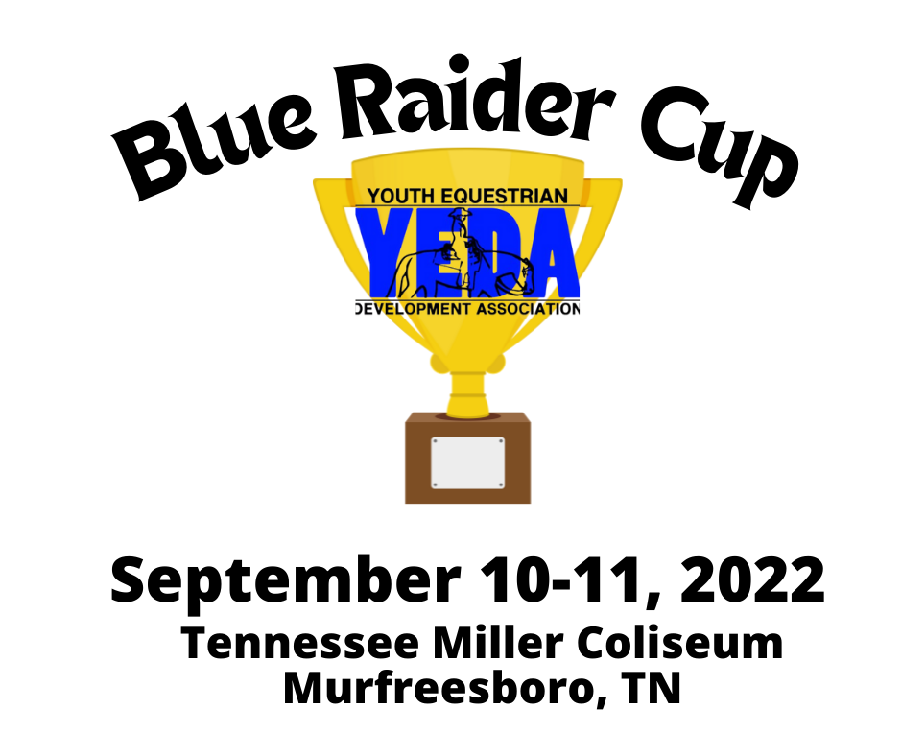
www.showyeda.com
Home of the MTSU Horse Science Program

Located at:
304 W. Thompson Lane
Murfreesboro, TN 37129

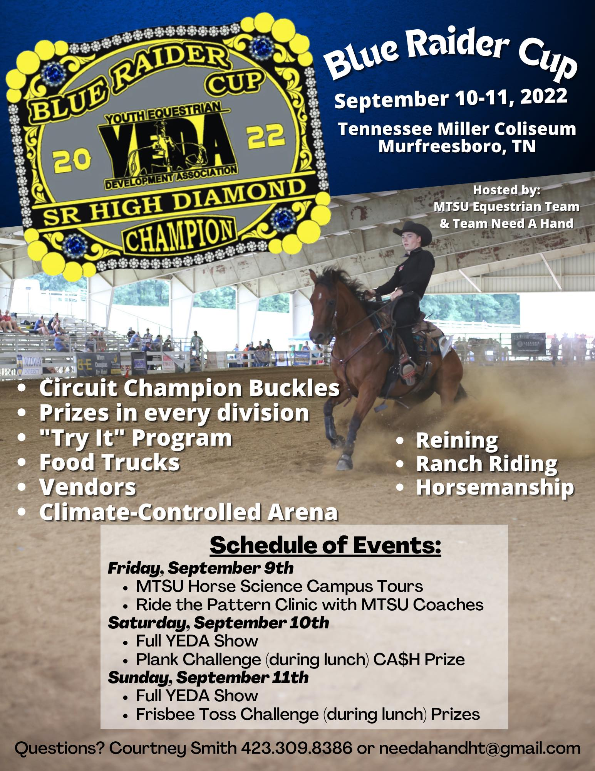
Schedule of Events
Friday Sept. 9th
MTSU Horse Science Program and Campus Tours
Contact Ariel Higgins, Director-Equestrian Programs, and IHSA Head coach, to reserve your team spot Ariel.Herrin@mtsu.edu

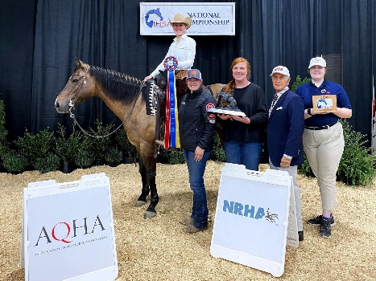
Friday September 9 @ 6:00 p.m. RIDE the Pattern Clinic

Join us as MTSU’s Head coach Ariel Higgins gives our participants tips and guidance on riding our YEDA patterns for the weekend. YEDA riders will get to watch MTSU’s Equestrian Team riders demonstrate horsemanship patterns on the MTSU’s horses that will be used throughout the weekend. Great opportunity to learn from an AQHA World Champion rider and IHSA National Championship coach.

For additional collegiate program
information visit mtsu.edu/programs/horse-science/

Saturday September 10th during the Lunch Break
The Plank Challenge
Does your team have what it takes to be a Plank Master?
Join us as we have a Plank Challenge where we test our rider’s fitness levels! Prizes for the top 5 Plank Masters!
Rules for The Plank Challenge
- Anyone may participate: Riders, Siblings, Parents, Coaches, Spectators!
- Winners are those who maintain proper planking form for the longest time
- Prizes for the TOP 5 Plank Masters
- $100 Cash Prize for the PLANK MASTER

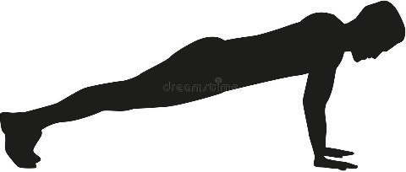0

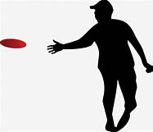
Sunday September 11th during lunch break Frisbee Toss!

See if you have what it takes to be the Frisbee Toss Champion! Get your #dontpanic Frisbee at select vendors and show office for your chance to win great prizes!
- Purchase your Frisbee at select vendors or show office
- The Frisbee that is hits the target (or is closest) WINS BIG!
- One GRAND prize winner but lots of chance to WIN
- Prizes for multiple Frisbee Toss Participants
- Prizes for multiple Frisbee Toss Participants

Sunday Time Schedule
7:00am Coaches Meeting/ Draw Horses
8:00am Schooling of Horses
8:45 Cowboy Church
9:15 am Opening Ceremonies “Never Forget”
9:15 Competition Begins:
Saturday Time Schedule
7:00am Coaches Meeting/ Draw Horses
8:00am Schooling of Horses
9:00 am Competition Begins:

CLASS ORDER SUBJECT TO CHANGE

Class 1 Elementary Pearl Rail Horsemanship
Class 2 Elementary Pearl Pattern Horsemanship
Class 3 Junior High Opal Rail Horsemanship
Class 4 Junior High Opal Pattern Horsemanship
Class 5 Junior High Emerald Rail Horsemanship
Class 6 Junior High Emerald Pattern Horsemanship
Class 7 Junior High Ruby Rail Horsemanship
Class 8 Junior High Ruby Pattern Horsemanship
Class 9 Junior High Sapphire Pattern Horsemanship
Class 10 Junior High Sapphire Division Ranch Riding Horsemanship
Class 11 Senior High Opal Rail Horsemanship
Class 12 Senior High Opal Pattern Horsemanship
Class 13 Senior High Emerald Rail Horsemanship
Class 14 Senior High Emerald Pattern Horsemanship
Class 15 Senior High Ruby Rail Horsemanship
Class 16 Senior High Ruby Pattern Horsemanship
Class 17 Senior High Sapphire Division Pattern Horsemanship
Class 18 Senior High Sapphire Division Ranch Riding Horsemanship
Class 19 Senior High Diamond Pattern Horsemanship
Class 20 Senior High Diamond Division - Reining
Class 21 EWD Amber Pattern and Rail Assisted Horsemanship
Class 22 EWD Amber Pattern and Rail Independent Horsemanship
Class 23EWD Topaz Pattern and Rail Assisted Horsemanship
Class 24 EWD Topaz Pattern and Rail Independent Horsemanship
Class 25 Alumni Emerald Horsemanship
Class 26 Alumni Emerald Pattern Horsemanship
Class 27 Alumni Sapphire Pattern Horsemanship
Class 28 Alumni Ranch Riding

Our mission is to provide an equestrian riding program for youth students, via both instructional and experiential learning opportunities. To accomplish this, we will engage in equestrian competitions, instructional clinics, networking events and occasions for recruitment that includes but not limited to scholarship disbursements.

Show Officials
Judge(s) Sept. 10th Carolyn Johnson AQHA and Sept. 11th Casey Henry AQHA
Ring Steward MTSU Equestrian Team
Show Steward Rebecca Huddleston IHSA Coach Cookeville, TN
Show Manager Courtney Smith Team NAH Murfreesboro, TN
Show Secretary Courtney Smith Team NAH Murfreesboro, TN
Announcer MTSU Equestrian Team
Medical Personal Jana Petree EMT Murfreesboro, TN

Patterns:
List which patterns you choose to use for the weekend. One number can be picked per day or you can assign a number per class or division. Below is an example from our show bills
Saturday Patterns | Class | Sunday Patterns
IHSA 10 | Senior High Diamond Reining | NRHA 2
10 | Senior High Diamond Pattern Horsemanship | 2
10 | Junior & Senior & Alumni High Sapphire Ranch Riding | 2
10 | Junior & Senior & Alumni High Sapphire Pattern Horsemanship | 2
10 | Junior & Senior High Ruby Pattern Horsemanship | 2
10 | Junior & Senior & Alumni High Emerald Pattern Horsemanship | 2
10 | Junior & Senior High Opal Pattern Horsemanship | 2
10 | Elementary Pearl Pattern Horsemanship | 2
10 | EWD Amber and Topaz Pattern Horsemanship | 2
OR

ON SATURDAY:
Pattern #10 (IHSA #10 for reining) will be used for the Senior High Diamond Reining, Senior and Junior High Sapphire Pattern/Rail Horsemanship, Ruby, Emerald, Opal, Elementary Pearl Classes, Alumni, Amber and Topaz EWD Classes.

ON SUNDAY:
Pattern #2 (NRHA #2 for reining) will be used for the Senior High Diamond Reining, Senior High Diamond Pattern/ Rail Horsemanship Class, Senior and Junior High Sapphire Pattern/Rail Horsemanship, Ruby, Emerald, Opal, Elementary Pearl Classes, Alumni, Amber and Topaz EWD Classes.

The pattern book can be found on SHOWYEDA.com
Accommodations: Below are some hotels in the area that are convenient to the facility and in a good location with lots of eating options and local shopping
Embassy Suites by Hilton 1200 Conference Center Blvd 615-890-4464
Hampton Inn and Suites 523 N Thompson Lane 615-890-2424
Home2 Suites by Hilton 90 N Thompson Lan Bldg A 615-895-2929
Holiday Inn Murfreesboro 1453 Silohill Lane 844-590-4975
Holiday Inn Express 165 Chaffin Pl 629-247-3269
Entry Information, Deadlines, and Scratch Refund Policy:

Entries will not be accepted without payment.
- Open date for entries July 25, 2022 recommended 30-60 days before the show.
- The due date for entries is August 22, 2022 recommended 2 weeks before the show.
    - It is suggested to send entries in ASAP, shows can fill up fast!
- Entries received after the due date may not be accepted.
- Entries are $40 per class.
- R40.04 Number of Entries and Limiting Entries No show should exceed 250 rides per day. Entries will be accepted on a first come basis. Meaning that entries will only be considered accepted once originals are received with horse description or horse payment and total payment for entries. Emailing entries is helpful however this will not be considered an official entry. Teams are limited to 42 total entries between Jr and Sr high teams. EWD, Pearl and 64 Alumni entries do not count toward the total number of entries (R1.01 B) Show committees may accept additional entries in the Jr and Sr high divisions from one team if the show has not exceeded the maximum number of entries by closing date.
- In the event that the maximum entries are reached entries will be accepted on a first come basis. Meaning that entries will only be considered accepted once originals are received with horse description or horse payment and total payment for entries. Emailing entries is helpful however this will not be considered an official entry.
- The Closing Date is the date in which the program will be published and any changes after the closing date will not be in the official program and will be hand written in at the coaches meeting.
- The closing date for the show is August 26, 2022 recommended within the week of the show.
- In the event you have a scratch prior to the closing date, use the Scratch and Refund Request Form to ensure a full refund. Remember, this document needs to completed in its entirety AND received by the show secretary by 5:00pm of the closing date to ensure a refund.
- Entry fees for scratches occurring after the closing date/time, will be refunded only under extraordinary circumstances. If you feel your rider/s circumstances rise to this level, you may complete a Scratch and Refund Request Form located under Coaches Forms on the YEDA Website.

Substitutions
Substitutions will be permitted providing they comply with ALL the below mentioned parameters:
- Same Day
- Same Division
- Same Class

Payment
- Please make checks payable to ____MTSU Equestrian Team_________.
- Any ‘Adds’ must be accompanied by payment
- When possible, please avoid writing multiple checks.

Events

Friday
MTSU Campus Tours please contact Ariel Higgins to reserve your team or riders tour of campus and the MTSU Horse Science program Email at Ariel.Herrin@MTSU.edu
6:00 PM “Ride the Pattern” Clinic with MTSU’s Head Coach Ariel Higgins Watch as the MTSU Equestrian team riders perform the pattern and get tips on how to prepare yourself for show day.
Saturday
Plank Challenge: In an effort to promote “Rider Fitness” Team Need A Hand has issued a PLANK CHALLENGE to all participating teams, coaches, horse providers and spectators. Be apart of the plank challenge on Saturday. During the Lunch Break we will have the Plank Challenge to see who can Plank the longest. Lots of prizes and giveaways and of course bragging rights for the Plank Master!

Sunday

Cowboy church 8:45
Opening Ceremonies “Never Forget” 9:15

Frisbee toss! Purchase as many frisbees as you want for more chances to win. During the lunch break participants will toss their Frisbee into the arena. The Frisbees closest to the target will win great prizes from our sponsors.

Rent and/or Provide a Horse
One horse is required for every six rides. For example, one rider competing in both rail and pattern class will equal two rides.
Per Rule 12.05 Horses that are considered height weight horses as defined (R16.01) will only be eligible to cover 4 rides.

If you are unable to provide enough horses to meet the needs of your entries, you may rent rides at the cost of $__35__ each.
Height/Weight:
Please take note the height/weight notification box. The show committee will follow the YEDA rulebook suggestion for Height/Weight riders. The limits for slight/older horses will be 5’9” – 160#. Height weight for Horses/Ponies 13.3 to 14.2 it is 5’5” – 135#. If the rider exceeds these either of these limits please mark the appropriate check box on the entry form. This will bring the rider to attention so that the riders height and weight can be observed in the database.
This same column is also offered on the horse description page to note which horses need to be height/weight horses. Horses who are height/weight horses are horses whom it is bad for their health or carry a rider of a size greater than 5’9” and/or 160#. Or a horse/pony between the size of 13.3 – 14.2, will have the limits of 5’5” – 135#.

Diamond Elite
The Diamond Elite class will not be offered at this horse show

Blue Raider Cup
September 10, 2022
Junior High Team
Coach Name:
Team Name:
Coach Phone Number:
Coach Email:
For Questions Contact ______  Cell: ______  Email: ______  Mail Entries to:  ______ |  |  | 9 | 10 | 7 | 8 | 5 | 6 | 3 |  | 4
 |  |  | Sapphire Pattern Horsemanship | Sapphire Ranch Riding | Ruby Rail Horsemanship | Ruby Pattern Class | Emerald Rail Horsemanship | Emerald Pattern Class | Opal Rail Horsemanship |  | Opal Pattern Class |  | $40  Per  Class
Back # | Ht Wt | Rider Name | ☐ | ☐ | ☐ | ☐ | ☐ | ☐ | ☐ |  | ☐ |  | Total $
 | ☐Ht  ☐Wt |  | ☐ | ☐ | ☐ | ☐ | ☐ | ☐ | ☐ |  | ☐
 | ☐Ht  ☐Wt |  | ☐ | ☐ | ☐ | ☐ | ☐ | ☐ | ☐ |  | ☐
 | ☐Ht  ☐Wt |  | ☐ | ☐ | ☐ | ☐ | ☐ | ☐ | ☐ |  | ☐
 | ☐Ht  ☐Wt |  | ☐ | ☐ | ☐ | ☐ | ☐ | ☐ | ☐ |  | ☐
 | ☐Ht  ☐Wt |  | ☐ | ☐ | ☐ | ☐ | ☐ | ☐ | ☐ |  | ☐
 | ☐Ht  ☐Wt |  | ☐ | ☐ | ☐ | ☐ | ☐ | ☐ | ☐ |  | ☐
 | ☐Ht  ☐Wt |  | ☐ | ☐ | ☐ | ☐ | ☐ | ☐ | ☐ |  | ☐
 | ☐Ht  ☐Wt |  | ☐ | ☐ | ☐ | ☐ | ☐ | ☐ | ☐ |  | ☐
 | ☐Ht  ☐Wt |  | ☐ | ☐ | ☐ | ☐ | ☐ | ☐ | ☐ |  | ☐
 | ☐Ht  ☐Wt |  | ☐ | ☐ | ☐ | ☐ | ☐ | ☐ | ☐ |  | ☐
If you need more room for more entries print additional entry forms Or extend the page using the inserting rows below tool. |  |  |  |  |  |  |  |  |  | Subtotal

Each Team Entry Form must contain the following statement to be signed by the Coach/ designated representative of each member team making entry.
This entry constitutes an agreement and affirmation that the team, riders, coaches, trainers and/or any affiliate, agent, and/or representative of the aforementioned individuals making entries (hereinafter collectively referred to as “Exhibitor(s)”), shall accept and abide by the rules of YEDA and of the Show, that each rider is eligible as entered. Exhibitors certify that each rider is eligible for competition in the level entered, and that Exhibitors will accept any rulings of the YEDA with respect to their conduct as final and beyond contestation. Additionally, Exhibitors agree to defend and hold YEDA, its directors, official, employees, and all persons, stables, and/or other entities providing facilities, horses or equipment for YEDA Shows and activities (hereinafter collectively referred to as “YEDA & Affiliates”), harmless for any claim action, or suit, including claim, action, or suit for injury, property damage, or death sustained during participation in the show by the entity, his/her coach, trainer or visitors.
Furthermore, Exhibitors hereby acknowledge and recognize that competing in YEDA and event and/or show is an inherently dangerous activity and may result in substantial and serious injury, including but not limited to, maiming, paralysis, and/or death, and that all of the aforementioned individuals openly and freely accept all of the potential risks association with participation in YEDA events/shows. Accordingly Exhibitors agree to waive, release, and hold harmless the YEDA & Affiliates from any and all actions, causes of action, suits, debts, promises, damages, judgments, claims, and/or demands whatsoever, in law and/or equity. In making entry into YEDA Competition or event, team and/or individuals explicitly indemnify YEDA & Affiliates from any threatened and/or actual liability, and agree to defend YEDA & Affiliates from the same.
Coaches Signature: ____________________________________________________________ Date: ________________
Blue Raider Cup
September 10, 2022
Senior High Team
Coach Name:
Team Name:
Coach Phone Number:
Coach Email:
For Questions Contact ______  Cell: ______  Email: ______  Mail Entries to:  ______ |  |  | 20 | 19 | 17 | 18 | 15 | 16 | 13 | 14 | 11 | 12
 |  |  | Diamond Reining | Diamond Pattern Horse. | Sapphire Pattern | Sapphire Ranch Riding | Ruby Rail Horsemanship | Ruby Pattern Class | Emerald Rail Horsemanship | Emerald Pattern Class | Opal Rail Horsemanship | Opal Pattern Class | $40  Per  Class
Back # | Ht Wt | Rider Name | ☐ | ☐ | ☐ | ☐ | ☐ | ☐ | ☐ | ☐ | ☐ | ☐ | Total $
 | ☐Ht  ☐Wt |  | ☐ | ☐ | ☐ | ☐ | ☐ | ☐ | ☐ | ☐ | ☐ | ☐
 | ☐Ht  ☐Wt |  | ☐ | ☐ | ☐ | ☐ | ☐ | ☐ | ☐ | ☐ | ☐ | ☐
 | ☐Ht  ☐Wt |  | ☐ | ☐ | ☐ | ☐ | ☐ | ☐ | ☐ | ☐ | ☐ | ☐
 | ☐Ht  ☐Wt |  | ☐ | ☐ | ☐ | ☐ | ☐ | ☐ | ☐ | ☐ | ☐ | ☐
 | ☐Ht  ☐Wt |  | ☐ | ☐ | ☐ | ☐ | ☐ | ☐ | ☐ | ☐ | ☐ | ☐
 | ☐Ht  ☐Wt |  | ☐ | ☐ | ☐ | ☐ | ☐ | ☐ | ☐ | ☐ | ☐ | ☐
 | ☐Ht  ☐Wt |  | ☐ | ☐ | ☐ | ☐ | ☐ | ☐ | ☐ | ☐ | ☐ | ☐
 | ☐Ht  ☐Wt |  | ☐ | ☐ | ☐ | ☐ | ☐ | ☐ | ☐ | ☐ | ☐ | ☐
 | ☐Ht  ☐Wt |  | ☐ | ☐ | ☐ | ☐ | ☐ | ☐ | ☐ | ☐ | ☐ | ☐
 | ☐Ht  ☐Wt |  | ☐ | ☐ | ☐ | ☐ | ☐ | ☐ | ☐ | ☐ | ☐ | ☐
If you need more room for more entries print additional entry forms Or extend the page using the inserting rows below tool. |  |  |  |  |  |  |  |  |  |  | Subtotal

Each Team Entry Form must contain the following statement to be signed by the Coach/ designated representative of each member team making entry.
This entry constitutes an agreement and affirmation that the team, riders, coaches, trainers and/or any affiliate, agent, and/or representative of the aforementioned individuals making entries (hereinafter collectively referred to as “Exhibitor(s)”), shall accept and abide by the rules of YEDA and of the Show, that each rider is eligible as entered. Exhibitors certify that each rider is eligible for competition in the level entered, and that Exhibitors will accept any rulings of the YEDA with respect to their conduct as final and beyond contestation. Additionally, Exhibitors agree to defend and hold YEDA, its directors, official, employees, and all persons, stables, and/or other entities providing facilities, horses or equipment for YEDA Shows and activities (hereinafter collectively referred to as “YEDA & Affiliates”), harmless for any claim action, or suit, including claim, action, or suit for injury, property damage, or death sustained during participation in the show by the entity, his/her coach, trainer or visitors.
Furthermore, Exhibitors hereby acknowledge and recognize that competing in YEDA and event and/or show is an inherently dangerous activity and may result in substantial and serious injury, including but not limited to, maiming, paralysis, and/or death, and that all of the aforementioned individuals openly and freely accept all of the potential risks association with participation in YEDA events/shows. Accordingly Exhibitors agree to waive, release, and hold harmless the YEDA & Affiliates from any and all actions, causes of action, suits, debts, promises, damages, judgments, claims, and/or demands whatsoever, in law and/or equity. In making entry into YEDA Competition or event, team and/or individuals explicitly indemnify YEDA & Affiliates from any threatened and/or actual liability, and agree to defend YEDA & Affiliates from the same.
Coaches Signature: ____________________________________________________________ Date: ________________
Blue Raider Cup
September 10, 2022
Non-Team Classes
Coach Name:
Team Name:
Coach Phone Number:
Coach Email:
For Questions Contact ______  Cell: ______  Email: ______  Mail Entries to:  ______ |  |  | 27 | 28 | 25 | 26 | 21 | 22 | 23 | 24 |  | 1 |  | 2
 |  |  | Sapphire Alumni  Rail & Patterns | Sapphire Alumni  Ranch Riding | Emerald Alumni  Rail Horsemanship | Emerald Alumni  Pattern | EWD Amber P/R Assisted | EWD Amber P/R Independent | EWD Topaz P/R Assisted | EWD Topaz P/R Independent |  | Pearl Rail Horsemanship |  | Pearl Pattern Class | $40  Per  Class
Back # | ☐ | Rider Name | ☐ | ☐ | ☐ | ☐ | ☐ | ☐ | ☐ | ☐ |  | ☐ |  | ☐ | Total $
 | ☐ |  | ☐ | ☐ | ☐ | ☐ | ☐ | ☐ | ☐ | ☐ |  | ☐ |  | ☐
 | ☐ |  | ☐ | ☐ | ☐ | ☐ | ☐ | ☐ | ☐ | ☐ |  | ☐ |  | ☐
 | ☐ |  | ☐ | ☐ | ☐ | ☐ | ☐ | ☐ | ☐ | ☐ |  | ☐ |  | ☐
 | ☐ |  | ☐ | ☐ | ☐ | ☐ | ☐ | ☐ | ☐ | ☐ |  | ☐ |  | ☐
 | ☐ |  | ☐ | ☐ | ☐ | ☐ | ☐ | ☐ | ☐ | ☐ |  | ☐ |  | ☐
 | ☐ |  | ☐ | ☐ | ☐ | ☐ | ☐ | ☐ | ☐ | ☐ |  | ☐ |  | ☐
 | ☐ |  | ☐ | ☐ | ☐ | ☐ | ☐ | ☐ | ☐ | ☐ |  | ☐ |  | ☐
 | ☐ |  | ☐ | ☐ | ☐ | ☐ | ☐ | ☐ | ☐ | ☐ |  | ☐ |  | ☐
 | ☐ |  | ☐ | ☐ | ☐ | ☐ | ☐ | ☐ | ☐ | ☐ |  | ☐ |  | ☐
 | ☐ |  | ☐ | ☐ | ☐ | ☐ | ☐ | ☐ | ☐ | ☐ |  | ☐ |  | ☐
If you need more room for more entries print additional entry forms Or extend the page using the inserting rows below tool. |  |  |  |  |  |  |  |  |  |  | Subtotal

Each Team Entry Form must contain the following statement to be signed by the Coach/ designated representative of each member team making entry.
This entry constitutes an agreement and affirmation that the team, riders, coaches, trainers and/or any affiliate, agent, and/or representative of the aforementioned individuals making entries (hereinafter collectively referred to as “Exhibitor(s)”), shall accept and abide by the rules of YEDA and of the Show, that each rider is eligible as entered. Exhibitors certify that each rider is eligible for competition in the level entered, and that Exhibitors will accept any rulings of the YEDA with respect to their conduct as final and beyond contestation. Additionally, Exhibitors agree to defend and hold YEDA, its directors, official, employees, and all persons, stables, and/or other entities providing facilities, horses or equipment for YEDA Shows and activities (hereinafter collectively referred to as “YEDA & Affiliates”), harmless for any claim action, or suit, including claim, action, or suit for injury, property damage, or death sustained during participation in the show by the entity, his/her coach, trainer or visitors.
Furthermore, Exhibitors hereby acknowledge and recognize that competing in YEDA and event and/or show is an inherently dangerous activity and may result in substantial and serious injury, including but not limited to, maiming, paralysis, and/or death, and that all of the aforementioned individuals openly and freely accept all of the potential risks association with participation in YEDA events/shows. Accordingly Exhibitors agree to waive, release, and hold harmless the YEDA & Affiliates from any and all actions, causes of action, suits, debts, promises, damages, judgments, claims, and/or demands whatsoever, in law and/or equity. In making entry into YEDA Competition or event, team and/or individuals explicitly indemnify YEDA & Affiliates from any threatened and/or actual liability, and agree to defend YEDA & Affiliates from the same.
Coaches Signature: ____________________________________________________________ Date: ________________

Blue Raider Cup
Teams must provide
1 horse for every 6 rides
1 Ht and/or Wt horse for every 4 rides
or a combination of both.
Rented rides are available for
$ ___ per ride

September 10-11, 2022
Horse Description Form

Entries will not be accepted without the inclusion of a YEDA Horse Description Form

Day Available |  | Team Name |  |  |  | Diamond Reining | Diamond Horsemanship | Sapphire & Alumni Pattern | Sapphire & Alumni Ranch Riding | Ruby Horsemanship | Ruby Pattern Class | Emerald& Alumni Horsemanship | Emerald Pattern Class | Opal Horsemanship | Opal Pattern Class | Pearl Rail Horsemanship | Pearl Pattern Class | EWD ALL CLASSES
SAT | SUN | Horse Name | Ht Wt | S  P  U  R | Description  Include: Spur option, gate information, if noted as a Ht/Wt Horse please indicates if it is a pony or slight horse, any other directions that would be helpful to the horse draw organizer or the rider.
 |  |  | ☐Ht  ☐Wt |  |  | ☐ | ☐ | ☐ | ☐ | ☐ | ☐ | ☐ | ☐ | ☐ | ☐ | ☐ | ☐ | ☐
 |  |  | ☐Ht  ☐Wt |  |  | ☐ | ☐ | ☐ | ☐ | ☐ | ☐ | ☐ | ☐ | ☐ | ☐ | ☐ | ☐ | ☐
 |  |  | ☐Ht  ☐Wt |  |  | ☐ | ☐ | ☐ | ☐ | ☐ | ☐ | ☐ | ☐ | ☐ | ☐ | ☐ | ☐ | ☐
 |  |  | ☐Ht  ☐Wt |  |  | ☐ | ☐ | ☐ | ☐ | ☐ | ☐ | ☐ | ☐ | ☐ | ☐ | ☐ | ☐ | ☐
 |  |  | ☐Ht  ☐Wt |  |  | ☐ | ☐ | ☐ | ☐ | ☐ | ☐ | ☐ | ☐ | ☐ | ☐ | ☐ | ☐ | ☒

If you need more room for more horses print additional forms. Or extend the page using the inserting rows below tool.

Blue Raider Cup
September 11, 2022
Junior High Team
Coach Name:
Team Name:
Coach Phone Number:
Coach Email:
For Questions Contact ______  Cell: ______  Email: ______  Mail Entries to:  ______ |  |  | 9 | 10 | 7 | 8 | 5 | 6 | 3 |  | 4
 |  |  | Sapphire Pattern Horsemanship | Sapphire Ranch Riding | Ruby Rail Horsemanship | Ruby Pattern Class | Emerald Rail Horsemanship | Emerald Pattern Class | Opal Rail Horsemanship |  | Opal Pattern Class |  | $40  Per  Class
Back # | Ht Wt | Rider Name | ☐ | ☐ | ☐ | ☐ | ☐ | ☐ | ☐ |  | ☐ |  | Total $
 | ☐Ht  ☐Wt |  | ☐ | ☐ | ☐ | ☐ | ☐ | ☐ | ☐ |  | ☐
 | ☐Ht  ☐Wt |  | ☐ | ☐ | ☐ | ☐ | ☐ | ☐ | ☐ |  | ☐
 | ☐Ht  ☐Wt |  | ☐ | ☐ | ☐ | ☐ | ☐ | ☐ | ☐ |  | ☐
 | ☐Ht  ☐Wt |  | ☐ | ☐ | ☐ | ☐ | ☐ | ☐ | ☐ |  | ☐
 | ☐Ht  ☐Wt |  | ☐ | ☐ | ☐ | ☐ | ☐ | ☐ | ☐ |  | ☐
 | ☐Ht  ☐Wt |  | ☐ | ☐ | ☐ | ☐ | ☐ | ☐ | ☐ |  | ☐
 | ☐Ht  ☐Wt |  | ☐ | ☐ | ☐ | ☐ | ☐ | ☐ | ☐ |  | ☐
 | ☐Ht  ☐Wt |  | ☐ | ☐ | ☐ | ☐ | ☐ | ☐ | ☐ |  | ☐
 | ☐Ht  ☐Wt |  | ☐ | ☐ | ☐ | ☐ | ☐ | ☐ | ☐ |  | ☐
 | ☐Ht  ☐Wt |  | ☐ | ☐ | ☐ | ☐ | ☐ | ☐ | ☐ |  | ☐
If you need more room for more entries print additional entry forms Or extend the page using the inserting rows below tool. |  |  |  |  |  |  |  |  |  | Subtotal

Each Team Entry Form must contain the following statement to be signed by the Coach/ designated representative of each member team making entry.
This entry constitutes an agreement and affirmation that the team, riders, coaches, trainers and/or any affiliate, agent, and/or representative of the aforementioned individuals making entries (hereinafter collectively referred to as “Exhibitor(s)”), shall accept and abide by the rules of YEDA and of the Show, that each rider is eligible as entered. Exhibitors certify that each rider is eligible for competition in the level entered, and that Exhibitors will accept any rulings of the YEDA with respect to their conduct as final and beyond contestation. Additionally, Exhibitors agree to defend and hold YEDA, its directors, official, employees, and all persons, stables, and/or other entities providing facilities, horses or equipment for YEDA Shows and activities (hereinafter collectively referred to as “YEDA & Affiliates”), harmless for any claim action, or suit, including claim, action, or suit for injury, property damage, or death sustained during participation in the show by the entity, his/her coach, trainer or visitors.
Furthermore, Exhibitors hereby acknowledge and recognize that competing in YEDA and event and/or show is an inherently dangerous activity and may result in substantial and serious injury, including but not limited to, maiming, paralysis, and/or death, and that all of the aforementioned individuals openly and freely accept all of the potential risks association with participation in YEDA events/shows. Accordingly Exhibitors agree to waive, release, and hold harmless the YEDA & Affiliates from any and all actions, causes of action, suits, debts, promises, damages, judgments, claims, and/or demands whatsoever, in law and/or equity. In making entry into YEDA Competition or event, team and/or individuals explicitly indemnify YEDA & Affiliates from any threatened and/or actual liability, and agree to defend YEDA & Affiliates from the same.
Coaches Signature: ____________________________________________________________ Date: ________________
Blue Raider Cup
September 11, 2022
Senior High Team
Coach Name:
Team Name:
Coach Phone Number:
Coach Email:
For Questions Contact ______  Cell: ______  Email: ______  Mail Entries to:  ______ |  |  | 20 | 19 | 17 | 18 | 15 | 16 | 13 | 14 | 11 | 12
 |  |  | Diamond Reining | Diamond Pattern Horse. | Sapphire Pattern | Sapphire Ranch Riding | Ruby Rail Horsemanship | Ruby Pattern Class | Emerald Rail Horsemanship | Emerald Pattern Class | Opal Rail Horsemanship | Opal Pattern Class | $40  Per  Class
Back # | Ht Wt | Rider Name | ☐ | ☐ | ☐ | ☐ | ☐ | ☐ | ☐ | ☐ | ☐ | ☐ | Total $
 | ☐Ht  ☐Wt |  | ☐ | ☐ | ☐ | ☐ | ☐ | ☐ | ☐ | ☐ | ☐ | ☐
 | ☐Ht  ☐Wt |  | ☐ | ☐ | ☐ | ☐ | ☐ | ☐ | ☐ | ☐ | ☐ | ☐
 | ☐Ht  ☐Wt |  | ☐ | ☐ | ☐ | ☐ | ☐ | ☐ | ☐ | ☐ | ☐ | ☐
 | ☐Ht  ☐Wt |  | ☐ | ☐ | ☐ | ☐ | ☐ | ☐ | ☐ | ☐ | ☐ | ☐
 | ☐Ht  ☐Wt |  | ☐ | ☐ | ☐ | ☐ | ☐ | ☐ | ☐ | ☐ | ☐ | ☐
 | ☐Ht  ☐Wt |  | ☐ | ☐ | ☐ | ☐ | ☐ | ☐ | ☐ | ☐ | ☐ | ☐
 | ☐Ht  ☐Wt |  | ☐ | ☐ | ☐ | ☐ | ☐ | ☐ | ☐ | ☐ | ☐ | ☐
 | ☐Ht  ☐Wt |  | ☐ | ☐ | ☐ | ☐ | ☐ | ☐ | ☐ | ☐ | ☐ | ☐
 | ☐Ht  ☐Wt |  | ☐ | ☐ | ☐ | ☐ | ☐ | ☐ | ☐ | ☐ | ☐ | ☐
 | ☐Ht  ☐Wt |  | ☐ | ☐ | ☐ | ☐ | ☐ | ☐ | ☐ | ☐ | ☐ | ☐
If you need more room for more entries print additional entry forms Or extend the page using the inserting rows below tool. |  |  |  |  |  |  |  |  |  |  | Subtotal

Each Team Entry Form must contain the following statement to be signed by the Coach/ designated representative of each member team making entry.
This entry constitutes an agreement and affirmation that the team, riders, coaches, trainers and/or any affiliate, agent, and/or representative of the aforementioned individuals making entries (hereinafter collectively referred to as “Exhibitor(s)”), shall accept and abide by the rules of YEDA and of the Show, that each rider is eligible as entered. Exhibitors certify that each rider is eligible for competition in the level entered, and that Exhibitors will accept any rulings of the YEDA with respect to their conduct as final and beyond contestation. Additionally, Exhibitors agree to defend and hold YEDA, its directors, official, employees, and all persons, stables, and/or other entities providing facilities, horses or equipment for YEDA Shows and activities (hereinafter collectively referred to as “YEDA & Affiliates”), harmless for any claim action, or suit, including claim, action, or suit for injury, property damage, or death sustained during participation in the show by the entity, his/her coach, trainer or visitors.
Furthermore, Exhibitors hereby acknowledge and recognize that competing in YEDA and event and/or show is an inherently dangerous activity and may result in substantial and serious injury, including but not limited to, maiming, paralysis, and/or death, and that all of the aforementioned individuals openly and freely accept all of the potential risks association with participation in YEDA events/shows. Accordingly Exhibitors agree to waive, release, and hold harmless the YEDA & Affiliates from any and all actions, causes of action, suits, debts, promises, damages, judgments, claims, and/or demands whatsoever, in law and/or equity. In making entry into YEDA Competition or event, team and/or individuals explicitly indemnify YEDA & Affiliates from any threatened and/or actual liability, and agree to defend YEDA & Affiliates from the same.
Coaches Signature: ____________________________________________________________ Date: ________________
Blue Raider Cup
September 11, 2022
Non-Team Classes
Coach Name:
Team Name:
Coach Phone Number:
Coach Email:
For Questions Contact ______  Cell: ______  Email: ______  Mail Entries to:  ______ |  |  | 27 | 28 | 25 | 26 | 21 | 22 | 23 | 24 |  | 1 |  | 2
 |  |  | Sapphire Alumni  Rail & Patterns | Sapphire Alumni  Ranch Riding | Emerald Alumni  Rail Horsemanship | Emerald Alumni  Pattern | EWD Amber P/R Assisted | EWD Amber P/R Independent | EWD Topaz P/R Assisted | EWD Topaz P/R Independent |  | Pearl Rail Horsemanship |  | Pearl Pattern Class | $40  Per  Class
Back # | ☐ | Rider Name | ☐ | ☐ | ☐ | ☐ | ☐ | ☐ | ☐ | ☐ |  | ☐ |  | ☐ | Total $
 | ☐ |  | ☐ | ☐ | ☐ | ☐ | ☐ | ☐ | ☐ | ☐ |  | ☐ |  | ☐
 | ☐ |  | ☐ | ☐ | ☐ | ☐ | ☐ | ☐ | ☐ | ☐ |  | ☐ |  | ☐
 | ☐ |  | ☐ | ☐ | ☐ | ☐ | ☐ | ☐ | ☐ | ☐ |  | ☐ |  | ☐
 | ☐ |  | ☐ | ☐ | ☐ | ☐ | ☐ | ☐ | ☐ | ☐ |  | ☐ |  | ☐
 | ☐ |  | ☐ | ☐ | ☐ | ☐ | ☐ | ☐ | ☐ | ☐ |  | ☐ |  | ☐
 | ☐ |  | ☐ | ☐ | ☐ | ☐ | ☐ | ☐ | ☐ | ☐ |  | ☐ |  | ☐
 | ☐ |  | ☐ | ☐ | ☐ | ☐ | ☐ | ☐ | ☐ | ☐ |  | ☐ |  | ☐
 | ☐ |  | ☐ | ☐ | ☐ | ☐ | ☐ | ☐ | ☐ | ☐ |  | ☐ |  | ☐
 | ☐ |  | ☐ | ☐ | ☐ | ☐ | ☐ | ☐ | ☐ | ☐ |  | ☐ |  | ☐
 | ☐ |  | ☐ | ☐ | ☐ | ☐ | ☐ | ☐ | ☐ | ☐ |  | ☐ |  | ☐
If you need more room for more entries print additional entry forms Or extend the page using the inserting rows below tool. |  |  |  |  |  |  |  |  |  |  | Subtotal

Each Team Entry Form must contain the following statement to be signed by the Coach/ designated representative of each member team making entry.
This entry constitutes an agreement and affirmation that the team, riders, coaches, trainers and/or any affiliate, agent, and/or representative of the aforementioned individuals making entries (hereinafter collectively referred to as “Exhibitor(s)”), shall accept and abide by the rules of YEDA and of the Show, that each rider is eligible as entered. Exhibitors certify that each rider is eligible for competition in the level entered, and that Exhibitors will accept any rulings of the YEDA with respect to their conduct as final and beyond contestation. Additionally, Exhibitors agree to defend and hold YEDA, its directors, official, employees, and all persons, stables, and/or other entities providing facilities, horses or equipment for YEDA Shows and activities (hereinafter collectively referred to as “YEDA & Affiliates”), harmless for any claim action, or suit, including claim, action, or suit for injury, property damage, or death sustained during participation in the show by the entity, his/her coach, trainer or visitors.
Furthermore, Exhibitors hereby acknowledge and recognize that competing in YEDA and event and/or show is an inherently dangerous activity and may result in substantial and serious injury, including but not limited to, maiming, paralysis, and/or death, and that all of the aforementioned individuals openly and freely accept all of the potential risks association with participation in YEDA events/shows. Accordingly Exhibitors agree to waive, release, and hold harmless the YEDA & Affiliates from any and all actions, causes of action, suits, debts, promises, damages, judgments, claims, and/or demands whatsoever, in law and/or equity. In making entry into YEDA Competition or event, team and/or individuals explicitly indemnify YEDA & Affiliates from any threatened and/or actual liability, and agree to defend YEDA & Affiliates from the same.
Coaches Signature: ____________________________________________________________ Date: ________________
Account Summary

Blue Raider Cup
September 10-11, 2022

Team: ___________________________________________________________

SATURDAY | # of Rides |  | Subtotal
Saturday Junior High | __________ | X $40 | $_________
Saturday Senior High | __________ | X $40 | $_________
Saturday Non-Team Entries | __________ | X $40 | $_________
Entry Subtotals | __________ |  | $_________

# of rides providing | __________
# of rented rides needed on Saturday  Number of entries – (Number of riders) | __________ | X $____ | $_________

SUNDAY | # of Rides |  | Subtotal
Sunday Junior High | __________ | X $40 | $_________
Sunday Senior High | __________ | X $40 | $_________
Sunday Non-Team Entries | __________ | X $40 | $_________
Entry Subtotals | __________ |  | $_________

# of rides providing | __________
# of rented rides needed on Sunday  Number of entries – (Number of riders) | __________ | X $____ | $_________

Add up all subtotals

____________ | ____________ | ____________ | ____________ | ____________
Saturday Entries + | Saturday Rented Rides + | Sunday Entries + | Sunday Rented Rides = | Total Amount Due

Please make checks payable to: ____________ Due date for entries and payment is_____________________

Office Use:
Date Received: _________________ Check # _____________________

