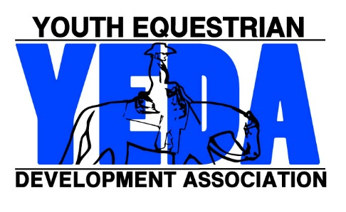
Team Registration Checklist

This form is for your personal use and does not need mailed in ..

Coach Paperwork Checklist
- Team Membership Form
- Coach Membership Form
- Proof of Coaches Liability Insurance
- Assistant Coach Membership Form (Optional)
Rider Membership Checklist
- Rider Membership and Placement Form
- Shirt Order Form
- Scholarship Incentive Fund Application Available to all riders 4-12 (Optional)
EWD Rider Membership Checklist
- Rider Membership and Placement Form
- Shirt Order Form
- Scholarship Incentive Fund Application Available to all riders 4-12 (Optional)
- YEDA Diagnosis Form
- YEDA Adaptive Equipment Form

Welcome to YEDA!
For more information or extra forms visit www.showyeda.com

