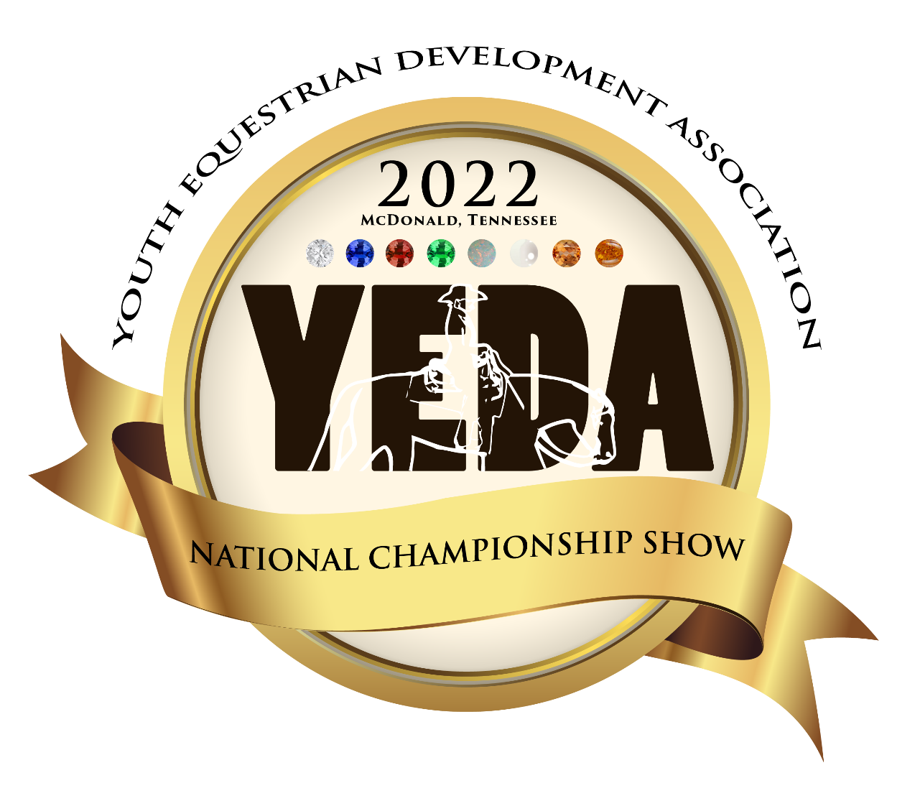

June 23-26, 2022
THURSDAY – FRIDAY – SATURDAY – SUNDAY

SHOWBILL Catalog

Tri-State Exhibition Center
200 Natures Trail SW
McDonald, TN 37353

Tri – State Exhibition Center Information

Address: 200 Natures Trail, McDonald, TN 37303

Directions: 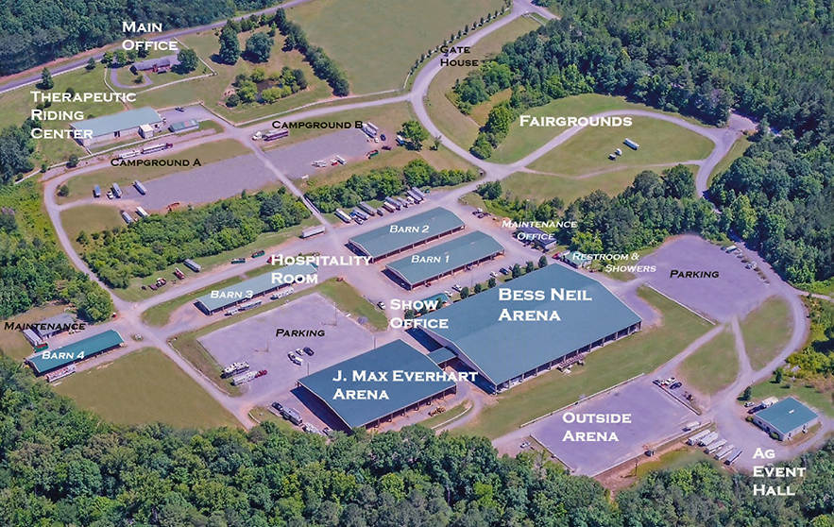
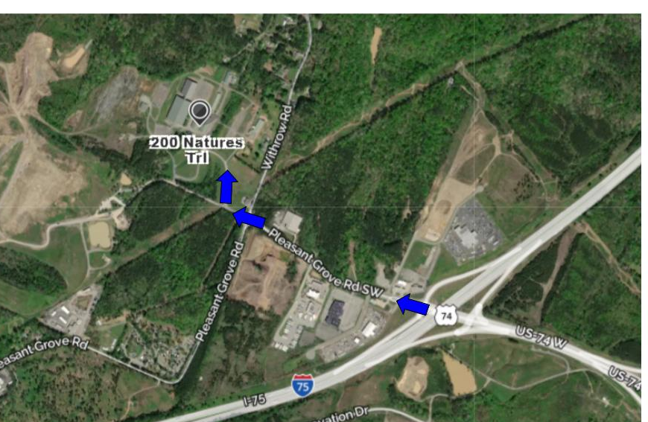
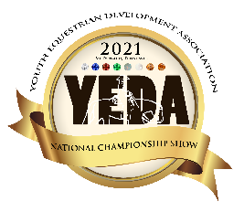 | Show Officials | 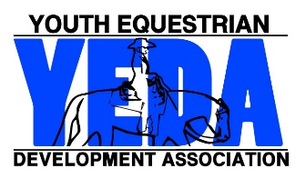

The Judges

Judge A:  Lori Gordon | Judge B:  Debra Jones Wright | Judge C:  Carolyn Johnson | Judge D:  Tony Kennedy

Stewards
Show Stewards  Jenna Kingery  National Steward  Stephanie Steiner  Becky Huddleston  Ashley Wilson | Ring Stewards  Jay Lanzer  Lauren Brown  Jordan Martin  Cory Elks

Announcer  Bess Neil Arena  Kent Morris |  | Announcer  J. Max Everhart Arena  Paul Hartschuh
Show Manager  Molly Niese | Show Secretary  Brandy Napier |  | Point Secretary  Haley Hartschuh

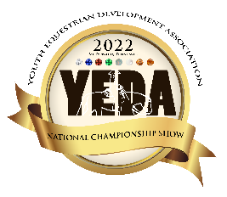 | June 23-26, 2022
YEDA MISSION STATEMENT
Our mission is to provide an equestrian riding program for youth students, via both instructional and experiential learning opportunities. To accomplish this we will engage in equestrian competitions, instructional clinics, networking events and occasions for recruitment that includes but not limited to scholarship disbursements.

National Championship Weekend Patterns

State Invitational: All Classes Pattern # 6
Individual Classes: All Classes Pattern #8
Team Classes: All Classes Pattern #4
Diamond Elite: Pattern #12
Note: All Reining classes will use the NRHA Patterns

The pattern book can be found on SHOWYEDA.com

Watch Live:
Live Feed will be available through YEDA’s YouTube channel provided by Brian Bode. More details to come soon.
TEAM DOOR DECORATIONS CONTESTS:
All YEDA Teams will be given a dressing room to store their items during the show. We would like to invite ALL teams to participate in a door decorating contest that captures the essence of your team and YEDA. Teams will create a door decoration that will cover the exterior of their dressing room door facing the aisle and exterior.
YEDA Door Decorating Contest and Judges Rubric 2022
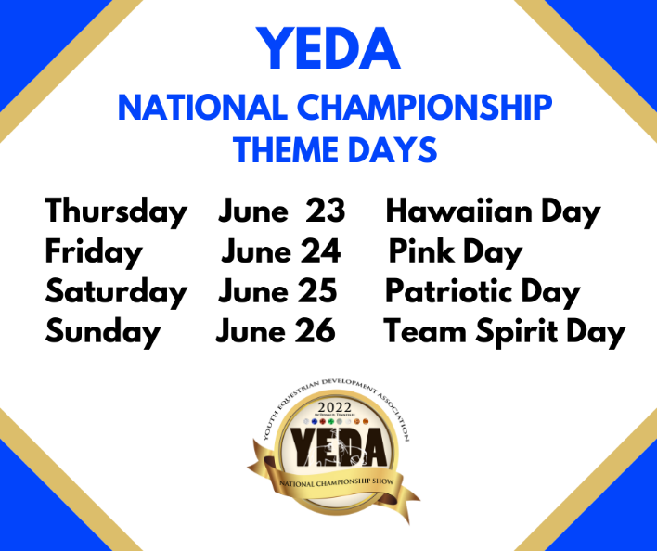

Time Schedule
June 23-26, 2022

Wednesday, June 22:  - Horse Check-In  - YEDA Royalty Competition Starts at 1 PM  - Coaches Welcome and Intro Meeting  4pm-4:45pm  - Horse Warmup at 5 pm  Thursday June 23:  THEME: Hawaiian Day  - 6:00 am Draw – All Coaches invited, not required  - 7:00 am Coaches Meeting  - 7:45 am Horse Warm Up  - 8:45am Clear Arena and Drag, Conclusion of drag: Opening Ceremony  - 9:00am Invitational Begins  - During Lunch Break Present YEDA Royalty Court  - Awards Presentation: Sportsmanship, Good Grooming and Horse of the Day  Friday June 24: Morning  THEME: Pink Day  - 6:00 am Draw – All Coaches invited, not required  - 7:00 am Coaches Meeting  - 7:45 am Horse Warm Up  - 8:45am Clear Arena and Drag, Conclusion of drag: Opening Ceremony  - 9:00am Individual Championship Day begins  - Lunch Break: TETWP Durango Boot Races  - Presentation: Sportsmanship, Good Grooming and Horse of the Day | Saturday June 25th:  THEME: Patriotic Day  - 6:00 am Draw – All Coaches invited, not required  - 7:00 am Coaches Meeting  - 7:45 am Horse Warm Up  - 8:45 am Clear Arena and Drag, Conclusion of drag: Opening Ceremony  - 9:00 am Finish the Individual Competition and begin  - Team Competition  - Lunch Break  - Chip Jackson Memorial Coaches Calcutta  - Awards Presentation: High Point Rider Awards, Sportsmanship, Good Grooming and Horse of the Day  Sunday June 26th:  THEME: Team Spirit Day  - 6:00 am Draw – All Coaches invited, not required  - 7:00 am Coaches Meeting  - 7:30 am Horse Warm Up  - 8:15-8:45 Cowboy Church  - 8:45 am Clear Arena and Drag, Conclusion of drag: Opening Ceremony  - 9:00 am Show Begins finish Team Competition  - Lunch Break: Presentation of Scholarships  - At the Conclusion of the show: Parade of Teams  - Awards Presentation: Team Awards, Sportsmanship, Good Grooming and Horse of the Day.

Thursday June 23, 2022  State Invitational  2 Arenas | - 6:00 am Draw – All Coaches invited, not required.  - 7:00 am Coaches Meeting  - 7:45 am Horse Warm Up  - 8:45am Clear Arena / Drag, Conclusion of drag: Opening Ceremony  - 9:00am Invitational Begins  THEME: Hawaiian Day

Tentative Class Order – Final order and classes will be determined after the last regular season qualifying show.
Bess Neil Arena  - Invitational Grp. 20 Diamond Reining  - Invitational Grp. 15 SR High Ruby Rail HMS Split A  - Invitational Grp. 15 SR High Ruby Rail HMS Split B  - Invitational Grp. 7 JR High Ruby Rail HMS  - Invitational Grp. 11 SR High Opal Rail HMS  - Invitational Grp. 3 JR High Opal Rail HMS Split A  - Invitational Grp. 3 JR High Opal Rail HMS Split B  - Invitational Grp. 1 Elem. Pearl Rail HMS Split A  - Invitational Grp. 1 Elem. Pearl Rail HMS Split B  - Invitational Grp. 13 SR High Emerald Rail HMS Split A  - Invitational Grp. 13 SR High Emerald Rail HMS Split B  - Invitational Grp. 5 JR High Emerald Rail HMS Split A  - Invitational Grp. 5 JR High Emerald Rail HMS Split B  - Invitational Grp. 18 SR High Sapphire Division Ranch Riding  - Invitational Grp. 1 Elem. Pearl Rail HMS Finals  - Invitational Grp. 10 JR High Sapphire Ranch Riding  - Invitational Grp. 28 Alumni Sapphire Ranch Riding  - Invitational Grp. 15 SR High Ruby Rail HMS Finals  - Invitational Grp. 3 JR High Opal Rail HMS Finals  - Invitational Grp. 5 JR High Emerald Rail HMS Finals  - Invitational Grp. 13 SR High Emerald Rail HMS Finals |  | J. Max Everhart Arena  - Invitational Grp. 25 Alumni Emerald Rail HMS  - Invitational Grp. 17 SR High Sapphire Pattern HMS  - Invitational Grp. 9 JR High Sapphire Pattern HMS  - Invitational Grp. 27 Alumni Sapphire Pattern HMS  - Invitational Grp. 6 JR High Emerald Pattern HMS  - Invitational Grp. 14 SR High Emerald Pattern HMS  - Invitational Grp. 27 Alumni Emerald Pattern HMS  - Invitational Grp. 4 JR High Opal Pattern HMS  - Invitational Grp. 12 SR High Opal Pattern HMS  - Invitational Grp. 2 Elementary Pearl Pattern HMS  - Invitational Grp. 19 SR High Diamond Pattern HMS  - Invitational Grp. 8 JR High Ruby Pattern  HMS  - Invitational Grp. 16 SR High Ruby Pattern HMS  During the Lunch Break  Time will be announced during the show.  YEDA Royalty Court Presentation  Awards Presentation  Sportsmanship  Schneiders Best Groomed Horse  Valley Vet Horse of the Day
Friday June 24, 2022  Individual National Championship  2 Arenas | - 6:00 am Draw – All Coaches invited, not required.  - 7:00 am Coaches Meeting  - 7:45 am Horse Warm Up  - 8:45am Clear Arena / Drag Opening Ceremony  - 9:00am Show Begins  THEME: Pink Day

Tentative Class Order – Final order and classes will be determined after the last regular season qualifying show.
Bess Neil Arena  - Individual Grp 20 Diamond Reining  - Individual Grp 15 SR High Ruby Rail HMS Split A  - Individual Grp 15 SR High Ruby Rail HMS Split B  - Individual Grp 7 JR High Ruby Rail HMS  - Individual Grp 3 JR High Opal Rail HMS Split A  - Individual Grp 3 JR High Opal Rail HMS Split B  - Individual Grp 3 JR High Opal Rail HMS Split A  - Individual Grp 1 Elem. Pearl Rail HMS Split A  - Individual Grp 1 Elem. Pearl Rail HMS Split B  - Individual Grp 1 Elem. Pearl Rail HMS Split C  - Individual Grp 28 Alumni Sapphire Division Ranch Riding  - Individual Grp 10 JR High Sapphire Division Ranch Riding  - Individual Grp 13 SR High Emerald Rail HMS Split A  - Individual Grp 13 SR High Emerald Rail HMS Split B  - Individual Grp 25 Alumni Emerald Rail HMS  - Individual Grp 5 JR High Emerald Rail HMS Split B  - Individual Grp 5 JR High Emerald Rail HMS Split A  - Individual Grp 5 JR High Emerald Rail HMS Split C  - Individual Grp 15 SR High Ruby Rail HMS Finals | J. Max Everhart Arena  - Individual Grp 26 Alumni Emerald Pattern HMS  - Individual Grp 14 SR High Emerald Pattern HMS  - Individual Grp 6 JR High Emerald Pattern HMS  - Individual Grp 24 EWD Topaz Pattern and Rail Independent HMS  - Individual Grp 27 Alumni Sapphire Pattern HMS  - Individual Grp 25 EWD Topaz Pattern and Rail Assisted HMS  - Individual Grp 16 SR High Ruby Pattern HMS  - Individual Grp 8 JR High Ruby Pattern HMS  - Individual Grp 23 EWD Amber Pattern and Rail Assisted HMS  - Individual Grp 22 EWD Amber Pattern and Rail Independent HMS  - Individual Grp 2 Elem. Pearl Pattern HMS  - Individual Grp 12 SR High Opal Pattern HMS  - Individual Grp 4 JR High Opal Pattern HMS  During Lunch Break  Time will be announced during the show.  Tough Enough to Wear Pink Durango Boot Races  After the Show Awards Presentation  Sportsmanship  Schneiders Best Groomed Horse  Valley Vet Horse of the Day

Saturday June 25, 2022  Individual & Team National Championship  1 Arena  Bess Neil Arena | - 6:00 am Draw – All Coaches invited, not required.  - 7:00 am Coaches Meeting  - 7:45 am Horse Warm Up  - 8:45am Clear Arena / Drag, Opening Ceremony  - 9:00am Show Begins  THEME: Patriotic Day
Tentative Class Order – Final order and classes will be determined after the last regular season qualifying show.

- Individual Grp 18 Senior High Sapphire Division Ranch Riding
- Individual Grp 11 Senior High Opal Rail Horsemanship
- Individual Grp 19 Senior High Diamond Pattern Horsemanship
- Individual Grp 3 Junior High Opal Rail Horsemanship Finals
- Individual Grp 10 Junior High Sapphire Pattern Horsemanship
- Individual Grp 1 Elementary Pearl Rail Horsemanship Finals
- Individual Grp 13 Senior High Emerald Rail Horsemanship Finals
- Individual Grp 5 Junior High Emerald Rail Horsemanship Finals
- Individual Group 17 Senior High Sapphire Pattern Horsemanship

- Team Grp 20 Senior High Diamond Division – Reining
- Team Grp 12 Senior High Opal Pattern Horsemanship
- Team Grp 4 Junior High Opal Pattern Horsemanship
- Team Grp 15 Senior High Ruby Rail Horsemanship
During Lunch Break
Time will be announced during the show.
Chip Jackson Memorial Coaches Calcutta

After the Show Awards Presentation
Ag Pro Senior High Point Rider Awards
Ag Pro Junior High Point Rider Awards
Sportsmanship
Schneiders Best Groomed Horse
Valley Vet Horse of the Day
Sunday June 26, 2022  Team National Championship  1 Arena  Bess Neil Arena | - 6:00 am Draw – All Coaches invited, not required.  - 7:00 am Coaches Meeting  - 7:30 am Horse Warm Up  - 8:15-8:45 Cowboy Church  - 8:45 am Clear Arena /Drag Opening Ceremony  - 9:00 am Show Begins finish Team Competition  THEME: Team Spirit Day

Tentative Class Order – Final order and classes will be determined after the last regular season qualifying show.

- Team Grp 18 Senior High Sapphire Ranch Riding
- Team Grp 7 Junior High Ruby Rail Horsemanship
- Team Grp 10 Junior Sapphire Ranch Riding
- Team Grp 14 Senior High Emerald Pattern Horsemanship
- Team Grp 6 Junior High Emerald Pattern Horsemanship
- Team Grp 11 Senior High Opal Rail Horsemanship
- Team Grp 3 Junior High Opal Rail Horsemanship
- Team Grp 19 Senior High Diamond Pattern Horsemanship
- Team Grp 5 Junior High Emerald Rail Horsemanship
- Team Grp 13 Senior High Emerald Rail Horsemanship
- Team Grp 16 Senior High Ruby Pattern Horsemanship
- Team Grp 8 Junior High Ruby Pattern Horsemanship
- Team Grp 9 Junior High Sapphire Pattern Horsemanship
- Team Grp 18 Senior High Sapphire Pattern Horsemanship
- Individual Grp 22 Diamond Elite Horsemanship
During Lunch Break
Time will be announced during the show.
Presentation of Scholarships

After the Show Awards Presentation
Parade of Teams
Ag Pro Senior High Point Team Awards
Ag Pro Junior High Point Team Awards
Sportsmanship
Schneiders Best Groomed Horse
Valley Vet Horse of the Day

Entry Information, Deadlines, and Scratch Refund Policy:

Please email all entries by May 20th. This is necessary to invite other riders in the event that a qualifier chooses not to participate.

- The due date for hard copy entries and payment is May 27, 2022.
- Entries received after the due date may not be accepted.
- The Closing Date is the date in which the program will be published and any changes after the closing date will not be in the official program and will be hand written in at the coaches meeting.
- The closing date for the show is 8:00am May 30, 2022. In the event you have a scratch prior to the closing date, use the attached Pre-Closing Date Refund Request Form to ensure a full refund. Remember, this document needs to complete in its entirety AND received by the show secretary by 8:00am of the closing date to ensure a refund.
- Entry fees for scratches occurring after the closing date/time, will be refunded only under extraordinary circumstances. If you feel your rider/s circumstances rise to this level, you may complete a Post-Closing Date Refund Request Form located under Coaches Forms on the YEDA Website. Your request will be reviewed and voted on the first scheduled meeting following its receipt. You will be notified of the results within two business days of the vote. In the event a refund is to be issued, a check will be mailed within two weeks of the vote.

Substitutions
Substitutions will be permitted for team classes only providing they comply with ALL the listed parameters, same day, same division, same class.

Diamond Elite
All High School Teams who qualified for can have a Diamond Elite Rider participate in Sunday’s Diamond Elite class.

Payment
- $70 per entry + $10 Office Fee + $10 Media Fee
- Please make checks payable to 'YEDA'.
- When possible, please avoid writing multiple checks.

Rent and/or Provide a Horse
1 horse is required for every 12 rides for the entire show. 1 height weight horse will cover 8 rides for the entire show. (This is not per day, add up your total entries for the entries show to determine your rides) For example, one rider competing in both rail and pattern class will equal two rides. If you are unable to provide enough horses to meet the needs of your entries, you may rent rides at the cost of $50 each. Horses need to be provided or rental fee must be paid for all rides including riders who qualify for nationals through the invitational on Friday and diamond elite.

Height/Weight:
Please take note the height/weight notification box. The show committee will follow the YEDA rulebook suggestion for Height/Weight riders. The limits for slight/older horses will be 5’9” – 160#. Please avoid brining horses and ponies between the size of 13.3 – 14.2. If the rider exceeds these either of these limits, please mark the appropriate check box on the entry form. This will bring the rider to attention so that the riders height and weight can be observed in the database.
This same column is also offered on the horse description page to note which horses need to be height/weight horses. Horses who are height/weight horses are horses whom it is bad for their health or carry a rider of a size greater than 5’9” and/or 160#. Please avoid brining horses and ponies between the size of 13.3 – 14.2.
It is very important that you try to provide horses Wednesday Evening through Sunday, because of the warmup and to use the horses to their full potential. There will be great consideration used to not overuse the horses throughout the week! If you cannot provide your horses for the full show, please contact a YEDA Founder to discuss options.
National Championship State Invitational
Thursday, June 23, 2022
Junior High Team
Coach Name:
Team Name:
Coach Phone Number:
Coach Email:
For Questions Contact Laura Smith Cell: 419-957-9054  Email: niesem72@gmail.com  Mail Entries to:  Molly Niese  18390 St Rt 568  Findlay, Ohio 45840 |  |  | 9 | 10 | 7 | 8 | 5 | 6 | 3 |  | 4
 |  |  | Sapphire Pattern Horsemanship | Sapphire Ranch Riding | Ruby Rail Horsemanship | Ruby Pattern Class | Emerald Rail Horsemanship | Emerald Pattern Class | Opal Rail Horsemanship |  | Opal Pattern Class |  | $90  Per  Class
Back # | Ht Wt | Rider Name |  |  |  |  |  |  |  |  |  |  | Total $
 | ☐Ht  ☐Wt |  | ☐ | ☐ | ☐ | ☐ | ☐ | ☐ | ☐ |  | ☐
 | ☐Ht  ☐Wt |  | ☐ | ☐ | ☐ | ☐ | ☐ | ☐ | ☐ |  | ☐
 | ☐Ht  ☐Wt |  | ☐ | ☐ | ☐ | ☐ | ☐ | ☐ | ☐ |  | ☐
 | ☐Ht  ☐Wt |  | ☐ | ☐ | ☐ | ☐ | ☐ | ☐ | ☐ |  | ☐
 | ☐Ht  ☐Wt |  | ☐ | ☐ | ☐ | ☐ | ☐ | ☐ | ☐ |  | ☐
 | ☐Ht  ☐Wt |  | ☐ | ☐ | ☐ | ☐ | ☐ | ☐ | ☐ |  | ☐
 | ☐Ht  ☐Wt |  | ☐ | ☐ | ☐ | ☐ | ☐ | ☐ | ☐ |  | ☐
 | ☐Ht  ☐Wt |  | ☐ | ☐ | ☐ | ☐ | ☐ | ☐ | ☐ |  | ☐
 | ☐Ht  ☐Wt |  | ☐ | ☐ | ☐ | ☐ | ☐ | ☐ | ☐ |  | ☐
 | ☐Ht  ☐Wt |  | ☐ | ☐ | ☐ | ☐ | ☐ | ☐ | ☐ |  | ☐
If you need more room for more entries print additional entry forms Or extend the page using the inserting rows below tool. |  |  |  |  |  |  |  |  |  | Subtotal
Each Team Entry Form must contain the following statement to be signed by the Coach/ designated representative of each member team making entry.
This entry constitutes an agreement and affirmation that the team, riders, coaches, trainers and/or any affiliate, agent, and/or representative of the aforementioned individuals making entries (hereinafter collectively referred to as “Exhibitor(s)”), shall accept and abide by the rules of YEDA and of the Show, that each rider is eligible as entered. Exhibitors certify that each rider is eligible for competition in the level entered, and that Exhibitors will accept any rulings of the YEDA with respect to their conduct as final and beyond contestation. Additionally, Exhibitors agree to defend and hold YEDA, its directors, official, employees, and all persons, stables, and/or other entities providing facilities, horses or equipment for YEDA Shows and activities (hereinafter collectively referred to as “YEDA & Affiliates”), harmless for any claim action, or suit, including claim, action, or suit for injury, property damage, or death sustained during participation in the show by the entity, his/her coach, trainer or visitors.
Furthermore, Exhibitors hereby acknowledge and recognize that competing in YEDA and event and/or show is an inherently dangerous activity and may result in substantial and serious injury, including but not limited to, maiming, paralysis, and/or death, and that all of the aforementioned individuals openly and freely accept all of the potential risks association with participation in YEDA events/shows. Accordingly Exhibitors agree to waive, release, and hold harmless the YEDA & Affiliates from any and all actions, causes of action, suits, debts, promises, damages, judgments, claims, and/or demands whatsoever, in law and/or equity. In making entry into YEDA Competition or event, team and/or individuals explicitly indemnify YEDA & Affiliates from any threatened and/or actual liability, and agree to defend YEDA & Affiliates from the same.
Coaches Signature: ____________________________________________________________ Date: ________________
National Championship State Invitational
Thursday, June 23, 2022
Senior High Team
Coach Name:
Team Name:
Coach Phone Number:
Coach Email:
For Questions Contact Laura Smith Cell: 419-957-9054  Email: niesem72@gmail.com  Mail Entries to:  Molly Niese  18390 St Rt 568  Findlay, Ohio 45840 |  |  | 20 | 19 | 17 | 18 | 15 | 16 | 13 | 14 | 11 | 12
 |  |  | Diamond Reining | Diamond Pattern Horsemanship | Sapphire Pattern Horsemanship | Sapphire Ranch Riding | Ruby Rail Horsemanship | Ruby Pattern Class | Emerald Rail Horsemanship | Emerald Pattern Class | Opal Rail Horsemanship | Opal Pattern Class | $90  Per  Class
Back # | Ht Wt | Rider Name |  |  |  |  |  |  |  |  |  |  | Total $
 | ☐Ht  ☐Wt |  | ☐ | ☐ | ☐ | ☐ | ☐ | ☐ | ☐ | ☐ | ☐ | ☐
 | ☐Ht  ☐Wt |  | ☐ | ☐ | ☐ | ☐ | ☐ | ☐ | ☐ | ☐ | ☐ | ☐
 | ☐Ht  ☐Wt |  | ☐ | ☐ | ☐ | ☐ | ☐ | ☐ | ☐ | ☐ | ☐ | ☐
 | ☐Ht  ☐Wt |  | ☐ | ☐ | ☐ | ☐ | ☐ | ☐ | ☐ | ☐ | ☐ | ☐
 | ☐Ht  ☐Wt |  | ☐ | ☐ | ☐ | ☐ | ☐ | ☐ | ☐ | ☐ | ☐ | ☐
 | ☐Ht  ☐Wt |  | ☐ | ☐ | ☐ | ☐ | ☐ | ☐ | ☐ | ☐ | ☐ | ☐
 | ☐Ht  ☐Wt |  | ☐ | ☐ | ☐ | ☐ | ☐ | ☐ | ☐ | ☐ | ☐ | ☐
 | ☐Ht  ☐Wt |  | ☐ | ☐ | ☐ | ☐ | ☐ | ☐ | ☐ | ☐ | ☐ | ☐
 | ☐Ht  ☐Wt |  | ☐ | ☐ | ☐ | ☐ | ☐ | ☐ | ☐ | ☐ | ☐ | ☐
 | ☐Ht  ☐Wt |  | ☐ | ☐ | ☐ | ☐ | ☐ | ☐ | ☐ | ☐ | ☐ | ☐
If you need more room for more entries print additional entry forms Or extend the page using the inserting rows below tool. |  |  |  |  |  |  |  |  |  |  | Subtotal
Each Team Entry Form must contain the following statement to be signed by the Coach/ designated representative of each member team making entry.
This entry constitutes an agreement and affirmation that the team, riders, coaches, trainers and/or any affiliate, agent, and/or representative of the aforementioned individuals making entries (hereinafter collectively referred to as “Exhibitor(s)”), shall accept and abide by the rules of YEDA and of the Show, that each rider is eligible as entered. Exhibitors certify that each rider is eligible for competition in the level entered, and that Exhibitors will accept any rulings of the YEDA with respect to their conduct as final and beyond contestation. Additionally, Exhibitors agree to defend and hold YEDA, its directors, official, employees, and all persons, stables, and/or other entities providing facilities, horses or equipment for YEDA Shows and activities (hereinafter collectively referred to as “YEDA & Affiliates”), harmless for any claim action, or suit, including claim, action, or suit for injury, property damage, or death sustained during participation in the show by the entity, his/her coach, trainer or visitors.
Furthermore, Exhibitors hereby acknowledge and recognize that competing in YEDA and event and/or show is an inherently dangerous activity and may result in substantial and serious injury, including but not limited to, maiming, paralysis, and/or death, and that all of the aforementioned individuals openly and freely accept all of the potential risks association with participation in YEDA events/shows. Accordingly Exhibitors agree to waive, release, and hold harmless the YEDA & Affiliates from any and all actions, causes of action, suits, debts, promises, damages, judgments, claims, and/or demands whatsoever, in law and/or equity. In making entry into YEDA Competition or event, team and/or individuals explicitly indemnify YEDA & Affiliates from any threatened and/or actual liability, and agree to defend YEDA & Affiliates from the same.
Coaches Signature: ____________________________________________________________ Date: ________________
National Championship State Invitational
Thursday, June 23, 2022
Non-Team Classes
Coach Name:
Team Name:
Coach Phone Number:
Coach Email:
For Questions Contact Laura Smith Cell: 419-957-9054  Email: niesem72@gmail.com  Mail Entries to:  Molly Niese  18390 St Rt 568  Findlay, Ohio 45840 |  |  | 27 | 28 | 25 | 26 | 21 | 22 | 23 | 24 |  | 1 | 2
 |  |  | Sapphire Alumni  Patterns | Sapphire Alumni  Ranch Riding | Emerald Alumni  Rail Horsemanship | Emerald Alumni  Pattern | EWD Amber P/R Assisted | EWD Amber P/R Independent | EWD Topaz P/R Assisted | EWD Topaz P/R Independent |  | Peal Rail Horsemanship | Peal Pattern Class |  | $90  Per  Class
Back # | ☐ | Rider Name | ☐ | ☐ | ☐ | ☐ |  |  |  |  |  | ☐ | ☐ |  | Total $
 | ☐ |  | ☐ | ☐ | ☐ | ☐ |  |  |  |  |  | ☐ | ☐
 | ☐ |  | ☐ | ☐ | ☐ | ☐ |  |  |  |  |  | ☐ | ☐
 | ☐ |  | ☐ | ☐ | ☐ | ☐ |  |  |  |  |  | ☐ | ☐
 | ☐ |  | ☐ | ☐ | ☐ | ☐ |  |  |  |  |  | ☐ | ☐
 | ☐ |  | ☐ | ☐ | ☐ | ☐ |  |  |  |  |  | ☐ | ☐
 | ☐ |  | ☐ | ☐ | ☐ | ☐ |  |  |  |  |  | ☐ | ☐
 | ☐ |  | ☐ | ☐ | ☐ | ☐ |  |  |  |  |  | ☐ | ☐
 | ☐ |  | ☐ | ☐ | ☐ | ☐ |  |  |  |  |  | ☐ | ☐
 | ☐ |  | ☐ | ☐ | ☐ | ☐ |  |  |  |  |  | ☐ | ☐
 | ☐ |  | ☐ | ☐ | ☐ | ☐ |  |  |  |  |  | ☐ | ☐
If you need more room for more entries print additional entry forms Or extend the page using the inserting rows below tool. |  |  |  |  |  |  |  |  |  |  | Subtotal
Each Team Entry Form must contain the following statement to be signed by the Coach/ designated representative of each member team making entry.
This entry constitutes an agreement and affirmation that the team, riders, coaches, trainers and/or any affiliate, agent, and/or representative of the aforementioned individuals making entries (hereinafter collectively referred to as “Exhibitor(s)”), shall accept and abide by the rules of YEDA and of the Show, that each rider is eligible as entered. Exhibitors certify that each rider is eligible for competition in the level entered, and that Exhibitors will accept any rulings of the YEDA with respect to their conduct as final and beyond contestation. Additionally, Exhibitors agree to defend and hold YEDA, its directors, official, employees, and all persons, stables, and/or other entities providing facilities, horses or equipment for YEDA Shows and activities (hereinafter collectively referred to as “YEDA & Affiliates”), harmless for any claim action, or suit, including claim, action, or suit for injury, property damage, or death sustained during participation in the show by the entity, his/her coach, trainer or visitors.
Furthermore, Exhibitors hereby acknowledge and recognize that competing in YEDA and event and/or show is an inherently dangerous activity and may result in substantial and serious injury, including but not limited to, maiming, paralysis, and/or death, and that all of the aforementioned individuals openly and freely accept all of the potential risks association with participation in YEDA events/shows. Accordingly Exhibitors agree to waive, release, and hold harmless the YEDA & Affiliates from any and all actions, causes of action, suits, debts, promises, damages, judgments, claims, and/or demands whatsoever, in law and/or equity. In making entry into YEDA Competition or event, team and/or individuals explicitly indemnify YEDA & Affiliates from any threatened and/or actual liability, and agree to defend YEDA & Affiliates from the same.
Coaches Signature: ____________________________________________________________ Date: ________________
National Championships
Individual Entries
June 24 - 25, 2022
Friday & Saturday
Junior High Team
Coach Name:
Team Name:
Coach Phone Number:
Coach Email:
For Questions Contact Laura Smith Cell: 419-957-9054  Email: niesem72@gmail.com  Mail Entries to:  Molly Niese  18390 St Rt 568  Findlay, Ohio 45840 |  |  | 9 | 10 | 7 | 8 | 5 | 6 | 3 |  | 4
 |  |  | Sapphire Pattern Horsemanship | Sapphire Ranch Riding | Ruby Rail Horsemanship | Ruby Pattern Class | Emerald Rail Horsemanship | Emerald Pattern Class | Opal Rail Horsemanship |  | Opal Pattern Class |  | $90  Per  Class
Back # | Ht Wt | Rider Name |  |  |  |  |  |  |  |  |  |  | Total $
 | ☐Ht  ☐Wt |  | ☐ | ☐ | ☐ | ☐ | ☐ | ☐ | ☐ |  | ☐
 | ☐Ht  ☐Wt |  | ☐ | ☐ | ☐ | ☐ | ☐ | ☐ | ☐ |  | ☐
 | ☐Ht  ☐Wt |  | ☐ | ☐ | ☐ | ☐ | ☐ | ☐ | ☐ |  | ☐
 | ☐Ht  ☐Wt |  | ☐ | ☐ | ☐ | ☐ | ☐ | ☐ | ☐ |  | ☐
 | ☐Ht  ☐Wt |  | ☐ | ☐ | ☐ | ☐ | ☐ | ☐ | ☐ |  | ☐
 | ☐Ht  ☐Wt |  | ☐ | ☐ | ☐ | ☐ | ☐ | ☐ | ☐ |  | ☐
 | ☐Ht  ☐Wt |  | ☐ | ☐ | ☐ | ☐ | ☐ | ☐ | ☐ |  | ☐
 | ☐Ht  ☐Wt |  | ☐ | ☐ | ☐ | ☐ | ☐ | ☐ | ☐ |  | ☐
 | ☐Ht  ☐Wt |  | ☐ | ☐ | ☐ | ☐ | ☐ | ☐ | ☐ |  | ☐
 | ☐Ht  ☐Wt |  | ☐ | ☐ | ☐ | ☐ | ☐ | ☐ | ☐ |  | ☐
If you need more room for more entries print additional entry forms Or extend the page using the inserting rows below tool. |  |  |  |  |  |  |  |  |  | Subtotal
Each Team Entry Form must contain the following statement to be signed by the Coach/ designated representative of each member team making entry.
This entry constitutes an agreement and affirmation that the team, riders, coaches, trainers and/or any affiliate, agent, and/or representative of the aforementioned individuals making entries (hereinafter collectively referred to as “Exhibitor(s)”), shall accept and abide by the rules of YEDA and of the Show, that each rider is eligible as entered. Exhibitors certify that each rider is eligible for competition in the level entered, and that Exhibitors will accept any rulings of the YEDA with respect to their conduct as final and beyond contestation. Additionally, Exhibitors agree to defend and hold YEDA, its directors, official, employees, and all persons, stables, and/or other entities providing facilities, horses or equipment for YEDA Shows and activities (hereinafter collectively referred to as “YEDA & Affiliates”), harmless for any claim action, or suit, including claim, action, or suit for injury, property damage, or death sustained during participation in the show by the entity, his/her coach, trainer or visitors.
Furthermore, Exhibitors hereby acknowledge and recognize that competing in YEDA and event and/or show is an inherently dangerous activity and may result in substantial and serious injury, including but not limited to, maiming, paralysis, and/or death, and that all of the aforementioned individuals openly and freely accept all of the potential risks association with participation in YEDA events/shows. Accordingly Exhibitors agree to waive, release, and hold harmless the YEDA & Affiliates from any and all actions, causes of action, suits, debts, promises, damages, judgments, claims, and/or demands whatsoever, in law and/or equity. In making entry into YEDA Competition or event, team and/or individuals explicitly indemnify YEDA & Affiliates from any threatened and/or actual liability, and agree to defend YEDA & Affiliates from the same.
Coaches Signature: ____________________________________________________________ Date: ________________
National Championships
Individual Entries
June 24 - 25, 2022
Friday & Saturday
Senior High Team
Coach Name:
Team Name:
Coach Phone Number:
Coach Email:
For Questions Contact Laura Smith Cell: 419-957-9054  Email: niesem72@gmail.com  Mail Entries to:  Molly Niese  18390 St Rt 568  Findlay, Ohio 45840 |  |  | 20 | 19 | 17 | 18 | 15 | 16 | 13 | 14 | 11 | 12
 |  |  | Diamond Reining | Diamond Pattern Horsemanship | Sapphire Pattern Horsemanship | Sapphire Ranch Riding | Ruby Rail Horsemanship | Ruby Pattern Class | Emerald Rail Horsemanship | Emerald Pattern Class | Opal Rail Horsemanship | Opal Pattern Class | $90  Per  Class
Back # | Ht Wt | Rider Name |  |  |  |  |  |  |  |  |  |  | Total $
 | ☐Ht  ☐Wt |  | ☐ | ☐ | ☐ | ☐ | ☐ | ☐ | ☐ | ☐ | ☐ | ☐
 | ☐Ht  ☐Wt |  | ☐ | ☐ | ☐ | ☐ | ☐ | ☐ | ☐ | ☐ | ☐ | ☐
 | ☐Ht  ☐Wt |  | ☐ | ☐ | ☐ | ☐ | ☐ | ☐ | ☐ | ☐ | ☐ | ☐
 | ☐Ht  ☐Wt |  | ☐ | ☐ | ☐ | ☐ | ☐ | ☐ | ☐ | ☐ | ☐ | ☐
 | ☐Ht  ☐Wt |  | ☐ | ☐ | ☐ | ☐ | ☐ | ☐ | ☐ | ☐ | ☐ | ☐
 | ☐Ht  ☐Wt |  | ☐ | ☐ | ☐ | ☐ | ☐ | ☐ | ☐ | ☐ | ☐ | ☐
 | ☐Ht  ☐Wt |  | ☐ | ☐ | ☐ | ☐ | ☐ | ☐ | ☐ | ☐ | ☐ | ☐
 | ☐Ht  ☐Wt |  | ☐ | ☐ | ☐ | ☐ | ☐ | ☐ | ☐ | ☐ | ☐ | ☐
 | ☐Ht  ☐Wt |  | ☐ | ☐ | ☐ | ☐ | ☐ | ☐ | ☐ | ☐ | ☐ | ☐
 | ☐Ht  ☐Wt |  | ☐ | ☐ | ☐ | ☐ | ☐ | ☐ | ☐ | ☐ | ☐ | ☐
If you need more room for more entries print additional entry forms Or extend the page using the inserting rows below tool. |  |  |  |  |  |  |  |  |  |  | Subtotal
Each Team Entry Form must contain the following statement to be signed by the Coach/ designated representative of each member team making entry.
This entry constitutes an agreement and affirmation that the team, riders, coaches, trainers and/or any affiliate, agent, and/or representative of the aforementioned individuals making entries (hereinafter collectively referred to as “Exhibitor(s)”), shall accept and abide by the rules of YEDA and of the Show, that each rider is eligible as entered. Exhibitors certify that each rider is eligible for competition in the level entered, and that Exhibitors will accept any rulings of the YEDA with respect to their conduct as final and beyond contestation. Additionally, Exhibitors agree to defend and hold YEDA, its directors, official, employees, and all persons, stables, and/or other entities providing facilities, horses or equipment for YEDA Shows and activities (hereinafter collectively referred to as “YEDA & Affiliates”), harmless for any claim action, or suit, including claim, action, or suit for injury, property damage, or death sustained during participation in the show by the entity, his/her coach, trainer or visitors.
Furthermore, Exhibitors hereby acknowledge and recognize that competing in YEDA and event and/or show is an inherently dangerous activity and may result in substantial and serious injury, including but not limited to, maiming, paralysis, and/or death, and that all of the aforementioned individuals openly and freely accept all of the potential risks association with participation in YEDA events/shows. Accordingly Exhibitors agree to waive, release, and hold harmless the YEDA & Affiliates from any and all actions, causes of action, suits, debts, promises, damages, judgments, claims, and/or demands whatsoever, in law and/or equity. In making entry into YEDA Competition or event, team and/or individuals explicitly indemnify YEDA & Affiliates from any threatened and/or actual liability, and agree to defend YEDA & Affiliates from the same.
Coaches Signature: ____________________________________________________________ Date: ________________
National Championships
Individual Entries
June 24 - 25, 2022
Friday & Saturday
Non – Team Classes
Coach Name:
Team Name:
Coach Phone Number:
Coach Email:
For Questions Contact Laura Smith Cell: 419-957-9054  Email: niesem72@gmail.com  Mail Entries to:  Molly Niese  18390 St Rt 568  Findlay, Ohio 45840 |  |  | 27 | 28 | 25 | 26 | 21 | 22 | 23 | 24 |  | 1 |  | 2
 |  |  | Sapphire Alumni  Pattern | Sapphire Alumni  Ranch Riding | Emerald Alumni  Rail Horsemanship | Emerald Alumni  Pattern | EWD Amber P/R Assisted | EWD Amber P/R Independent | EWD Topaz P/R Assisted | EWD Topaz P/R Independent |  | Peal Rail Horsemanship |  | Peal Pattern Class | $90  Per  Class
Back # | ☐ | Rider Name | ☐ | ☐ | ☐ | ☐ | ☐ | ☐ | ☐ | ☐ |  | ☐ |  | ☐ | Total $
 | ☐ |  | ☐ | ☐ | ☐ | ☐ | ☐ | ☐ | ☐ | ☐ |  | ☐ |  | ☐
 | ☐ |  | ☐ | ☐ | ☐ | ☐ | ☐ | ☐ | ☐ | ☐ |  | ☐ |  | ☐
 | ☐ |  | ☐ | ☐ | ☐ | ☐ | ☐ | ☐ | ☐ | ☐ |  | ☐ |  | ☐
 | ☐ |  | ☐ | ☐ | ☐ | ☐ | ☐ | ☐ | ☐ | ☐ |  | ☐ |  | ☐
 | ☐ |  | ☐ | ☐ | ☐ | ☐ | ☐ | ☐ | ☐ | ☐ |  | ☐ |  | ☐
 | ☐ |  | ☐ | ☐ | ☐ | ☐ | ☐ | ☐ | ☐ | ☐ |  | ☐ |  | ☐
 | ☐ |  | ☐ | ☐ | ☐ | ☐ | ☐ | ☐ | ☐ | ☐ |  | ☐ |  | ☐
 | ☐ |  | ☐ | ☐ | ☐ | ☐ | ☐ | ☐ | ☐ | ☐ |  | ☐ |  | ☐
 | ☐ |  | ☐ | ☐ | ☐ | ☐ | ☐ | ☐ | ☐ | ☐ |  | ☐ |  | ☐
 | ☐ |  | ☐ | ☐ | ☐ | ☐ | ☐ | ☐ | ☐ | ☐ |  | ☐ |  | ☐
If you need more room for more entries print additional entry forms Or extend the page using the inserting rows below tool. |  |  |  |  |  |  |  |  |  |  | Subtotal
Each Team Entry Form must contain the following statement to be signed by the Coach/ designated representative of each member team making entry.
This entry constitutes an agreement and affirmation that the team, riders, coaches, trainers and/or any affiliate, agent, and/or representative of the aforementioned individuals making entries (hereinafter collectively referred to as “Exhibitor(s)”), shall accept and abide by the rules of YEDA and of the Show, that each rider is eligible as entered. Exhibitors certify that each rider is eligible for competition in the level entered, and that Exhibitors will accept any rulings of the YEDA with respect to their conduct as final and beyond contestation. Additionally, Exhibitors agree to defend and hold YEDA, its directors, official, employees, and all persons, stables, and/or other entities providing facilities, horses or equipment for YEDA Shows and activities (hereinafter collectively referred to as “YEDA & Affiliates”), harmless for any claim action, or suit, including claim, action, or suit for injury, property damage, or death sustained during participation in the show by the entity, his/her coach, trainer or visitors.
Furthermore, Exhibitors hereby acknowledge and recognize that competing in YEDA and event and/or show is an inherently dangerous activity and may result in substantial and serious injury, including but not limited to, maiming, paralysis, and/or death, and that all of the aforementioned individuals openly and freely accept all of the potential risks association with participation in YEDA events/shows. Accordingly Exhibitors agree to waive, release, and hold harmless the YEDA & Affiliates from any and all actions, causes of action, suits, debts, promises, damages, judgments, claims, and/or demands whatsoever, in law and/or equity. In making entry into YEDA Competition or event, team and/or individuals explicitly indemnify YEDA & Affiliates from any threatened and/or actual liability, and agree to defend YEDA & Affiliates from the same.
Coaches Signature: ____________________________________________________________ Date: ________________
National Championships
Team Entries
June 25 - 26, 2022
Saturday & Sunday
Junior High Team
Coach Name:
Team Name:
Coach Phone Number:
Coach Email:
For Questions Contact Laura Smith Cell: 419-957-9054  Email: niesem72@gmail.com  Mail Entries to:  Molly Niese  18390 St Rt 568  Findlay, Ohio 45840 |  |  | 9 | 10 | 7 | 8 | 5 | 6 | 3 |  | 4
 |  |  | Sapphire Pattern Horsemanship | Sapphire Ranch Riding | Ruby Rail Horsemanship | Ruby Pattern Class | Emerald Rail Horsemanship | Emerald Pattern Class | Opal Rail Horsemanship |  | Opal Pattern Class |  | $90  Per  Class
Back # | Ht Wt | Rider Name |  |  |  |  |  |  |  |  |  |  | Total $
 | ☐Ht  ☐Wt |  | ☐ | ☐ | ☐ | ☐ | ☐ | ☐ | ☐ |  | ☐
 | ☐Ht  ☐Wt |  | ☐ | ☐ | ☐ | ☐ | ☐ | ☐ | ☐ |  | ☐
 | ☐Ht  ☐Wt |  | ☐ | ☐ | ☐ | ☐ | ☐ | ☐ | ☐ |  | ☐
 | ☐Ht  ☐Wt |  | ☐ | ☐ | ☐ | ☐ | ☐ | ☐ | ☐ |  | ☐
 | ☐Ht  ☐Wt |  | ☐ | ☐ | ☐ | ☐ | ☐ | ☐ | ☐ |  | ☐
 | ☐Ht  ☐Wt |  | ☐ | ☐ | ☐ | ☐ | ☐ | ☐ | ☐ |  | ☐
 | ☐Ht  ☐Wt |  | ☐ | ☐ | ☐ | ☐ | ☐ | ☐ | ☐ |  | ☐
 | ☐Ht  ☐Wt |  | ☐ | ☐ | ☐ | ☐ | ☐ | ☐ | ☐ |  | ☐
 | ☐Ht  ☐Wt |  | ☐ | ☐ | ☐ | ☐ | ☐ | ☐ | ☐ |  | ☐
 | ☐Ht  ☐Wt |  | ☐ | ☐ | ☐ | ☐ | ☐ | ☐ | ☐ |  | ☐
If you need more room for more entries print additional entry forms Or extend the page using the inserting rows below tool. |  |  |  |  |  |  |  |  |  | Subtotal
Each Team Entry Form must contain the following statement to be signed by the Coach/ designated representative of each member team making entry.
This entry constitutes an agreement and affirmation that the team, riders, coaches, trainers and/or any affiliate, agent, and/or representative of the aforementioned individuals making entries (hereinafter collectively referred to as “Exhibitor(s)”), shall accept and abide by the rules of YEDA and of the Show, that each rider is eligible as entered. Exhibitors certify that each rider is eligible for competition in the level entered, and that Exhibitors will accept any rulings of the YEDA with respect to their conduct as final and beyond contestation. Additionally, Exhibitors agree to defend and hold YEDA, its directors, official, employees, and all persons, stables, and/or other entities providing facilities, horses or equipment for YEDA Shows and activities (hereinafter collectively referred to as “YEDA & Affiliates”), harmless for any claim action, or suit, including claim, action, or suit for injury, property damage, or death sustained during participation in the show by the entity, his/her coach, trainer or visitors.
Furthermore, Exhibitors hereby acknowledge and recognize that competing in YEDA and event and/or show is an inherently dangerous activity and may result in substantial and serious injury, including but not limited to, maiming, paralysis, and/or death, and that all of the aforementioned individuals openly and freely accept all of the potential risks association with participation in YEDA events/shows. Accordingly Exhibitors agree to waive, release, and hold harmless the YEDA & Affiliates from any and all actions, causes of action, suits, debts, promises, damages, judgments, claims, and/or demands whatsoever, in law and/or equity. In making entry into YEDA Competition or event, team and/or individuals explicitly indemnify YEDA & Affiliates from any threatened and/or actual liability, and agree to defend YEDA & Affiliates from the same.
Coaches Signature: ____________________________________________________________ Date: ________________
National Championships
Team Entries
June 25 - 26, 2022
Saturday & Sunday
Senior High Team
Coach Name:
Team Name:
Coach Phone Number:
Coach Email:
For Questions Contact Laura Smith  Cell: 419-957-9054  Email: mniese@showyeda.com  Mail Entries to:  18390 St. Rt. 568  Findlay, OH 45840 |  |  | 20 | 19 | 17 | 18 | 15 | 16 | 13 | 14 | 11 | 12 | 22
 |  |  | Diamond Reining | Diamond Pattern Horsemanship | Sapphire Pattern HMS | Sapphire Ranch Riding | Ruby Rail Horsemanship | Ruby Pattern Class | Emerald Rail Horsemanship | Emerald Pattern Class | Opal Rail Horsemanship | Opal Pattern Class | Diamond Elite | $90  Per  Class
Back # | Ht Wt | Rider Name |  |  |  |  |  |  |  |  |  |  |  | Total $
 | ☐Ht  ☐Wt |  | ☐ | ☐ | ☐ | ☐ | ☐ | ☐ | ☐ | ☐ | ☐ | ☐ | ☐
 | ☐Ht  ☐Wt |  | ☐ | ☐ | ☐ | ☐ | ☐ | ☐ | ☐ | ☐ | ☐ | ☐ | ☐
 | ☐Ht  ☐Wt |  | ☐ | ☐ | ☐ | ☐ | ☐ | ☐ | ☐ | ☐ | ☐ | ☐ | ☐
 | ☐Ht  ☐Wt |  | ☐ | ☐ | ☐ | ☐ | ☐ | ☐ | ☐ | ☐ | ☐ | ☐ | ☐
 | ☐Ht  ☐Wt |  | ☐ | ☐ | ☐ | ☐ | ☐ | ☐ | ☐ | ☐ | ☐ | ☐ | ☐
 | ☐Ht  ☐Wt |  | ☐ | ☐ | ☐ | ☐ | ☐ | ☐ | ☐ | ☐ | ☐ | ☐ | ☐
 | ☐Ht  ☐Wt |  | ☐ | ☐ | ☐ | ☐ | ☐ | ☐ | ☐ | ☐ | ☐ | ☐ | ☐
 | ☐Ht  ☐Wt |  | ☐ | ☐ | ☐ | ☐ | ☐ | ☐ | ☐ | ☐ | ☐ | ☐ | ☐
 | ☐Ht  ☐Wt |  | ☐ | ☐ | ☐ | ☐ | ☐ | ☐ | ☐ | ☐ | ☐ | ☐ | ☐
 | ☐Ht  ☐Wt |  | ☐ | ☐ | ☐ | ☐ | ☐ | ☐ | ☐ | ☐ | ☐ | ☐ | ☐
If you need more room for more entries print additional entry forms Or extend the page using the inserting rows below tool. |  |  |  |  |  |  |  |  |  |  | Subtotal
Each Team Entry Form must contain the following statement to be signed by the Coach/ designated representative of each member team making entry.
This entry constitutes an agreement and affirmation that the team, riders, coaches, trainers and/or any affiliate, agent, and/or representative of the aforementioned individuals making entries (hereinafter collectively referred to as “Exhibitor(s)”), shall accept and abide by the rules of YEDA and of the Show, that each rider is eligible as entered. Exhibitors certify that each rider is eligible for competition in the level entered, and that Exhibitors will accept any rulings of the YEDA with respect to their conduct as final and beyond contestation. Additionally, Exhibitors agree to defend and hold YEDA, its directors, official, employees, and all persons, stables, and/or other entities providing facilities, horses or equipment for YEDA Shows and activities (hereinafter collectively referred to as “YEDA & Affiliates”), harmless for any claim action, or suit, including claim, action, or suit for injury, property damage, or death sustained during participation in the show by the entity, his/her coach, trainer or visitors.
Furthermore, Exhibitors hereby acknowledge and recognize that competing in YEDA and event and/or show is an inherently dangerous activity and may result in substantial and serious injury, including but not limited to, maiming, paralysis, and/or death, and that all of the aforementioned individuals openly and freely accept all of the potential risks association with participation in YEDA events/shows. Accordingly Exhibitors agree to waive, release, and hold harmless the YEDA & Affiliates from any and all actions, causes of action, suits, debts, promises, damages, judgments, claims, and/or demands whatsoever, in law and/or equity. In making entry into YEDA Competition or event, team and/or individuals explicitly indemnify YEDA & Affiliates from any threatened and/or actual liability, and agree to defend YEDA & Affiliates from the same.
Coaches Signature: ____________________________________________________________ Date: ________________

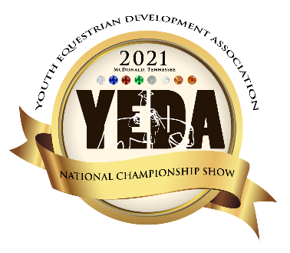
1 – 12 rides = 1 horse
13 – 24 rides = 2 horses
25 – 36 rides = 3 horses
37 – 48 rides = 4 horses
This is based on the horses being there all 4 days of the horse show.
If a horse cannot be provided $_50_ per rented ride

To help have the best horses for each class we would like to use the horses any day they are there. Consideration will be taken regarding frequency.
National Championships
June 23-26, 2022
Horse Description Form
Ride & Horse count is based on the total number of riders for the entire show.
Day Available |  |  |  | Team Name |  |  |  | Diamond Reining | Diamond Pattern & Elite | Sapphire Pattern | Sapphire Ranch Riding Class | Ruby Horsemanship | Ruby Pattern Class | Emerald Horsemanship | Emerald Pattern Class | Opal Horsemanship | Opal Pattern Class | Peal Rail Horsemanship | Peal Pattern Class | EWD ALL CLASSES
THUR | FRI | SAT | SUN | Horse Name | Ht Wt | S  P  U  R | Description  Include: Spur option, gate information, if noted as a Ht/Wt Horse please indicates if it is a pony or slight horse, any other directions that would be helpful to the horse draw organizer or the rider. 1 hand or 2?
☐ | ☐ | ☐ | ☐ |  | ☐Ht  ☐Wt |  |  | ☐ | ☐ | ☐ | ☐ | ☐ | ☐ | ☐ | ☐ | ☐ | ☐ | ☐ | ☐ | ☐
☐ | ☐ | ☐ | ☐ |  | ☐Ht  ☐Wt |  |  | ☐ | ☐ | ☐ | ☐ | ☐ | ☐ | ☐ | ☐ | ☐ | ☐ | ☐ | ☐ | ☐
☐ | ☐ | ☐ | ☐ |  | ☐Ht  ☐Wt |  |  | ☐ | ☐ | ☐ | ☐ | ☐ | ☐ | ☐ | ☐ | ☐ | ☐ | ☐ | ☐ | ☐
☐ | ☐ | ☐ | ☐ |  | ☐Ht  ☐Wt |  |  | ☐ | ☐ | ☐ | ☐ | ☐ | ☐ | ☐ | ☐ | ☐ | ☐ | ☐ | ☐ | ☐
☐ | ☐ | ☐ | ☐ |  | ☐Ht  ☐Wt |  |  | ☐ | ☐ | ☐ | ☐ | ☐ | ☐ | ☐ | ☐ | ☐ | ☐ | ☐ | ☐ | ☐

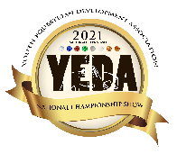 | YEDA National Championships  June 23 - 26, 2022  Account Summary | 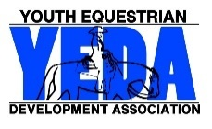

Team: ___________________________________________________________
State Invitational Entries THURSDAY | # of Rides | $70 Entire Fee  $10 Office Fee  $10 Media Fee | Subtotal
Junior High | __________ | X $90 | $_________
Senior High | __________ | X $90 | $_________
Non-Team Entries | __________ | X $90 | $_________
Entry Subtotals | __________ | X $90 | $_________

Individual Entries FRIDAY & SATURDAY | # of Rides | $70 Entire Fee  $10 Office Fee  $10 Media Fee | Subtotal
Junior High | __________ | X $90 | $_________
Senior High | __________ | X $90 | $_________
Non-Team Entries | __________ | X $90 | $_________
Entry Subtotals | __________ | X $90 | $_________

Team Entries SATURDAY & SUNDAY | # of Rides | $70 Entire Fee  $10 Office Fee  $10 Media Fee | Subtotal
Junior High | __________ | X $90 | $_________
Senior High | __________ | X $90 | $_________
Entry Subtotals | __________ | X $90 | $_________

Renting or Providing Horses? # Horses  This is based on brining horses all 4 days.  1 Horse = 12 rides  1 H/W Horse = 8 rides |  | # of Rides Providing | # Rides Renting  $50/ride |  | Subtotal
Total Number of Entries for the entire show | ________ | ________ | TH_______X$50 |  | $_________
 |  |  | FRI_______X$50 |  | $_________
__________ |  |  | SAT_______X$50 |  | $_________
 |  |  | SUN_______X$50 |  | $_________
It is important that you try to provide horses Wednesday Evening through Sunday, because of the warmup and to use the horses to their full potential. There will be great consideration used to not overuse the horses throughout the week! If you cannot provide your horses for the full show please contact a YEDA Founder to discuss options. |  |  |  | Subtotal | $_________
Ride & Horse count is based on the total number of riders for the entire show.

Total Owed: ______________
Please make checks payable to: YEDA Due date for entries and payment is May 27, 2022
For Questions Contact Laura Smith Cell: 419-957-9054 Email: mniese@showyeda.com
Mail Entries to: 18390 St. Rt. 568 Findlay, OH 45840
Office Use:
Date Received: _________________ Check # _____________________

