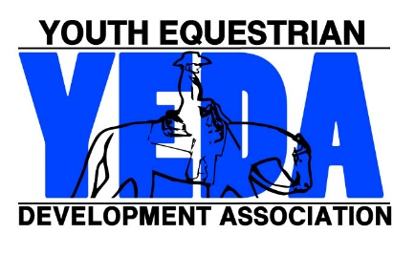
Add Form
Updated 2021

Complete one form per rider if there is a change from the original entries.
If there are more then 3 changes please submit updated entry forms.

Mail or email this form to the show management ASAP so they can prepare for changes. .

Name of Show |  | Date of show
Team Name
Rider Name |  | Back #
- Elementary  - JR High School  - High School  - EWD | _________________________  Division |  | - Rail  - Pattern | - Saturday  - Sunday
Check All Appropriate Boxes Above
Payment Attached Payment will be completed at the show
This entry constitutes an agreement and affirmation that the team, riders, coaches, trainers and/or any affiliate, agent, and/or representative of the aforementioned individuals making entries (hereinafter collectively referred to as “Exhibitor(s)”), shall accept and abide by the rules of YEDA and of the Show, that each rider is eligible as entered. Exhibitors certify that each rider is eligible for competition in the level entered, and that Exhibitors will accept any rulings of the YEDA with respect to their conduct as final and beyond contestation. Additionally, Exhibitors agree to defend and hold YEDA, its directors, official, employees, and all persons, stables, and/or other entities providing facilities, horses or equipment for YEDA Shows and activities (hereinafter collectively referred to as “YEDA & Affiliates”), harmless for any claim action, or suit, including claim, action, or suit for injury, property damage, or death sustained during participation in the show by the entity, his/her coach, trainer or visitors.
Furthermore, Exhibitors hereby acknowledge and recognize that competing in YEDA and event and/or show is an inherently dangerous activity and may result in substantial and serious injury, including but not limited to, maiming, paralysis, and/or death, and that all of the aforementioned individuals openly and freely accept all of the potential risks association with participation in YEDA events/shows. Accordingly Exhibitors agree to waive, release, and hold harmless the YEDA & Affiliates from any and all actions, causes of action, suits, debts, promises, damages, judgments, claims, and/or demands whatsoever, in law and/or equity. In making entry into YEDA Competition or event, team and/or individuals explicitly indemnify YEDA & Affiliates from any threatened and/or actual liability, and agree to defend YEDA & Affiliates from the same.
Coach Signature ________________________________ Date _______________

Office Use Only:
Show Secretary Signature _____________________ Date of Receipt __________
Date Recived Mailed _________________ Check #: ________ Initials ________

