St. Patrick’s Neigh Show Shirt Order Form
Order Deadline February 22, 2019
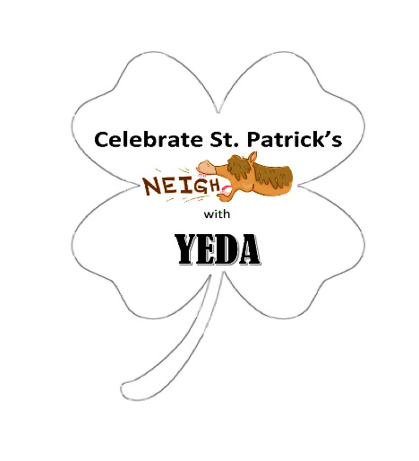
All Shirts are unisex – Shirt color under graphic is GREEN; Graphic on front/middle
Size Options:
Youth – Small, Medium, Large or Extra Large
Adults – Small, Medium, Large, Extra Large, 2X Large, 3X Large
Prices: T-Shirt $15 Sweatshirt/Hoodie $30 Add $2 for 2XL and $3 for 3XL

Name | Contact Number |  | Team Name | T-Shirt  Quantity  Size | Hoodie Quantity  Size
 |  | COST |  | $18 | $35
 |  | Total Number Ordered
 |  | Add $2 for 2XL or $3 for 3XL
 |  | Total Cost

Make check out to Southern Ohio Equestrian Team
You can mail your check and order form to Lisa Campbell – 6481 St. Rt. 125 Georgetown, Ohio 45121

