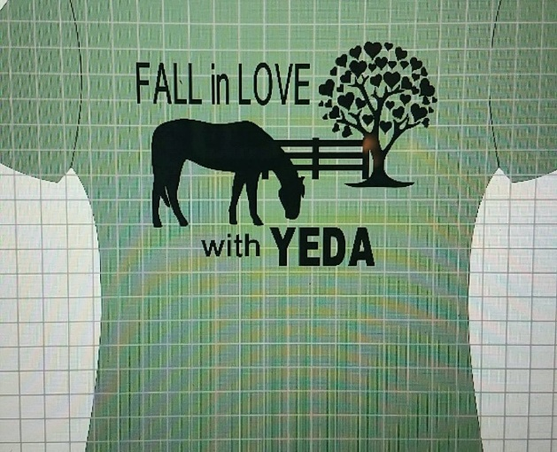
Fall in Love With YEDA
T-shirts and Hoodies
Shirts $25
Hoodie $35
Orders to be picked up at the Nov 10/11 show

Size | Tshirt | Hoodie
Small
Medium
Large
Xl
2X or larger 5$ extra
Payment due by Nov 1
Check to Champion Hill Performance Horses 10621 Navarre Rd SW #2 Navarre OH 44662 PayPal option available text Jamie at 3304187867

