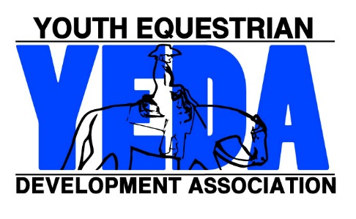
YEDA Coach Registration Form
Try It
All completed applications will be processed in the order in which they are received.
Please allow fifteen business days for processing.

Members who register by July 1st will receive a $5 discount

Payment of $10 fee and proof of insurance must be accompanied with this form

Name: | First Last
Team Name | Team Name
Coach Address: | Street Address
 | City State Zip Code
Phone Number: | ( ) - - |  | Email:
Emergency Contact | Name |  | PH #
Please Mark all professional affiliations
☐ USEF ☐ USHJA ☐ USPC ☐ AQHA ☐ APHA
☐ CHA ☐ 4H ☐ PtHA ☐ Other _________________________
Is your team accepting new members? ☐ YES ☐ NO
Are you interested in our referral program? ☐ YES ☐ NO
Liability Insurance Information
In order to qualify as a YEDA Coach, you much attach to this application a valid Certificate of Insurance, or other adequate proof of insurance.

Proof of Insurance must include:
- Coach Name
- Minimum Liability Coverage of $500,000 per intendent.
- Specific Language stating coverage includes:
  - “Professional Liability Coverage
    - OR -
  - “Riding Instruction both on and off premises, both on owned and non-owned horses”
Signature __________________________________ Date _______________
Make Checks out to: YEDA  Mail Form to:  Debbie Arnold  2415 State Route 603  Ashland, OH 44805 |  | For Questions Contact Debbie Arnold (CFO)  Phone: 419 – 566 – 6589  Email: DArnold@showyeda.com

