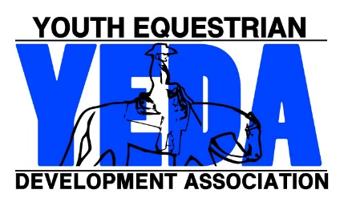

Decline to Show at
2018 Nationals

Rider Name |  |  | Back #
Team Name
Circle all appropriate options:
Elementary  JR High  SR High |  | Rail  Pattern  Reining
Diamond Sapphire Ruby Emerald Opal Pearl

I hereby recognize by signing this form that I am choosing to not show at Nationals. I understand that this decision is final, no matter what circumstances may change. I understand that another rider could be awarded my position.

Rider Signature ________________________________ Date _______________
Parent Signature ________________________________ Date _______________
Coach Signature ________________________________ Date _______________

Office Use Only:
Show Secretary Signature _____________________ Date of Receipt __________

