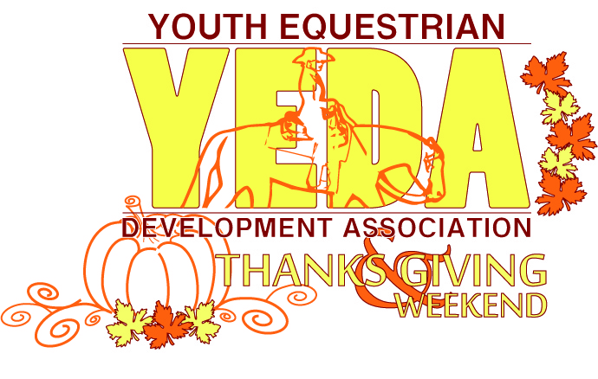
www.showyeda.com

YEDA Thanks and Giving Classic
SHOWBILL
November 4-5, 2017

WB Ranch

1640 Co Rd B
Swanton, OH 43558

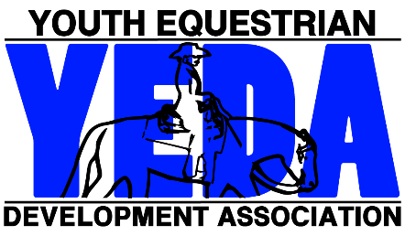

Our mission is to provide an equestrian riding program for youth students, via both instructional and experiential learning opportunities. To accomplish this, we will engage in equestrian competitions, instructional clinics, networking events and occasions for recruitment that includes but not limited to scholarship disbursements.

Show Officials

Saturday’s Judge:  Marc Delisle  Paw Paw, MI | Sunday’s Judge:  Dawn Kreakie Clason  Seville, Ohio

Steward: Stephanie Steiner
Show Manager: Jenna Kingery
Show Secretary: Molly Niese
Medical Personal: Sue Ortiz RN

Patterns:
ON SATURDAY: Pattern #6 will be used for the Senior and Junior High Sapphire, Ruby, Emerald, Opal and Elementary Pearl Classes. Pattern #6 will be used for Diamond Pattern/ Rail horsemanship class and Pattern #6 NRHA diamond reining. Pattern #11 will be used for the Diamond Elite class.
ON SUNDAY Pattern #7 will be used for the Senior and Junior High Sapphire, Ruby, Emerald, Opal and Elementary Pearl Classes. Pattern #7 will be used for Diamond Pattern/ Rail horsemanship class and Pattern #7 NRHA diamond reining.
The pattern book can be found on SHOWYEDA.com
Accommodations:
Staybridge Suites Toledo – Maumee  Located in: The Shops At Fallen Timbers  Address: 2300 Village Dr E #1800,  Maumee, OH 43537  Phone: (419) 878-8999 | Quality Inn  Address: 10621 Fremont Pike,  Perrysburg, OH 43551  Phone Number : 419-874-3101

SATURDAY Time Schedule

7:00am Coaches Meeting/ Draw Horses 8:00am Schooling of Horses 9:00 am Competition Begins:

Class 1. | Group 20 Senior High Diamond Reining | 7
Class 2. | Group 17 Senior High Sapphire Rail Horsemanship Split A | 8
Class 3. | Group 3 Junior High Opal Rail Horsemanship Split A | 6
Class 4. | Group 17 Senior High Sapphire Rail Horsemanship Split B | 7
Class 5. | Group 3 Junior High Opal Rail Horsemanship Split B | 6
Class 6. | Group 7 Junior High Ruby Rail Horsemanship | 11
Class 7. | Group 3 Junior High Opal Rail Horsemanship Split C | 6
Class 8. | Group 13 Senior High Emerald Rail Horsemanship Split A | 11
Class 9. | Group 19 Senior High Diamond Rail/Pattern Horsemanship | 8
Class 10. | Group 1 Elementary Pearl Rail Horsemanship Split A | 7
Class 11. | Group 1 Elementary Pearl Rail Horsemanship Split B | 6
Class 12. | Group 1 Elementary Pearl Rail Horsemanship Split C | 6
Class 13. | Group 1 Elementary Pearl Rail Horsemanship Split D | 6
Class 14. | Group 1 Elementary Pearl Rail Horsemanship Split E | 6
Class 15. | Group 2 Elementary Pearl Pattern Horsemanship Split A | 7
Class 16. | Group 2 Elementary Pearl Pattern Horsemanship Split B | 8
Class 17. | Group 2 Elementary Pearl Pattern Horsemanship Split C | 7
Class 18. | Group 2 Elementary Pearl Pattern Horsemanship Split D | 7
Class 19. | Group 15 Senior High Ruby Rail Horsemanship Split A | 6
Class 20. | Group 11 Senior High Opal Rail Horsemanship | 4
Class 21. | Group 15 Senior High Ruby Rail Horsemanship Split B | 6
Class 22. | Group 5 Junior High Emerald Rail Horsemanship | 10
Class 23. | Group 15 Senior High Ruby Rail Horsemanship Split C | 6
Class 24. | Group 9 Junior High Sapphire Rail Horsemanship | 9
Class 25. | Group 15 Senior High Ruby Rail Horsemanship Split D | 6
Class 26. | Group 21 Alumni Rail/Pattern Horsemanship | 2
Class 27. | Group 10 Junior High Sapphire Pattern Horsemanship | 9
Class 28. | Group 18 Senior High Sapphire Pattern Horsemanship Split A | 7
Class 29. | Group 18 Senior High Sapphire Pattern Horsemanship Split B | 8
Class 30. | Group 4 Junior High Opal Pattern Horsemanship Split A | 6
Class 31. | Group 4 Junior High Opal Pattern Horsemanship Split B | 6
Class 32. | Group 4 Junior High Opal Pattern Horsemanship Split C | 6
Class 33. | Group 12 Senior High Opal Pattern Horsemanship | 4
Class 34. | Group 14 Senior High Emerald Pattern Horsemanship | 9
Class 35. | Group 6 Junior High Emerald Pattern Horsemanship | 9
Class 36. | Group 8 Junior High Ruby Pattern Horsemanship | 11
Class 37. | Group 16 Senior High Ruby Pattern Horsemanship Split A | 6
Class 38. | Group 16 Senior High Ruby Pattern Horsemanship Split B | 6
Class 39. | Group 16 Senior High Ruby Pattern Horsemanship Split C | 6
Class 40. | Group 16 Senior High Ruby Pattern Horsemanship Split D | 6
Class 41. | Diamond Elite Horsemanship

Class 1 Group 20 Senior High Diamond Reining (7)
Back# | Name | Team | Draw | Horse
371 | Madison Pendleton | Bay Hill Farm
339 | Emily Coe | Bay Hill Farm
271 | Nathan Sparren | Equine Differences
310 | Sara Rosenberger | Hancock Horseman
101 | Allison Sparks | Hancock Horseman
151 | Aria Morgan | Hancock Horseman
202 | Teryn Ferrell | Royal Creek Equestrian Team

1st: | 339 | 2nd: | 151 | 3rd: | 202 | 4th: | 310 | 5th: | 101 | 6th: | x

Class 2 Group 17 Senior High Sapphire Rail Horsemanship Split A (8)
Back# | Name | Team | Draw | Horse
123 | Hannah Abfall | Arnold Equestrian Team
344 | Brianna Merklin | Bay Hill Farm
481 | Eli Wolfe | Equine Differences
442 | Kylee Simpson | Hancock Horseman
437 | Chrissy Robers | Hickory Ridge Equestrian Team
134 | Brooklyn Wright | KCPH Equestrian Team
180 | Abby Wirick | McColley Equestrian Team
209 | Sydni Nilles | Timmermann's Show Team

1st: | 481 | 2nd: | 180 | 3rd: | 442 | 4th: | 437 | 5th: | 209 | 6th: | 123

Class 3 Group 3 Junior High Opal Rail Horsemanship Split A (7)
Back# | Name | Team | Draw | Horse
208 | Hannah Whitney | Arnold Equestrian Team
110 | Ainsley Rhoades | Bay Hill Farm
130 | Morgan DiCesare | Equine Differences
125 | Abby Kerns | Hickory Ridge Equestrian Team
418 | Evan McColley | McColley Equestrian Team
225 | Kara Alexander | Timmermann's Show Team

1st: | 208 | 2nd: | 110 | 3rd: | 125 | 4th: | 418 | 5th: | 225 | 6th: | 130

Class 4 Group 17 Senior High Sapphire Rail Horsemanship Split B (7)
Back# | Name | Team | Draw | Horse
211 | Maryn Klaus | Arnold Equestrian Team
449 | Hailey Nelson | Bay Hill Farm
466 | Jordan Schauer | Hancock Horseman
314 | Madilyn Youngpeter | Hancock Horseman
112 | Hannah Copley | Hickory Ridge Equestrian Team
333 | Wyatt Humbert | KCPH Equestrian Team
166 | Adison Miller | McColley Equestrian Team

1st: | 211 | 2nd: | 333 | 3rd: | 314 | 4th: | 449 | 5th: | 112 | 6th: | 466

Class 5 Group 3 Junior High Opal Rail Horsemanship Split B (6)
Back# | Name | Team | Draw | Horse
470 | Chelsea Manning | Equine Differences
313 | Allison Tuggle | Equine Differences
227 | Anna Divis | Hancock Horseman
369 | Kaylyn Warthman | Hickory Ridge Equestrian Team
348 | Kendra Hochstedler | McColley Equestrian Team
464 | Hannah Barnes | Silver Spur Equestrian Team

1st: | 348 | 2nd: | 227 | 3rd: | 464 | 4th: | 470 | 5th: | 313 | 6th: | 369

Class 6 Group 7 Junior High Ruby Rail Horsemanship (11)
Back# | Name | Team | Draw | Horse
201 | Paige Mullins | Arnold Equestrian Team
218 | Evan Merklin | Bay Hill Farm
288 | Madison Gordon | Equine Differences
264 | Chloe Jansen | Equine Differences
438 | Skylar Super | Hancock Horseman
188 | Ellen Schloemer | Hancock Horseman
321 | Kaylee Bond | Hickory Ridge Equestrian Team
385 | Jordyn Humbert | KCPH Equestrian Team
403 | Reagan Dunn | M & M Equestrians
236 | Macee Roberts | Royal Creek Equestrian Team
249 | Adrianna Runzo | Silver Spur Equestrian Team

1st: | 264 | 2nd: | 438 | 3rd: | 236 | 4th: | 385 | 5th: | 188 | 6th: | 249

Class 7 Group 3 Junior High Opal Rail Horsemanship Split C (6)
Back# | Name | Team | Draw | Horse
435 | Casey Danczak | Arnold Equestrian Team
118 | Jocelyn Taylor | Equine Differences
383 | Lexi Edwards | Hancock Horseman
317 | Luke Arnold | KCPH Equestrian Team
224 | Kaylee Weisner | M & M Equestrians
122 | Eleanor Hughes | Silver Spur Equestrian Team

1st: | 383 | 2nd: | 118 | 3rd: | 317 | 4th: | 122 | 5th: | 435 | 6th: | 224

Class 8 Group 13 Senior High Emerald Rail Horsemanship Split A (11)
Back# | Name | Team | Draw | Horse
325 | Carson Mullins | Arnold Equestrian Team
326 | Robin Danczak | Arnold Equestrian Team
152 | Maggie Vesper | Arnold Equestrian Team
388 | Carrie Leeper | Bay Hill Farm
409 | Halle Parsley | Bay Hill Farm
275 | Tayler Thomas | Hancock Horseman
141 | Alyssa Detillion | KCPH Equestrian Team
199 | Brooke Miller | McColley Equestrian Team
488 | Dessa Weed | McColley Equestrian Team
189 | Olivia Stanley | Royal Creek Equestrian Team
368 | Lauren Goodyear | Silver Spur Equestrian Team

1st: | 199 | 2nd: | 141 | 3rd: | 368 | 4th: | 388 | 5th: | 326 | 6th: | 325

Class 9 Group 19 Senior High Diamond Rail/Pattern Horsemanship (8)
Back# | Name | Team | Draw | Horse
478 | Aubree Jones | Arnold Equestrian Team
371 | Madison Pendleton | Bay Hill Farm
339 | Emily Coe | Bay Hill Farm
271 | Nathan Sparren | Equine Differences
310 | Sara Rosenberger | Hancock Horseman
101 | Allison Sparks | Hancock Horseman
151 | Aria Morgan | Hancock Horseman
202 | Teryn Ferrell | Royal Creek Equestrian Team

1st: | 339 | 2nd: | 151 | 3rd: | 310 | 4th: | 101 | 5th: | 478 | 6th: | 202

Class 10 Group 1 Elementary Pearl Rail Horsemanship Split A (7)
Back# | Name | Team | Draw | Horse
230 | Danika Denman | Arnold Equestrian Team
244 | Katie Wilson | Bay Hill Farm
105 | Arianna Smith | Hancock Horseman
226 | Karly Humbert | KCPH Equestrian Team
491 | Jolie Ervin | Royal Creek Equestrian Team
467 | Audrey Reynolds | Timmermann's Show Team
213 | Taylor Coen | Hickory Ridge Equestrian Team

1st: | 226 | 2nd: | 230 | 3rd: | 213 | 4th: | 244 | 5th: | 491 | 6th: | 467

Class 11 Group 1 Elementary Pearl Rail Horsemanship Split B (6)
Back# | Name | Team | Draw | Horse
116 | Rori Hiller | Arnold Equestrian Team
145 | Addison Beal | Equine Differences
363 | Grace Michels | Hancock Horseman
286 | Tyler Ousley | KCPH Equestrian Team
250 | Savanna Benoit | Royal Creek Equestrian Team
251 | Ava Pope | Timmermann's Show Team

1st: | 251 | 2nd: | 145 | 3rd: | 250 | 4th: | 116 | 5th: | 286 | 6th: | 363

Class 12 Group 1 Elementary Pearl Rail Horsemanship Split C (6)
Back# | Name | Team | Draw | Horse
169 | Sophia Hillman | Arnold Equestrian Team
330 | Addison Webb | Equine Differences
133 | Kaya Strausbaugh | Hancock Horseman
241 | Dixie McKibbin | McColley Equestrian Team
159 | Alexis Baum | Silver Spur Equestrian Team
353 | Josaphine Tilford | Timmermann's Show Team

1st: | 133 | 2nd: | 330 | 3rd: | 169 | 4th: | 159 | 5th: | 241 | 6th: | 353

Class 13 Group 1 Elementary Pearl Rail Horsemanship Split D (6)
Back# | Name | Team | Draw | Horse
240 | Eavan Clark | Bay Hill Farm
366 | Ayden Maclean | Equine Differences
446 | Marina Fox | Hancock Horseman
440 | Zoey Holmes | McColley Equestrian Team
172 | Autumn Schrock | Silver Spur Equestrian Team
142 | Kylee Rigsby | Timmermann's Show Team

1st: | 446 | 2nd: | 240 | 3rd: | 142 | 4th: | 440 | 5th: | 366 | 6th: | 172

Class 14 Group 1 Elementary Pearl Rail Horsemanship Split E (6)
Back# | Name | Team | Draw | Horse
278 | Molly Hobbs | Bay Hill Farm
157 | Alyssa Jaeck | Hancock Horseman
105 | Arianna Smith | Hancock Horseman
266 | Sadie Staats | Hancock Horseman
389 | Sydney Preston | M & M Equestrians
405 | Leah Reynolds | Timmermann's Show Team
247 | Alexandria Knudtson | Timmermann's Show Team

1st: | 389 | 2nd: | 105 | 3rd: | 157 | 4th: | 278 | 5th: | 247 | 6th: | 405

Class 15 Group 2 Elementary Pearl Pattern Horsemanship Split A (7)
Back# | Name | Team | Draw | Horse
244 | Katie Wilson | Bay Hill Farm
366 | Ayden Maclean | Equine Differences
133 | Kaya Strausbaugh | Hancock Horseman
241 | Dixie McKibbin | McColley Equestrian Team
250 | Savanna Benoit | Royal Creek Equestrian Team
353 | Josaphine Tilford | Timmermann's Show Team
467 | Audrey Reynolds | Timmermann's Show Team

1st: | 241 | 2nd: | 250 | 3rd: | 133 | 4th: | 244 | 5th: | 353 | 6th: | 467

Class 16 Group 2 Elementary Pearl Pattern Horsemanship Split B (8)
Back# | Name | Team | Draw | Horse
116 | Rori Hiller | Arnold Equestrian Team
278 | Molly Hobbs | Bay Hill Farm
157 | Alyssa Jaeck | Hancock Horseman
446 | Marina Fox | Hancock Horseman
440 | Zoey Holmes | McColley Equestrian Team
159 | Alexis Baum | Silver Spur Equestrian Team
251 | Ava Pope | Timmermann's Show Team
213 | Taylor Coen | Hickory Ridge Equestrian Team

1st: | 278 | 2nd: | 251 | 3rd: | 159 | 4th: | 157 | 5th: | 440 | 6th: | 116

Class 17 Group 2 Elementary Pearl Pattern Horsemanship Split C (7)
Back# | Name | Team | Draw | Horse
240 | Eavan Clark | Bay Hill Farm
145 | Addison Beal | Equine Differences
105 | Arianna Smith | Hancock Horseman
266 | Sadie Staats | Hancock Horseman
446 | Marina Fox | Hancock Horseman
389 | Sydney Preston | M & M Equestrians
172 | Autumn Schrock | Silver Spur Equestrian Team
405 | Leah Reynolds | Timmermann's Show Team

1st: | 446 | 2nd: | 105 | 3rd: | 405 | 4th: | 389 | 5th: | 172 | 6th: | 240

Class 18 Group 2 Elementary Pearl Pattern Horsemanship Split D (7)
Back# | Name | Team | Draw | Horse
230 | Danika Denman | Arnold Equestrian Team
330 | Addison Webb | Equine Differences
363 | Grace Michels | Hancock Horseman
226 | Karly Humbert | KCPH Equestrian Team
491 | Jolie Ervin | Royal Creek Equestrian Team
142 | Kylee Rigsby | Timmermann's Show Team
247 | Alexandria Knudtson | Timmermann's Show Team

1st: | 142 | 2nd: | 226 | 3rd: | 491 | 4th: | 230 | 5th: | 330 | 6th: | 247

Class 19 Group 15 Senior High Ruby Rail Horsemanship Split A (6)
Back# | Name | Team | Draw | Horse
285 | Amanda Wildermuth | Arnold Equestrian Team
126 | Kelsey Frame | Bay Hill Farm
283 | Lily Chamberlin | Hancock Horseman
109 | Hailey Rayle | Hancock Horseman
296 | Rachel Bowers | McColley Equestrian Team
429 | Frances Hughes | Silver Spur Equestrian Team

1st: | 126 | 2nd: | 296 | 3rd: | 285 | 4th: | 429 | 5th: | 109 | 6th: | 283

Class 20 Group 11 Senior High Opal Rail Horsemanship (4)
Back# | Name | Team | Draw | Horse
146 | Jana Eicher | Bay Hill Farm
304 | Cori Reitmann | Equine Differences
234 | Asya Modert | McColley Equestrian Team
263 | Kalyn Dewey | McColley Equestrian Team

1st: | 146 | 2nd: | 263 | 3rd: | 234 | 4th: | 304 | 5th: | x | 6th: | x

Class 21 Group 15 Senior High Ruby Rail Horsemanship Split B (6)
Back# | Name | Team | Draw | Horse
410 | Katie Shuster | Arnold Equestrian Team
458 | Sydney Mayer | Bay Hill Farm
334 | Micaela Jackson | Equine Differences
290 | Hannah Stange | Hancock Horseman
414 | Roxanne Simpson | Hancock Horseman
114 | Mikaela Gleeson | McColley Equestrian Team

1st: | 334 | 2nd: | 114 | 3rd: | 458 | 4th: | 290 | 5th: | 414 | 6th: | 410

Class 22 Group 5 Junior High Emerald Rail Horsemanship (10)
Back# | Name | Team | Draw | Horse
462 | Jada Lowery | Arnold Equestrian Team
137 | Kennedy Kirkham | Bay Hill Farm
376 | Skylar Twite | Equine Differences
417 | Maria DiCesare | Equine Differences
191 | Hayden Miller | Equine Differences
454 | Elizabeth Schloemer | Hancock Horseman
279 | Samantha Wagner | Hancock Horseman
377 | Mattahew Rudolph | M & M Equestrians
259 | Riley Long | McColley Equestrian Team
127 | Skylar Livengood | Silver Spur Equestrian Team

1st: | 191 | 2nd: | 279 | 3rd: | 462 | 4th: | 376 | 5th: | 259 | 6th: | 127

Class 23 Group 15 Senior High Ruby Rail Horsemanship Split C (6)
Back# | Name | Team | Draw | Horse
331 | Bailey VanDriest | Arnold Equestrian Team
485 | Zoe Bricker | Bay Hill Farm
181 | Alyssa Rhoades | Bay Hill Farm
411 | Courtney Fox | Hancock Horseman
204 | McKenzie Schultz | Hickory Ridge Equestrian Team
231 | Taylor Klimmer | McColley Equestrian Team
136 | Ashley Yoder | Arnold Equestrian Team

1st: | 331 | 2nd: | 231 | 3rd: | 136 | 4th: | 411 | 5th: | 204 | 6th: | 485

Class 24 Group 9 Junior High Sapphire Rail Horsemanship (9)
Back# | Name | Team | Draw | Horse
479 | Katelynn Smeltzer | Arnold Equestrian Team
260 | Ava Coughlin | Bay Hill Farm
140 | Quinn Foor | Equine Differences
400 | Lauren Ferguson | Equine Differences
154 | Gracie Casebolt | Hancock Horseman
459 | Katie Ruffener | KCPH Equestrian Team
160 | Violet Shetler | M & M Equestrians
255 | Erin Ortiz | The Grimm Riders
312 | Shayna Rigsby | Timmermann's Show Team

1st: | 154 | 2nd: | 140 | 3rd: | 400 | 4th: | 479 | 5th: | 459 | 6th: | 160

Class 25 Group 15 Senior High Ruby Rail Horsemanship Split D (6)
Back# | Name | Team | Draw | Horse
219 | Grace Murphy | Arnold Equestrian Team
220 | Bailey Deal | Bay Hill Farm
347 | Austen Nissen | Hancock Horseman
474 | Kaylee Fair | Hancock Horseman
329 | Dane Creps | Hancock Horseman
392 | Madison Rife | Royal Creek Equestrian Team

1st: | 219 | 2nd: | 220 | 3rd: | 347 | 4th: | 329 | 5th: | 474 | 6th: | 392

Class 26 Group 21 Alumni Rail/Pattern Horsemanship (2)
Back# | Name | Team | Draw | Horse
356 | Savannah Mileti | Equine Differences
212 | Jessica Hipple | Silver Spur Equestrian Team

1st: | 356 | 2nd: | 212 | 3rd: | x | 4th: | x | 5th: | x | 6th: | x

Class 27 Group 10 Junior High Sapphire Pattern Horsemanship (9)
Back# | Name | Team | Draw | Horse
479 | Katelynn Smeltzer | Arnold Equestrian Team
260 | Ava Coughlin | Bay Hill Farm
140 | Quinn Foor | Equine Differences
400 | Lauren Ferguson | Equine Differences
154 | Gracie Casebolt | Hancock Horseman
459 | Katie Ruffener | KCPH Equestrian Team
160 | Violet Shetler | M & M Equestrians
255 | Erin Ortiz | The Grimm Riders
312 | Shayna Rigsby | Timmermann's Show Team

1st: | 312 | 2nd: | 255 | 3rd: | 160 | 4th: | 154 | 5th: | 459 | 6th: | 479

Class 28 Group 18 Senior High Sapphire Pattern Horsemanship Split A (7)
Back# | Name | Team | Draw | Horse
123 | Hannah Abfall | Arnold Equestrian Team
449 | Hailey Nelson | Bay Hill Farm
314 | Madilyn Youngpeter | Hancock Horseman
112 | Hannah Copley | Hickory Ridge Equestrian Team
333 | Wyatt Humbert | KCPH Equestrian Team
180 | Abby Wirick | McColley Equestrian Team
209 | Sydni Nilles | Timmermann's Show Team

1st: | 209 | 2nd: | 449 | 3rd: | 123 | 4th: | 112 | 5th: | 180 | 6th: | 314

Class 29 Group 18 Senior High Sapphire Pattern Horsemanship Split B (8)
Back# | Name | Team | Draw | Horse
211 | Maryn Klaus | Arnold Equestrian Team
344 | Brianna Merklin | Bay Hill Farm
481 | Eli Wolfe | Equine Differences
466 | Jordan Schauer | Hancock Horseman
442 | Kylee Simpson | Hancock Horseman
437 | Chrissy Robers | Hickory Ridge Equestrian Team
134 | Brooklyn Wright | KCPH Equestrian Team
166 | Adison Miller | McColley Equestrian Team

1st: | 211 | 2nd: | 437 | 3rd: | 166 | 4th: | 481 | 5th: | 442 | 6th: | 344

Class 30 Group 4 Junior High Opal Pattern Horsemanship Split A (6)
Back# | Name | Team | Draw | Horse
110 | Ainsley Rhoades | Bay Hill Farm
130 | Morgan DiCesare | Equine Differences
369 | Kaylyn Warthman | Hickory Ridge Equestrian Team
125 | Abby Kerns | Hickory Ridge Equestrian Team
224 | Kaylee Weisner | M & M Equestrians
464 | Hannah Barnes | Silver Spur Equestrian Team

1st: | 125 | 2nd: | 464 | 3rd: | 224 | 4th: | 110 | 5th: | 369 | 6th: | 130

Class 31 Group 4 Junior High Opal Pattern Horsemanship Split B (7)
Back# | Name | Team | Draw | Horse
435 | Casey Danczak | Arnold Equestrian Team
313 | Allison Tuggle | Equine Differences
118 | Jocelyn Taylor | Equine Differences
383 | Lexi Edwards | Hancock Horseman
418 | Evan McColley | McColley Equestrian Team
225 | Kara Alexander | Timmermann's Show Team

1st: | 383 | 2nd: | 435 | 3rd: | 313 | 4th: | 225 | 5th: | 418 | 6th: | 118

Class 32 Group 4 Junior High Opal Pattern Horsemanship Split C (6)
Back# | Name | Team | Draw | Horse
208 | Hannah Whitney | Arnold Equestrian Team
470 | Chelsea Manning | Equine Differences
227 | Anna Divis | Hancock Horseman
317 | Luke Arnold | KCPH Equestrian Team
348 | Kendra Hochstedler | McColley Equestrian Team
122 | Eleanor Hughes | Silver Spur Equestrian Team

1st: | 317 | 2nd: | 227 | 3rd: | 122 | 4th: | 470 | 5th: | 348 | 6th: | 208

Class 33 Group 12 Senior High Opal Pattern Horsemanship (4)
Back# | Name | Team | Draw | Horse
146 | Jana Eicher | Bay Hill Farm
304 | Cori Reitmann | Equine Differences
263 | Kalyn Dewey | McColley Equestrian Team
234 | Asya Modert | McColley Equestrian Team

1st: | 263 | 2nd: | 234 | 3rd: | 146 | 4th: | 304 | 5th: | X | 6th: | x

Class 34 Group 14 Senior High Emerald Pattern Horsemanship (9)
Back# | Name | Team | Draw | Horse
152 | Maggie Vesper | Arnold Equestrian Team
326 | Robin Danczak | Arnold Equestrian Team
388 | Carrie Leeper | Bay Hill Farm
409 | Halle Parsley | Bay Hill Farm
275 | Tayler Thomas | Hancock Horseman
141 | Alyssa Detillion | KCPH Equestrian Team
488 | Dessa Weed | McColley Equestrian Team
189 | Olivia Stanley | Royal Creek Equestrian Team
368 | Lauren Goodyear | Silver Spur Equestrian Team

1st: | 488 | 2nd: | 189 | 3rd: | 152 | 4th: | 326 | 5th: | 368 | 6th: | 409

Class 35 Group 6 Junior High Emerald Pattern Horsemanship (9)
Back# | Name | Team | Draw | Horse
462 | Jada Lowery | Arnold Equestrian Team
137 | Kennedy Kirkham | Bay Hill Farm
376 | Skylar Twite | Equine Differences
417 | Maria DiCesare | Equine Differences
191 | Hayden Miller | Equine Differences
454 | Elizabeth Schloemer | Hancock Horseman
279 | Samantha Wagner | Hancock Horseman
259 | Riley Long | McColley Equestrian Team
127 | Skylar Livengood | Silver Spur Equestrian Team

1st: | 191 | 2nd: | 259 | 3rd: | 462 | 4th: | 376 | 5th: | 454 | 6th: | 279

Class 36 Group 8 Junior High Ruby Pattern Horsemanship (11)
Back# | Name | Team | Draw | Horse
201 | Paige Mullins | Arnold Equestrian Team
218 | Evan Merklin | Bay Hill Farm
288 | Madison Gordon | Equine Differences
264 | Chloe Jansen | Equine Differences
438 | Skylar Super | Hancock Horseman
188 | Ellen Schloemer | Hancock Horseman
321 | Kaylee Bond | Hickory Ridge Equestrian Team
385 | Jordyn Humbert | KCPH Equestrian Team
403 | Reagan Dunn | M & M Equestrians
236 | Macee Roberts | Royal Creek Equestrian Team
249 | Adrianna Runzo | Silver Spur Equestrian Team

1st: | 264 | 2nd: | 385 | 3rd: | 438 | 4th: | 218 | 5th: | 249 | 6th: | 288

Class 37 Group 16 Senior High Ruby Pattern Horsemanship Split A (7)
Back# | Name | Team | Draw | Horse
410 | Katie Shuster | Arnold Equestrian Team
485 | Zoe Bricker | Bay Hill Farm
220 | Bailey Deal | Bay Hill Farm
414 | Roxanne Simpson | Hancock Horseman
109 | Hailey Rayle | Hancock Horseman
429 | Frances Hughes | Silver Spur Equestrian Team

1st: | 414 | 2nd: | 485 | 3rd: | 410 | 4th: | 429 | 5th: | 220 | 6th: | 109

Class 38 Group 16 Senior High Ruby Pattern Horsemanship Split B (6)
Back# | Name | Team | Draw | Horse
285 | Amanda Wildermuth | Arnold Equestrian Team
458 | Sydney Mayer | Bay Hill Farm
347 | Austen Nissen | Hancock Horseman
329 | Dane Creps | Hancock Horseman
204 | McKenzie Schultz | Hickory Ridge Equestrian Team
114 | Mikaela Gleeson | McColley Equestrian Team

1st: | 347 | 2nd: | 329 | 3rd: | 204 | 4th: | 458 | 5th: | 285 | 6th: | 114

Class 39 Group 16 Senior High Ruby Pattern Horsemanship Split C (6)
Back# | Name | Team | Draw | Horse
331 | Bailey VanDriest | Arnold Equestrian Team
126 | Kelsey Frame | Bay Hill Farm
334 | Micaela Jackson | Equine Differences
290 | Hannah Stange | Hancock Horseman
474 | Kaylee Fair | Hancock Horseman
296 | Rachel Bowers | McColley Equestrian Team

1st: | 296 | 2nd: | 474 | 3rd: | 334 | 4th: | 331 | 5th: | 290 | 6th: | 126

Class 40 Group 16 Senior High Ruby Pattern Horsemanship Split D (6)
Back# | Name | Team | Draw | Horse
219 | Grace Murphy | Arnold Equestrian Team
181 | Alyssa Rhoades | Bay Hill Farm
283 | Lily Chamberlin | Hancock Horseman
411 | Courtney Fox | Hancock Horseman
231 | Taylor Klimmer | McColley Equestrian Team
392 | Madison Rife | Royal Creek Equestrian Team
136 | Ashley Yoder | Arnold Equestrian Team

1st: | 136 | 2nd: | 392 | 3rd: | 219 | 4th: | 231 | 5th: | 283 | 6th: | 411

Class 41 Diamond Elite Horsemanship
Back# | Name | Team | Draw | Horse
478 | Aubree Jones | Arnold Equestrian Team
339 | Emily Coe | Bay Hill Farm
101 | Allison Sparks | Hancock Horseman
202 | Teryn Ferrell | Royal Creek Equestrian Team
Winner: Aubree Jones

Show Results
SR High School Team |  | JR High School Team
High Point Team | Bay Hill | High Point Team | Equine Differences
Res. High Point Team | McColley | Res. High Point Team | Hancock Horseman
High Point Rider | Emily Coe  (Bay Hill) | High Point Rider | Gracie Casebolt (Hancock Horseman)
Res. High Point Rider | Aria Morgan  (Hancock Horseman) | Res. High Point Rider | Shayna Rigsby (Timmermann’s)
Horse of the Show |  | Reggie (M & M Equestrians)

SATURDAY SCOREBOARD
Senior High School Team
Team | Diamond Rail/Pattern  Horsemanship | Diamond Reining | Sapphire Rail  Horsemanship | Sapphire Pattern  Horsemanship | Ruby Rail  Horsemanship | Ruby Pattern  Horsemanship | Emerald Rail  Horsemanship | Emerald Pattern  Horsemanship | Opal Rail  Horsemanship | Opal Pattern  Horsemanship | Total | Final Placings
Arnold | - | 2 | 6 | 6 | 6 | 6 | 2 | 4 | - | - | 32
Bay Hill | 6 | 6 | 3 | 5 | 6 | 5 | 3 | 1 | 4 | 2 | 41
Equine Differences | 0 | - | 6 | 3 | 6 | 4 | - | - | 1 | 1 | 21
Hancock | 5 | 5 | 4 | 2 | 4 | 6 | 0 | 0 | - | - | 26
Hickory Ridge | - | - | 3 | 5 | 2 | 4 | - | - | - | - | 14
KCPH | - | - | 5 | 0 | - | - | 5 | 0 | - | - | 10
McColley | - | - | 5 | 4 | 5 | 6 | 6 | 6 | 3 | 4 | 39
Royal Creek | 4 | 1 | - | - | 1 | 5 | 0 | 5 | - | - | 16
Silver Spur | - | - | - | - | 3 | 3 | 4 | 2 | - | - | 12
Timmermann's | - | - | 2 | 6 | - | - | - | - | - | - | 8

SATURDAY SCOREBOARD
Junior High School Team
Team | Sapphire Rail  Horsemanship | Sapphire Pattern  Horsemanship | Ruby Rail  Horsemanship | Ruby Pattern  Horsemanship | Emerald Rail  Horsemanship | Emerald Pattern  Horsemanship | Opal Rail  Horsemanship | Opal Pattern  Horsemanship | Total | Final Placings
Arnold | 3 | 1 | 0 | 0 | 4 | 4 | 6 | 5 | 23
Bay Hill | 0 | 0 | 0 | 3 | 0 | 0 | 5 | 3 | 11
Equine Differences | 5 | 0 | 6 | 6 | 6 | 6 | 5 | 4 | 38
Grimm | 0 | 4 | - | - | - | - | - | - | 4
Hancock | 6 | 3 | 5 | 4 | 5 | 2 | 6 | 6 | 37
Hickory Ridge | - | - | 0 | 0 | - | - | 4 | 6 | 10
KCPH | 2 | 2 | 3 | 5 | - | - | 4 | 6 | 22
M & M | 1 | 4 | 0 | 0 | 0 | - | 1 | 4 | 10
McColley | - | - | - | - | 2 | 5 | 6 | 2 | 15
Royal Creek | - | - | 4 | 0 | - | - | - | - | 4
Silver Spur | - | - | 1 | 2 | 1 | 0 | 4 | 5 | 13
Timmermann's | 0 | 6 | - | - | - | - | 2 | 3 | 11

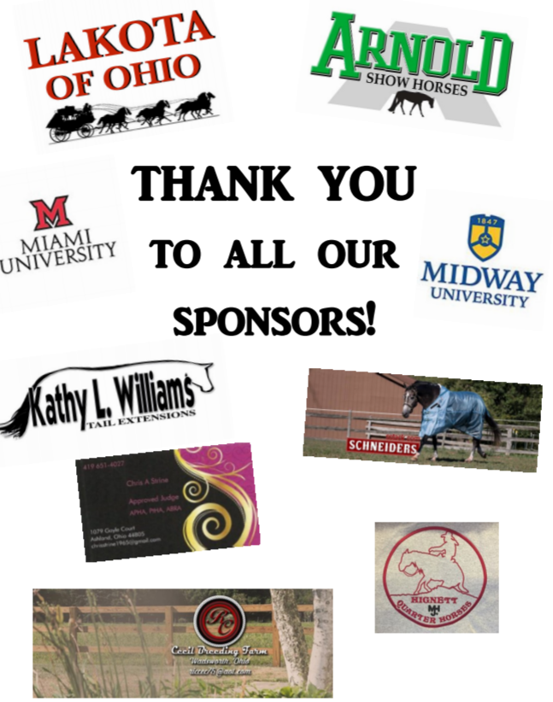
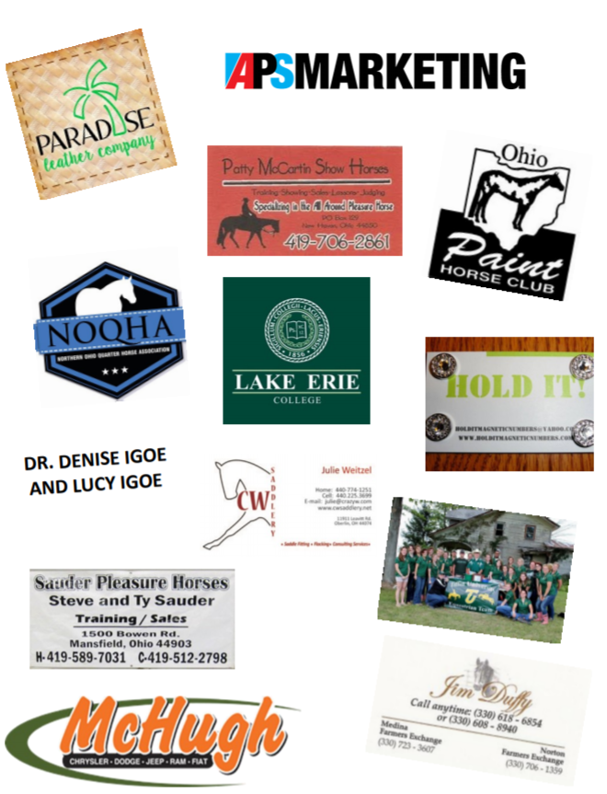
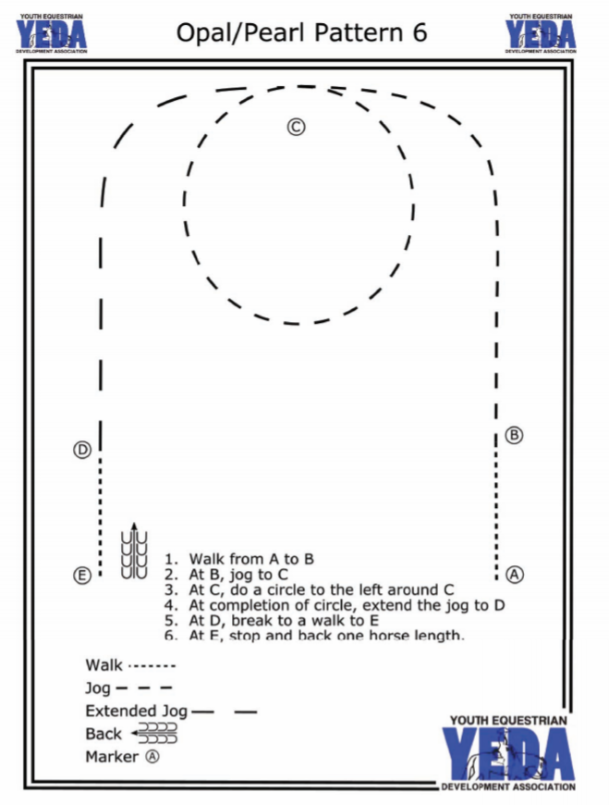
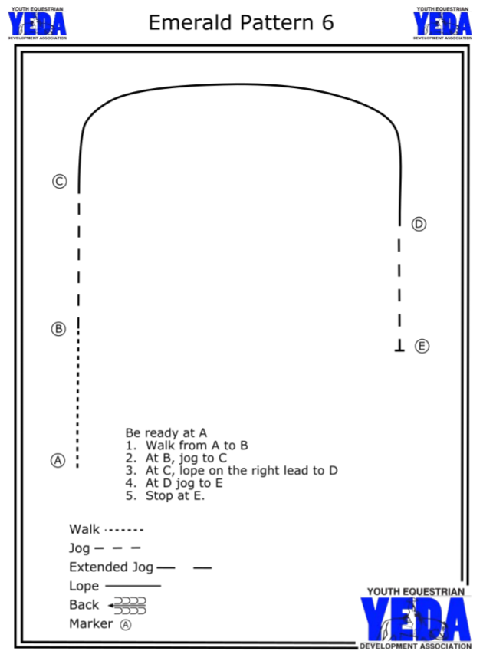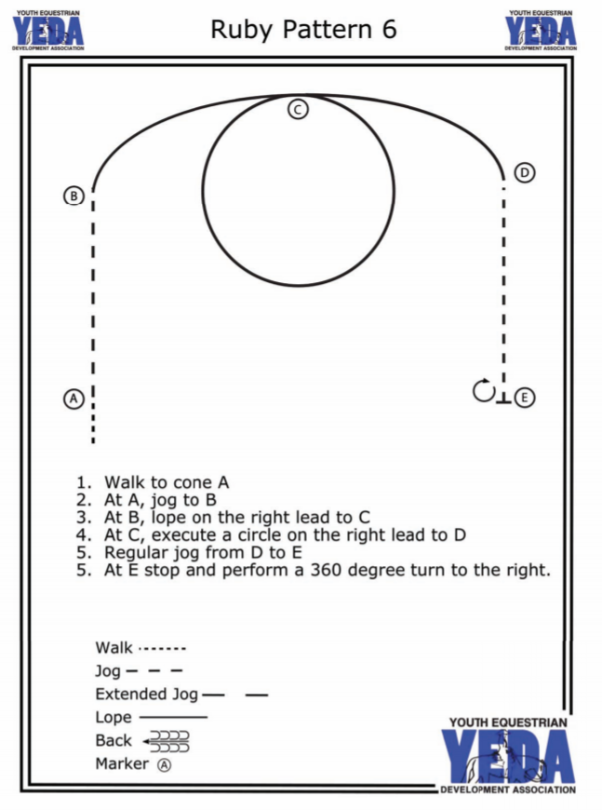
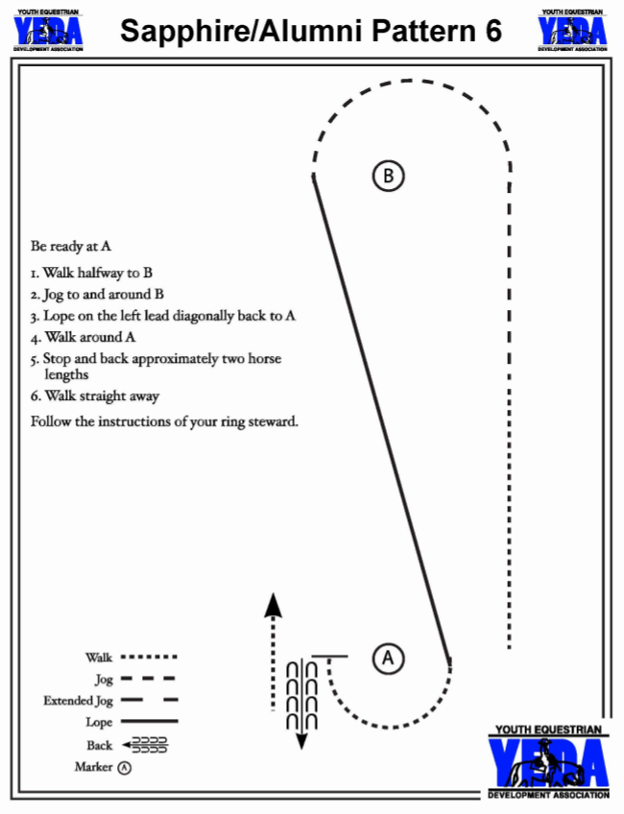
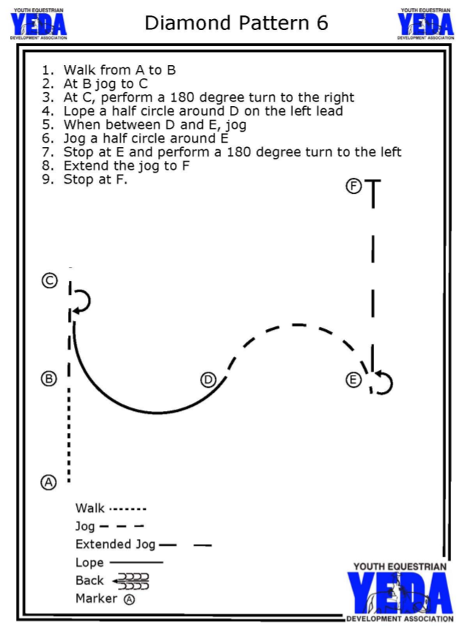
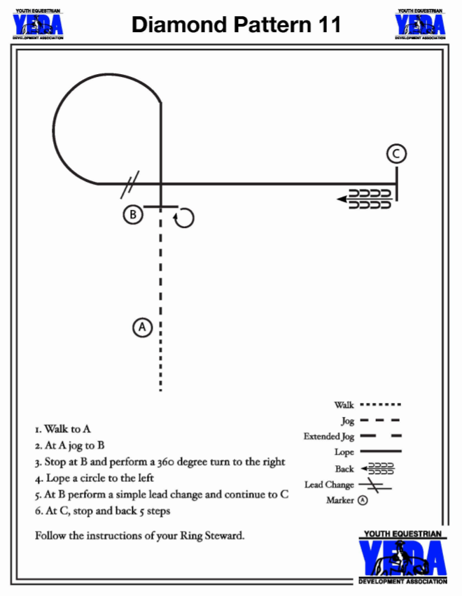
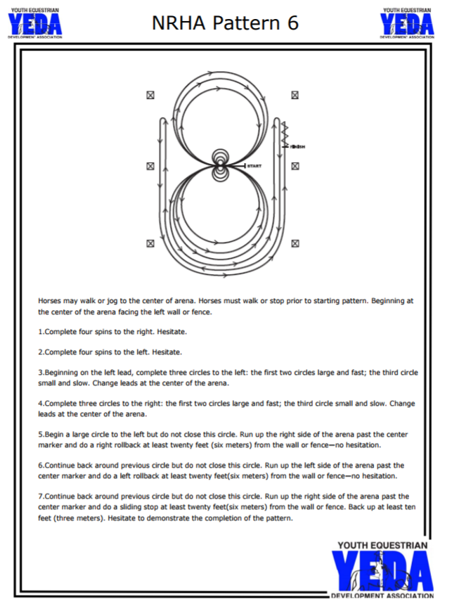

Horse Descriptions
Andy (Hancock)-sorrel paint- must have spurs, rowels preferred but ball ok. Spur stop, light contact in mouth, light squeeze to slow down, squeeze and kiss to back. Use your voice.
Apple (M&M) – PONY, Regular Ride, Ball Spurs if allowed, cannot use a crop, may get lazy as he gets tired. Light contact, stay out of his face. Does not have a spur stop.
Bella: (Bayhill) Good Spins. Good lead changes. Will get restless in the middle so don't stand very long. she will get hot if you try to run her too hard.
Blue (Marsha) – Reiner – Works off of the riders legs, with light rein. She spins, stops, circles and changes leads very nicely with proper cuing from the rider. A lot of run to ride. Rider may wear spurs, but probably will not need to use them.
Bree (Hancock)- Appy Mare, Great Draw, Set up for RIGHT lead, Don’t Bridle too tight. Ball spur option
Bud - (McColley) light contact, spurs recommended, but not needed for Opal or Pearl, has a lead change so watch legs during lope, good draw Spur trained, can use spurs if division allows, good draw
Charlie – (McColley) Tall HUS Horse, light contact, spurs recommended, leg release to stop, can be spooky to the right, responds well to voice command Leg Release, Good Draw
Chester- (Hancock) Chestnut Quarter Horse Gelding. Good draw. Stay relaxed on him. Can ride with light contact. Easy draw and great pattern horse. Squeeze to slow down and kiss to lope off. Talk to him when you stop and break down to trot or walk. Ball spurs preferred but can use rowel.
DANNY​ - (BayHill) sorrel gelding, light contact. If you hold too tight he won't go forward. Set up for leads, spurs or a crop.
Dynamo – (McColley) FOR SALE! Spurs recommended, but not needed for Opal or Pearl, spur stops, light contact, responds to voice commands, good draw Spur Stop, light contact.
EMMETT -​ (BayHill) sorrel gelding, can be lazy, spurs or crop.
Emmy- (Hancock) Black Quarter Pony Mare. Good draw. Keep light contact on her face. Ride with your legs. Ball spurs only or no spurs. Can get a quick lope if you push her forward and let her get away with it.
Forrest: (Arnold) Light rein contact. Rowel or ball spur depending on division. Use hand and leg to support into lope transition and to collect on rail. Has spur stop for patterns.
Fred (KCPH) – Awesome Draw! Leg horse. Spur Stop. Can be Lazy at the lope. Takes leads easy. Spur Stop!
Freddie: ​(Arnold) Good Draw! Loose rein easy ride ball spurs.
Gabby: (Arnold) Good Draw! Use light contact. No Spurs
Gator (Hancock) Palomino QH, Good Draw, Reiner Trained.
GINGER - ​(BayHill) sorrel mare, great draw, light contact. Set up for leads, spurs or crop
Grinder: (MH) Does all maneuvers well, needs to be pushed into bridle and supported to stops. Otherwise, he will front end his stops. Light contact on bit and guided with riders legs.
HOLLYWOOD (​BayHill):​ Reiner Type, Good Draw, Spurs. Bridle up, will go slow if you ask him to.
Jake - (McColley) Spurs recommended, keep a soft leg, leg release stop, medium contact, responds to voice commands, do not use in patterns with spins
Jess: (MH)- Does all maneuvers very well. Rides with light bit contact. Can get quick in the run down to stops. Rider can wear spurs.
Jett (Royal Creek) – SATUDAY ONLY Sorrell mare QH- can use with or without spurs - great draw : kiss and push opposite leg for lope - very easy to ride
Junior: Bay QH Gelding (EQD)- Ranch type horse, has some reining training. Responds quickly off of cues. Will go slow if asked but need to keep in the bridle. Set up for right lead. Spurs ok.
Kandy (Hancock)- walk trot only- light contact in mouth, squeeze with legs to help slow down and when stopping, kiss when backing. Talk to her, USE YOUR VOICE.
Mick (Hancock) Pony, Ht/Wt, No Spurs. Set up for leads. Wills slow down with snug rein and light leg
Milky Way (Timmerman’s) ranchy, has a slow jog and collected lope, can be lazy, needs a strong leg for lope. No Spurs, may change throughout the day check with the steward. Big solid horse. Light contact
Milo: (Hancock) Reiner, Use spurs allowed by your division. Will be good in walk/jog divisions without spurs. Overall consistent good draw.
Minnie – (EQD) Bay QH Mare Can get quick or be lazy depending on the rider. Lazy in transitions. Spurs or crop OK.
Mya – (Timmerman’s) Can have a big motor. Don’t let her go to fast, she can go slow at the lope and jog. No Spurs, Light Contact.
Ozzie (Royal Creek) – SATURDAY ONLY Bay gelding QH - great draw kiss and ouch opposite leg to lope. Can use any spurs or no spurs head can get a little high no worries
Patty (M&M) – She is very lazy and the riders will need a strong leg, using a crop is suggested. She is a little bouncy and does not have a good headset. Responds well to voice commands “easy” to slow and “whoa” to stop.
Pete: Sorrel Paint Gelding (EQD)- Spur broke. Good draw. May drift to inside if allowed.
Reggie aka Too Tuff to Kiss (M&M) – SUNDAY ONLY Congress Caliber, Spur Stop, Lots of leg needed. Great Horsemanship Horse, Spurs
Remi- (Hancock) Sorrel Quarter Horse Mare. Good draw. Ride with light contact. Has a leg release stop. Set up for leads. Great pattern horse. To slow down release your legs off of her, but not so much she will stop. Do not squeeze to slow her down, it will make her go faster. Ball spurs only.
Rocky: (Arnold) Light rein contact. No Spurs. May anticipate on patterns. Just don't rush him in transitions. No Spurs. Let horse holder put numbers in number holders HATES to have his flank area touched. Great to ride. Great Draw.
Rusty Draft X (EQD)- Set up for right lead. Keep mouth contact. Lots of legs
Sarah: Sorrel Paint Mare (EQD)- Spurs optional. Ride with light contact. Will drift to inside if allowed. Smooth ride, light contact.
Scotch (KCPH) – Good Draw! Must use Legs! Spurs if allowed. Press into bridle and can be great draw. Leg horse, Spur Stop.
Sissy: (Arnold) Light rein contact. Support with hand and use leg to collect. Needs to be set up for right lead. Hand to rail and push hip in. Stay forward in turns for patterns. Rowel or ball spur OK depending on division rules
Sly (BayHill) – Bay Gelding, set up for leads. Smooth lope and trot. Can go without spurs. Great Pattern Horse, Reiner Type.
STAN​ (EQD): Sorrel POA Gelding. Can get quick. Hold with quiet rein. Set up for leads. May need spurs later in day.
Sugar: Buckskin QH Mare (EQD)- Use soft holding contact on her mouth. Can slow her bouncy trot by softening mouth. Set up for leads. Will go with or without spurs.
Teddy- (Hancock) Can use spurs. Medium length rein, better down transition with voice commands. Neck rein or works off leg/spur.
Tuffy - (McColley) Spurs needed, set up for right lead, leg release to stop, light contact, will go slow but you have to make him and it requires a lot of leg, responds to voice command. Possible Two-Handed Option (check with show steward). Requires leg contact at the lope.
Yogi – (Timmerman’s) gelding shown at the Congress, steady eddy, good little pleasure horse. No Spurs Light contact

