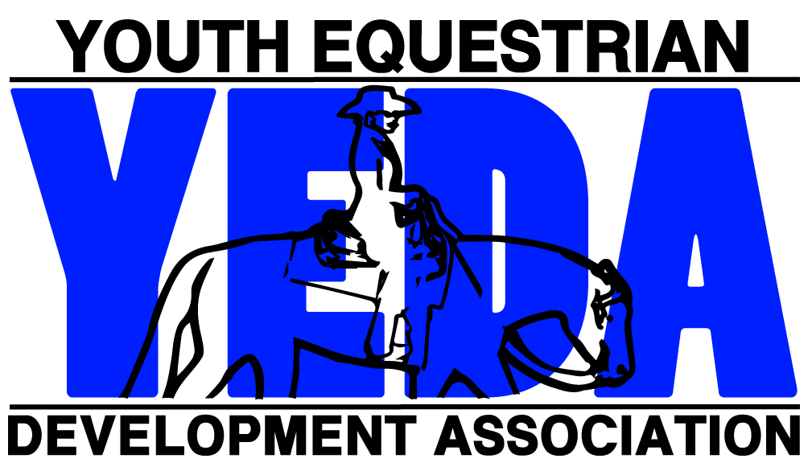

YEDA National Class Sponsorship Form

Thank-you for helping support our YEDA National horse show! All sponsors will be announced during the duration of the horse show as well as have the opportunity to choose to showcase their banner and/or their name in the arena and custom ad in our show program!
Please select your sponsorship level and preferred class to sponsor.

□ $250 Diamond Sponsor
- Includes your full size custom banner in the arena and a full page ad in the program
□ $125 Gold Sponsor
- Includes your name with the other Gold sponsors listed on a big banner in the arena and a 1/2-page ad in the program
□ $50 silver Sponsor
- Includes your name listed on a smaller Silver sponsors banner in the arena and a small business card ad in the program
Please mail payment & forms: YEDA Attn: Debbie Arnold, 2415 St. Rt 603 Ashland, OH 44805
** **
++ Please select at least 3 classes, and number them in order of preference. If all the classes you have selected are already sponsored, show management will select a class for you.

Jr. High Classes:

- Class 1 Pearl Division – Rail Horsemanship
- Class 2 Opal Division - Rail Horsemanship
- Class 3 Emerald Division - Rail Horsemanship
- Class 4 Ruby Division - Rail Horsemanship
- Class 5 Ruby Division - Pattern Horsemanship
- Class 6 Sapphire Division - Rail Horsemanship
- Class 7 Sapphire Division - Pattern Horsemanship

Sr. High Classes:
- Class 8 Opal Division - Rail Horsemanship
- Class 9 Emerald Division - Rail Horsemanship
- Class 10 Ruby Division - Rail Horsemanship
- Class 11 Ruby Division - Pattern Horsemanship
- Class 12 Sapphire Division - Rail Horsemanship
- Class 13 Sapphire Division - Pattern Horsemanship
- Class 14 Diamond Division - Pattern Horsemanship
- Class 15 Diamond Division - Reining
- Class 16 Diamond Elite Horsemanship

Name: Mailing Address:
City, State, Zip:
Email Address:
Message to be announced (optional):

